St. Michael’s C.E. Primary School
Headteacher:  Mrs S. Dring MA, BA (Hons), Headteacher  Love Faith    Honesty Respect  Courage Kindness |  | Leigh Road  Howe Bridge  Atherton  Manchester  M46 0PA  ☏ (01942) 883118  

enquiries@admin.howebridge.wigan.sch.uk

‘Immersed in a Christian Community, each individual is encouraged, challenged and nurtured to learn and grow to achieve their full potential.’

Love, Respect, Kindness, Faith, Honesty and Courage

Newsletter
7th November 2025


Remembrance Sunday Service – Sunday 9th November 2025
This year’s Remembrance Service will take place at St Michael’s and All Angels Church at 9:00am. The church service will last approximately 1.5 hours, after which we will join the parade to the Cenotaph for a further service.
We would love to see as many children as possible, particularly junior children, at the service. The full service and parade may be too long for our youngest children. Alternatively, you may wish to join us directly at the Cenotaph at 10:50am.
Important information for parents:

- Parents must stay with their child and walk with them to the Cenotaph for health and safety reasons.
- Some children will also be attending in Brownie or Cub uniforms — it’s always wonderful to see them representing their groups.
- Children attending the church service should arrive by 9:00am in full school uniform.
- Children joining at the Cenotaph should arrive by 10:50am.
- Please ensure your child is dressed warmly — coat, gloves, and hat are recommended as it can be very cold outdoors.

We hope to see as many families as possible representing St Michael’s CE Primary School at this important event.

Weekly Class Attendance

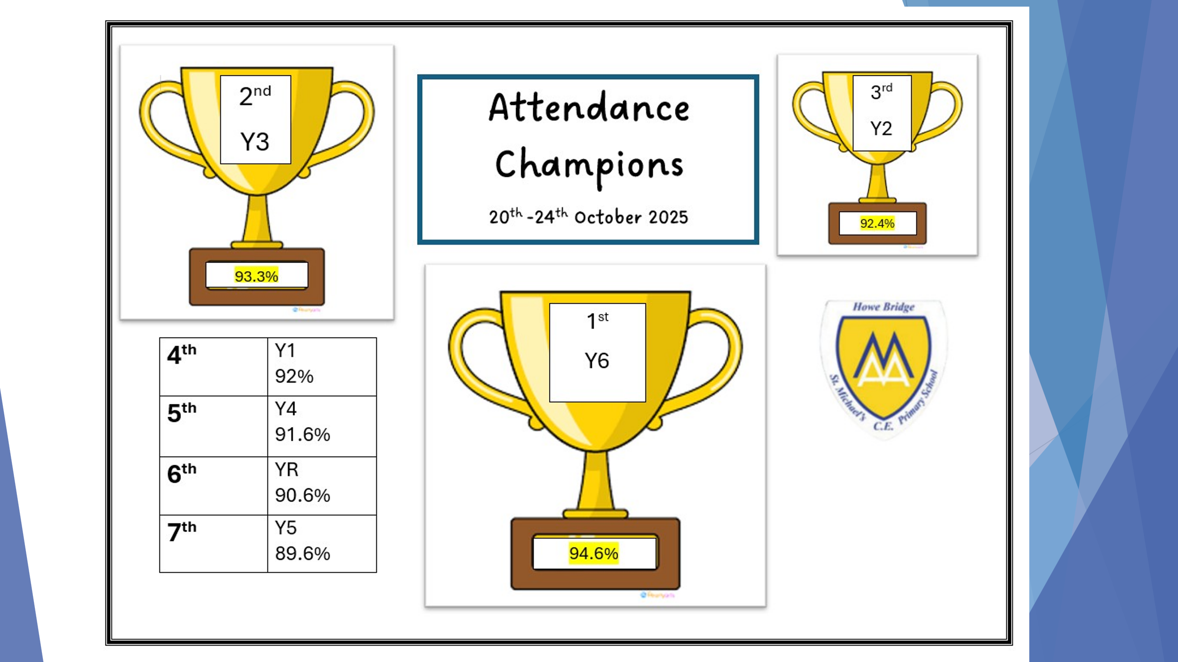
The Royal British Legion Poppy Appeal 🌺
Some of our Year 6 pupils will visit each class each day after lunch to offer items for purchase.
Please ensure your child brings the correct change, as no change will be available. All money collected will go directly into the Poppy Box to support this important cause.
Each item has a minimum suggested donation:
- 🌺 Paper Poppy – 20p
- ✨ Reflector Poppy – 50p
- 🎗️ Wristband – £1.00
- 💫 Snap Band – £1.50
These items have been extremely popular in previous years, and we expect them to sell out quickly again this time. The Poppy Appeal have kindly issued us an extra box, so hopefully everyone will have the chance to get what they’d like.
Thank you for supporting this meaningful cause. ❤️
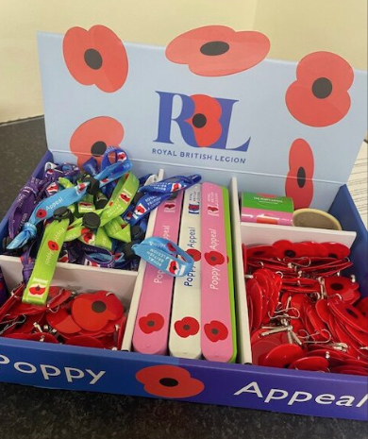

Panto Trip Payment Reminder ✨🎭
We’re so excited for our upcoming Panto trip, it’s going to be a magical experience for the children! 🎉
A huge thank you to everyone who has already made their £13 payment via Arbor (School Shop section) we really appreciate it! 💫
If you haven’t yet paid, please do so by Monday 24th November. Unfortunately, the trip may have to be cancelled if payments aren’t received in time, and we’d love every child to join in the festive fun. 🎄
Thank you for helping us make this a wonderful outing for all our students.


Parents Evening Appointments
Our parents evening this term will be held on Tuesday 11th and Wednesday 12th November. Appointments have now made available to book on Arbor. Please make sure you book an appointment with your child’s class teacher(s).

Christmas Jumper Dash – Thursday 11th December.
Children will be bringing a sponsor form for our annual Christmas jumper dash. On this day children can come in their own clothes/Christmas jumpers then they will take part in a festive run! It is always a great event! Please help us to raise as much money for school as we can. Thank you to Mrs Marsh who is working with Barclays to match fund up to £1,000 for us.

Stars of the Week

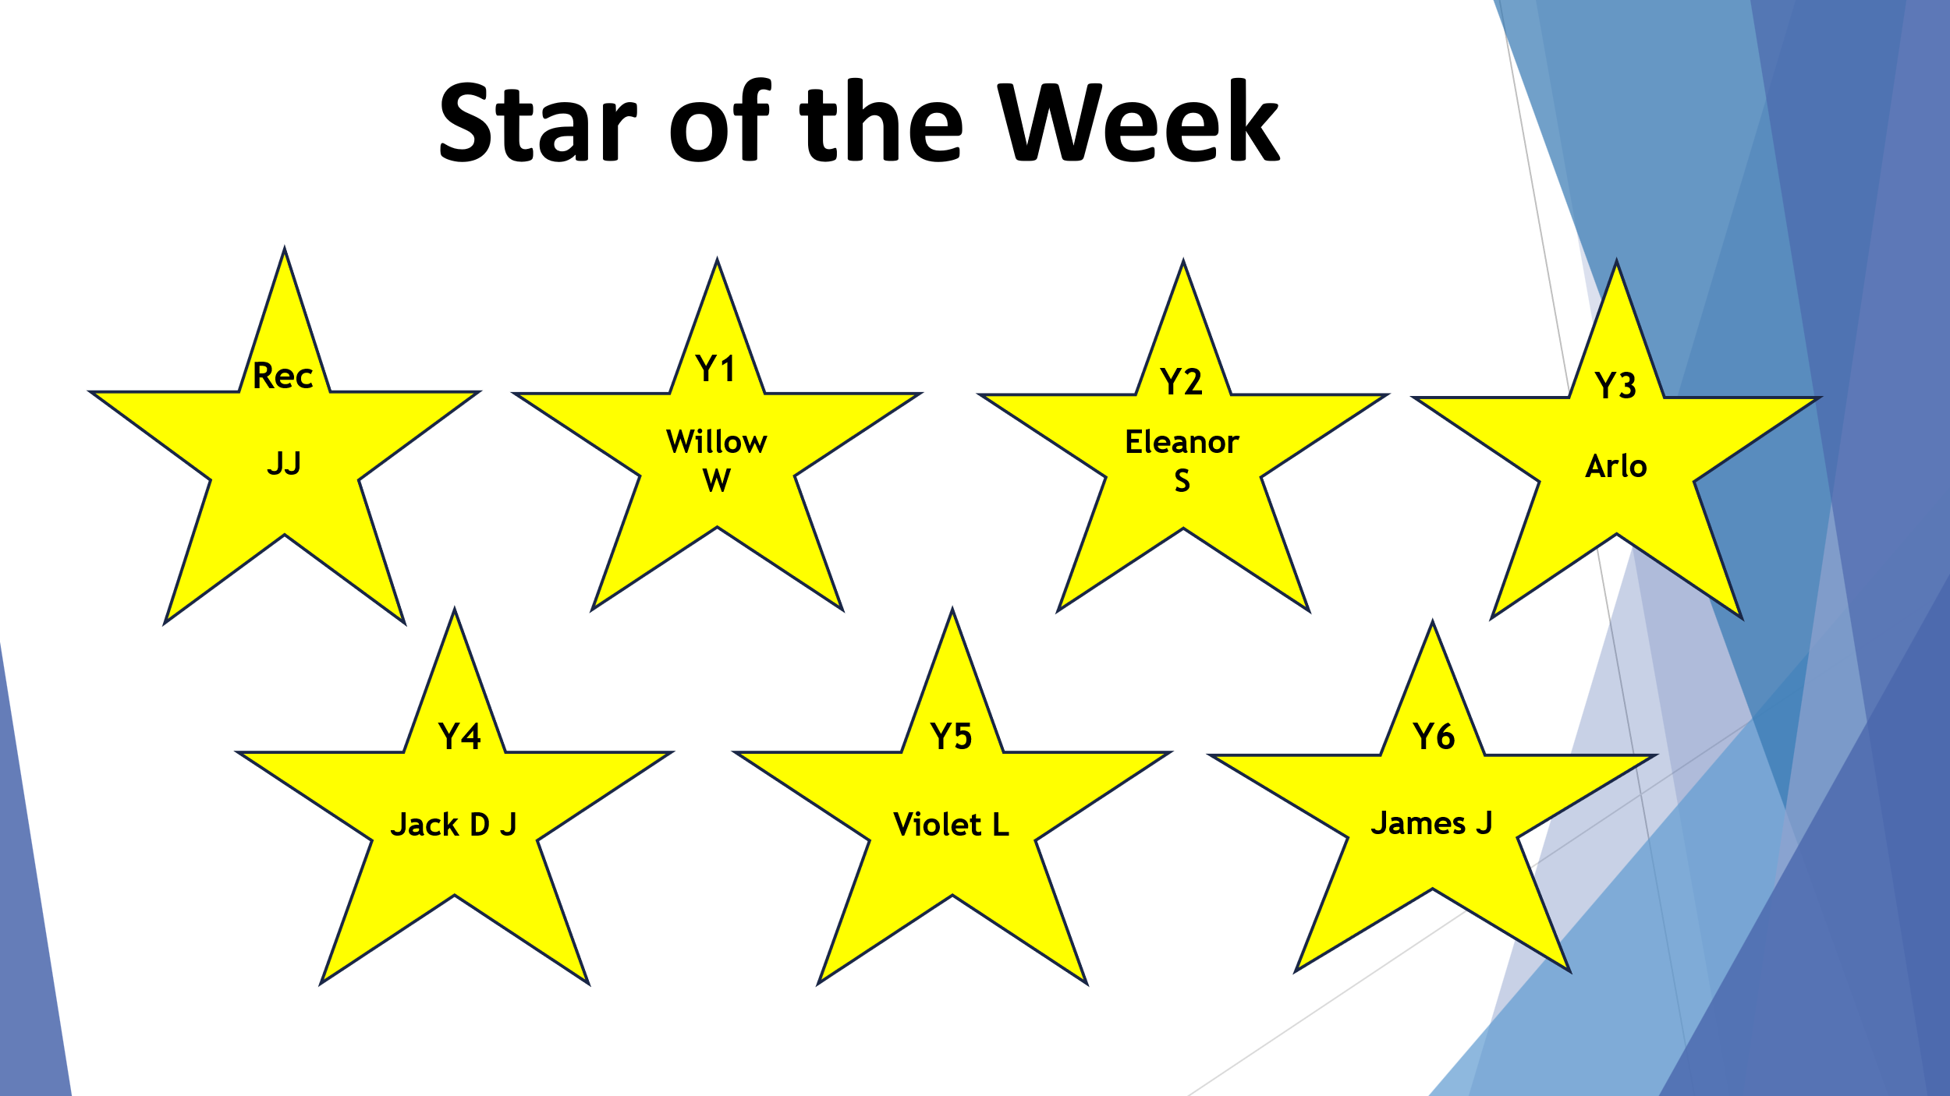

House Points
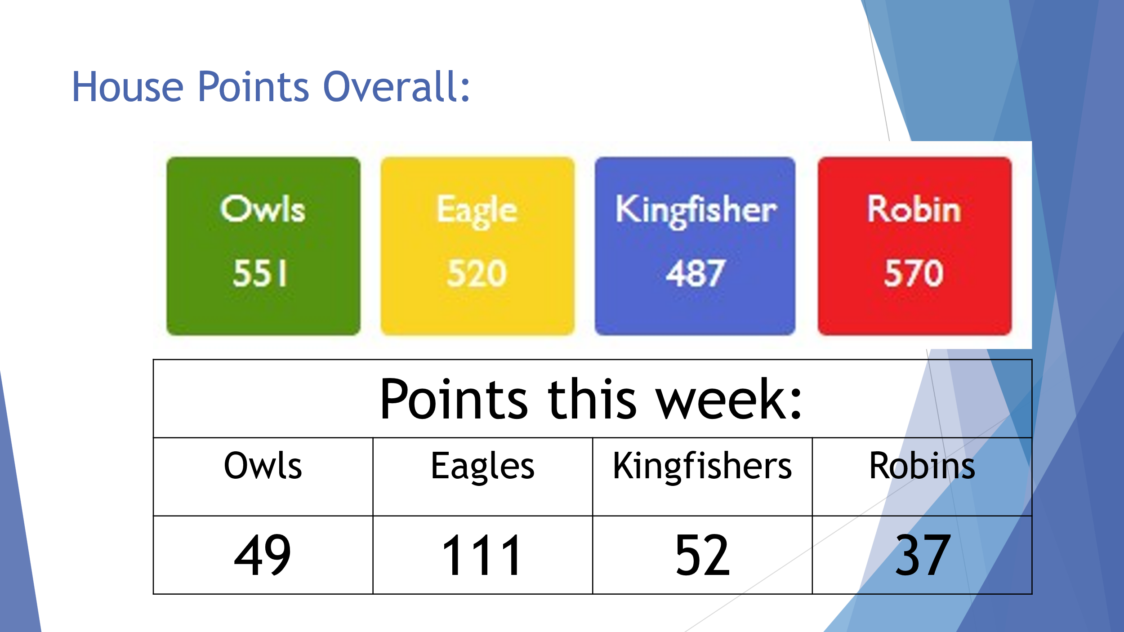

Next week at a glance
Anti-Bullying Week
Week beginning  10th Nov | Before school | During the school day | Music tuition | After school
Monday | Breakfast club | Whole school Collective Worship  Year 1 outdoor PE  Year 4 outdoor PE  Year 3 indoor PE  Odd Sock Day   | Guitar | ABC childcare
Tuesday | Breakfast club | Whole school  singing worship  Y3 outdoor PE  Y4 Wigan Music Service  Remembrance Coffee Morning  Year 1 are hosting  (everyone welcome)   | Drums  Violin | ABC childcare  Parents evening
Wednesday | Breakfast club | Whole school Collective Worship  Rec indoor PE  Year 1 outdoor PE |  | ABC childcare  Parents evening
Thursday | Breakfast club | Class Worship  Rec indoor PE  Y5 indoor PE  Y6 indoor PE  Year 2 outdoor PE |  | ABC childcare
Friday | Breakfast club | Whole school Celebration Worship  Year 5 Swimming  Year 2 outdoor PE  Year 6 outdoor PE  Year 4 indoor PE  Children in need  PJs and £1 donation  Y5 Poetry Event  (Y5 in full school uniform they will be having a separate own clothes day for Children in Need) | Keyboard | ABC childcare

Future dates for your diary
(Please note, these will be added to frequently)
10th November | PTA Christmas card deadline
w/c 24th November | Assessment Week
26th November | KS2 at St Michaels Church
1st December | KS1 Panto
5th December | 
8th December | KS2 Panto
9th December | Reception and Year 1 Christingle making with parents at 9am
10th December | Little Barn Mobile Farm Visit
11th December | Reception & Y6  Health check with School Nurse  Christmas Jumper dash day  Christmas Dinner Day
16th & 17th December  16th (9.30am)  17th (2.30pm) | KS1 Nativity Performances
18th December | KS2 Carol Concert
19th December | Finish for Christmas Break at 3:30pm
24th December | Christingle service at St Michael’s Church at 3.30pm
5th January | Inset day – Staff only
6th January | Children return to school at 8:50am
5th February | Young Voices
16th February – 20th February | Half Term
23rd March – 25th March | Year 4 Robinwood residential
Thursday 2nd April | Finish for Easter Break at 3:30pm
20th April | Children return to school at 8:50am
4th May | Bank Holiday Monday
25th May – 29th May | Half Term
29th June – 3rd July | Year 6 Residential trip
9th July | 
16th July | Finish for Summer Break at 3:30pm
17th July | Inset day – Staff only
1st September | Inset day – Staff only
2nd September | Children return to school at 8:50am
9th September | Rock Kidz 🤘🏼🎸

Useful Links
School Instagram Account https://www.instagram.com/st.michaelsceprimaryschool/
School Facebook Account https://www.facebook.com/HoweBridgeStMichaelsPrimary
School Lunches to be ordered on https://app.schoolgrid.co.uk
Apply for Free School Meals https://forms.wigan.gov.uk/xfp/form/750
Internet Safety Links: Safer Internet Day 2025 - UK Safer Internet Centre
Mental Health and wellbeing details – www.actionforhappiness.org
Samaritans 116 123 (freephone 24 hours a day)
Mind - www.mind.org.uk
Online resources
For parents:
https://www.nspcc.org.uk/keeping-children-safe/online-safety/
https://www.saferinternet.org.uk/advice-centre/parents-and-carers
https://www.thinkuknow.co.uk/parents/
https://www.childnet.com/parents-and-carers
For children:
http://www.safetynetkids.org.uk/personal-safety/staying-safe-online/
https://www.thinkuknow.co.uk/
https://www.internetmatters.org/advice/6-10/

