Number sense Assessment grid
Stage/Book | How to Assess | Resource to use
Stage 1 Book 1 | Show the child the subitising 1-5 dot sheet and give them six seconds to identify the amount shown in the image, orally. Tick if correct, x if incorrect. If the child must count the dots individually the this is not automatic recognition so should be marked as incorrect | 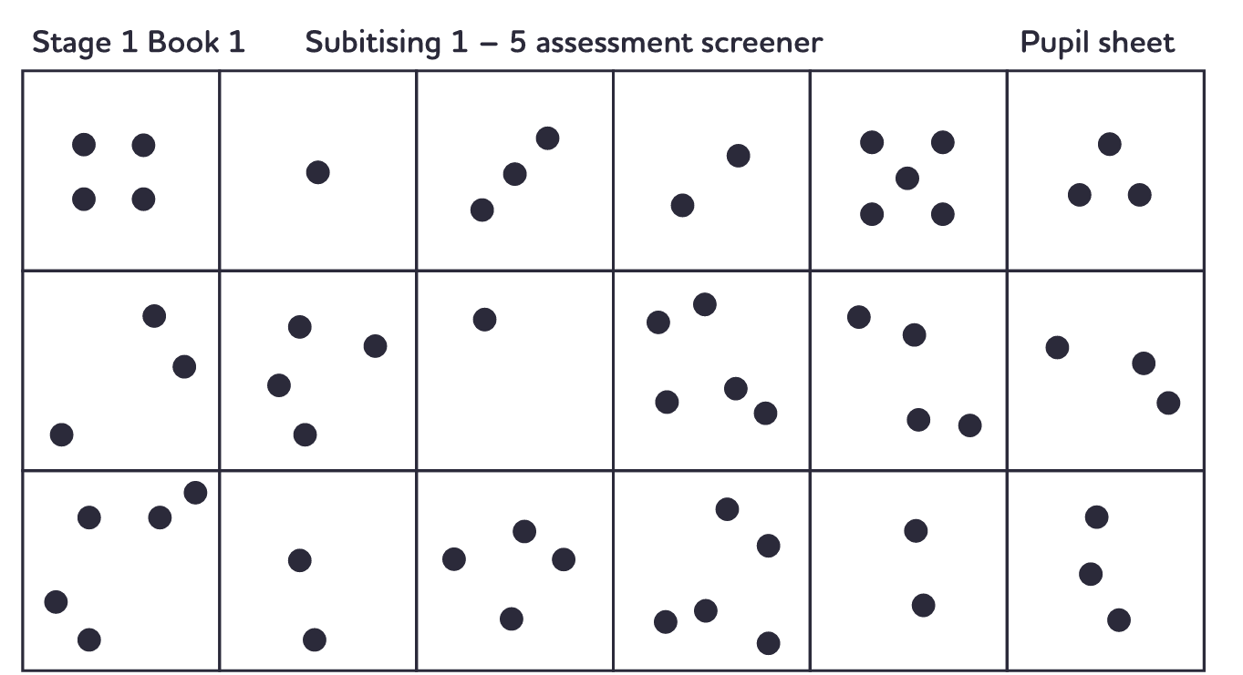
Stage 1 Book 2 | Show the child the subitising 6-10 dot sheet and give them six seconds to identify the amount shown in the image, with their hands or verbally. Tick if correct, x if incorrect. If the child must count the dots, beads or fingers individually the this is not automatic recognition so should be marked as incorrect | 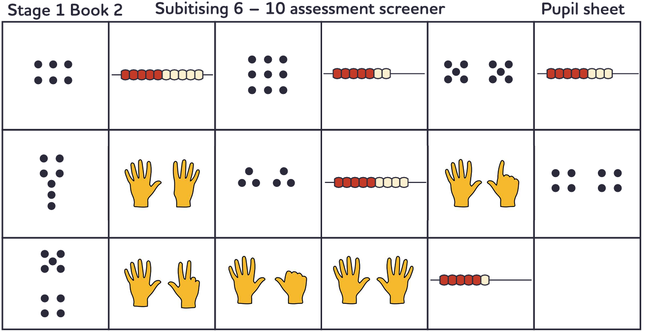
Stage 1 Book 3 | Show the child the subitising 1-5 and 6-10 on a tens frame sheet and give them six seconds to identify the amount shown in the image, with their hands or verbally. Tick if correct, x if incorrect. If the child must count the counters individually the this is not automatic recognition so should be marked as incorrect | 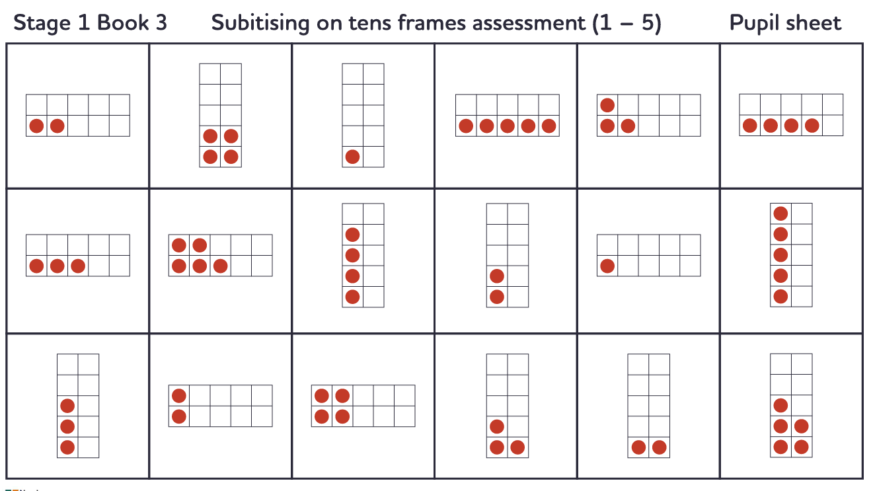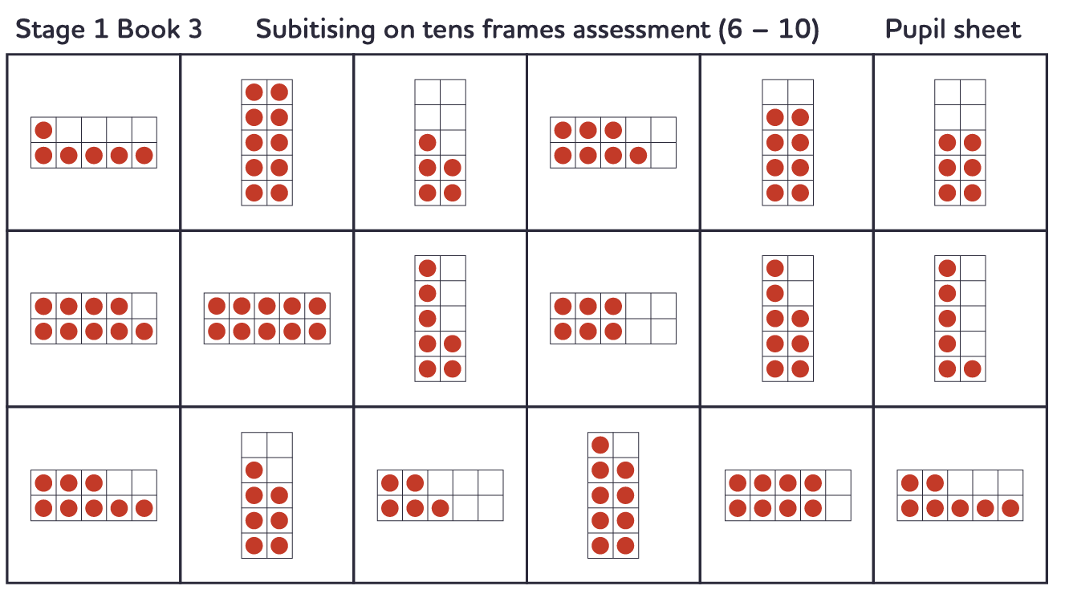
Stage 2 Book 1,2 | Using the generate number facts tool, select the highlighted facts taught to create a set of 30 questions. Give the children 3 minutes to answer the question sheet (6 seconds per question). All questions must be answered correctly within the allocated time to be fluent. | 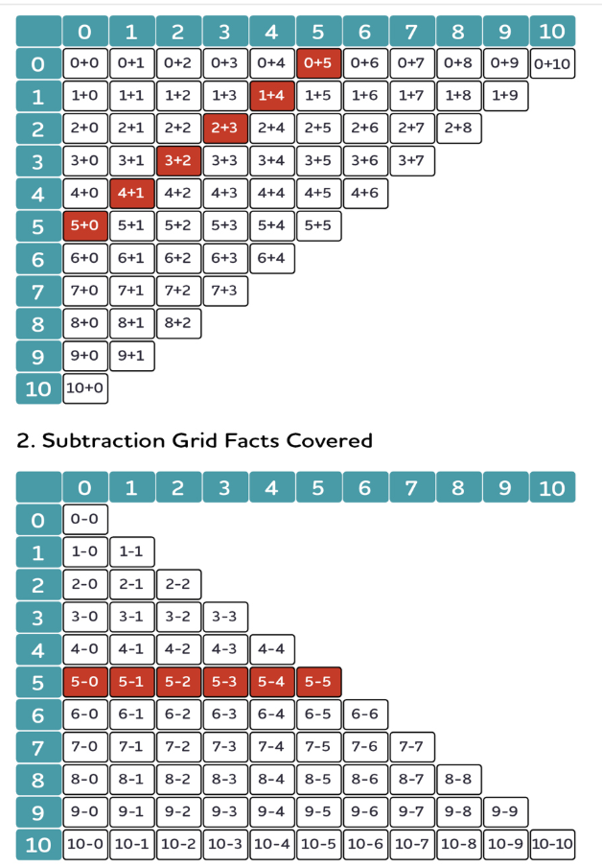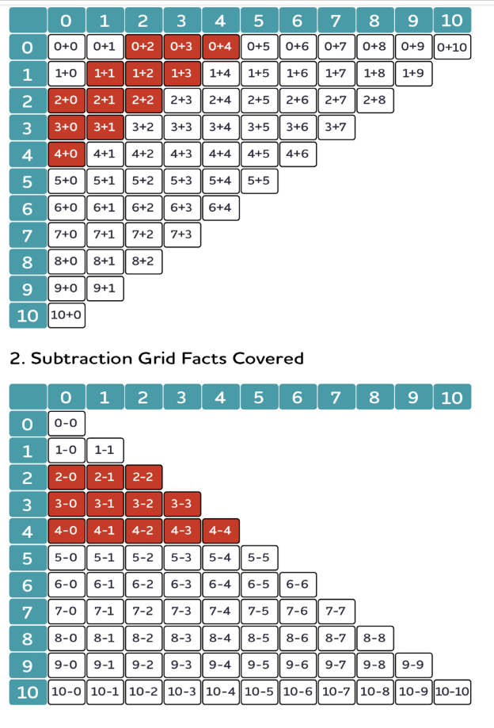
Stage 2 Book 3,4 | Using the generate number facts tool, select the highlighted facts taught to create a set of 30 questions. Give the children 3 minutes to answer the question sheet (6 seconds per question). All questions must be answered correctly within the allocated time to be fluent. | 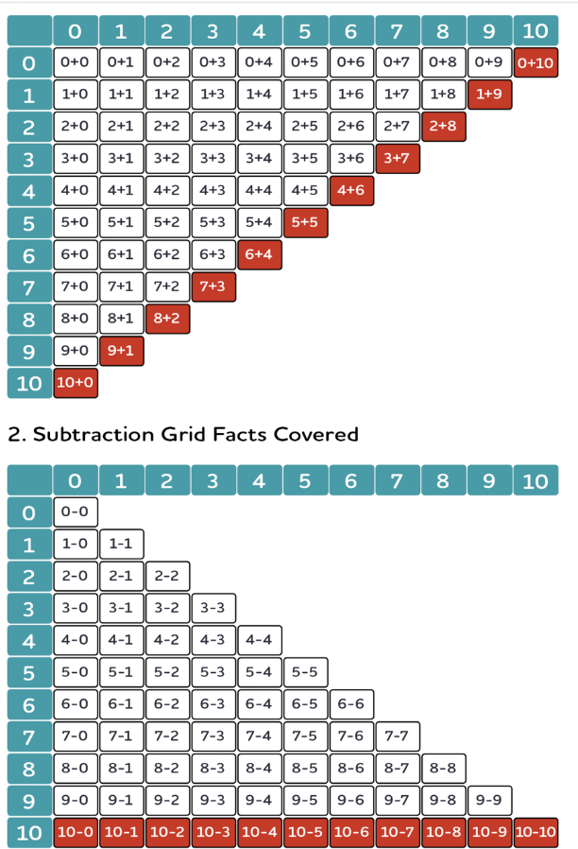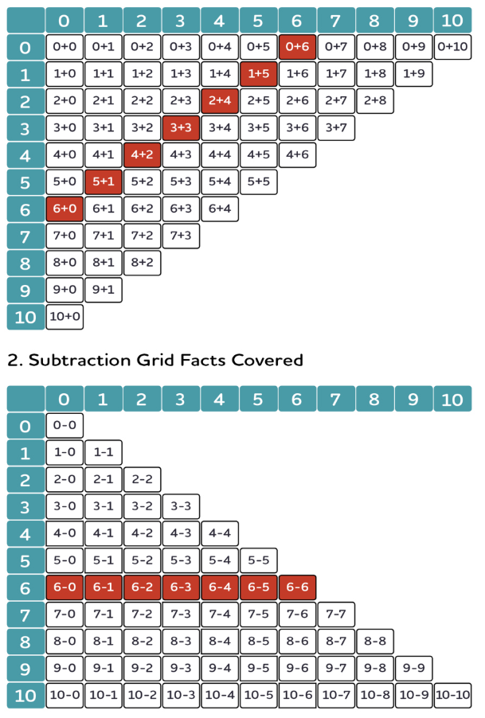
Stage 2 Book 5,6,7 | Using the generate number facts tool, select the highlighted facts taught to create a set of 30 questions. Give the children 3 minutes to answer the question sheet (6 seconds per question). All questions must be answered correctly within the allocated time to be fluent. | 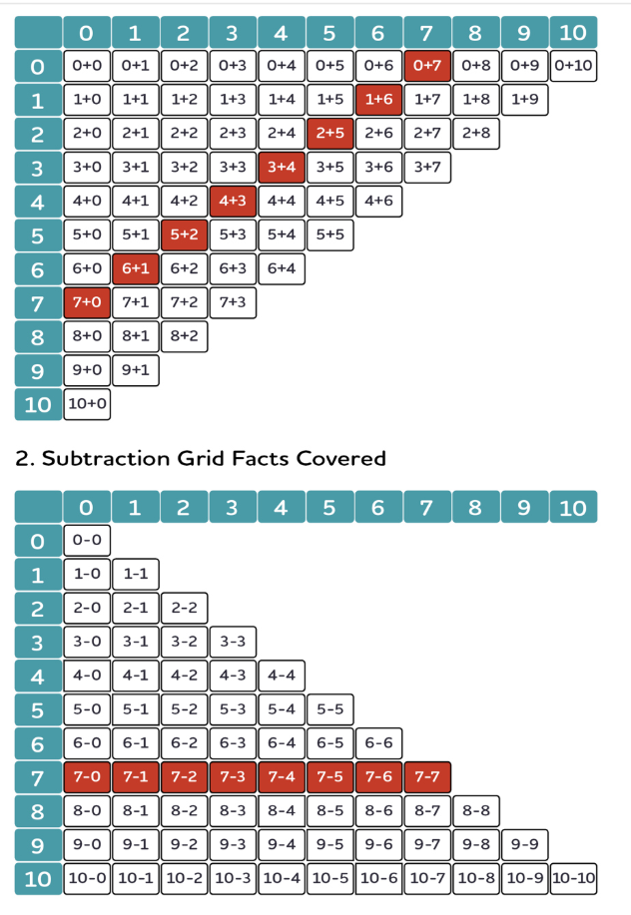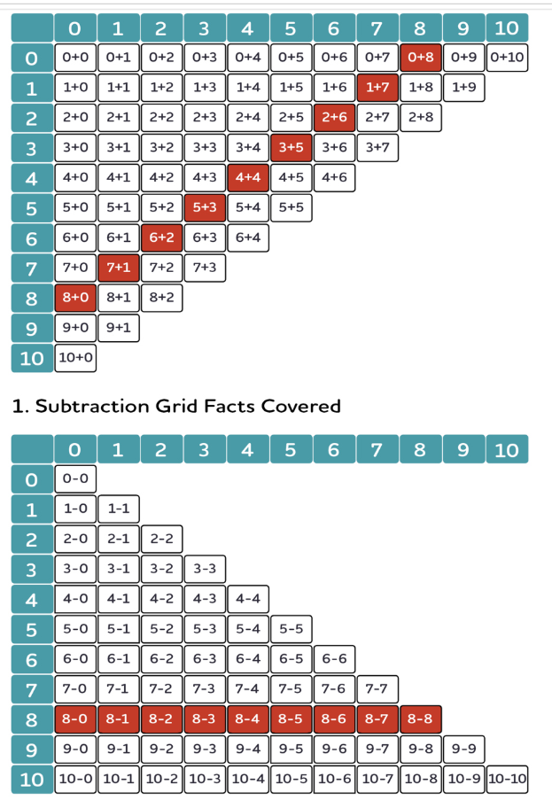  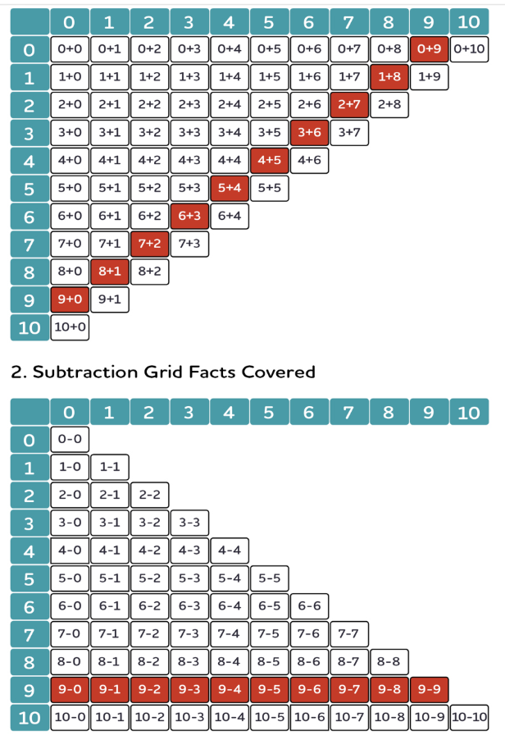
Stage 3 Books 1-4 | Using the generate number facts tool, select the highlighted facts taught to create a set of 30 questions. Give the children 3 minutes to answer the question sheet (6 seconds per question). All questions must be answered correctly within the allocated time to be fluent. | 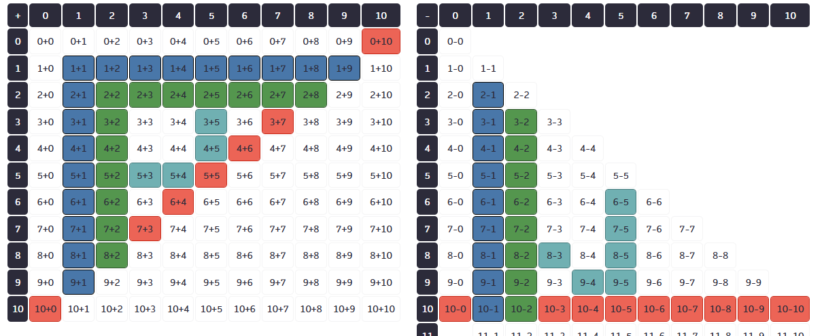
Stage 3 Books 5-8 | Using the generate number facts tool, select the highlighted facts taught to create a set of 30 questions. Give the children 3 minutes to answer the question sheet (6 seconds per question). All questions must be answered correctly within the allocated time to be fluent. | 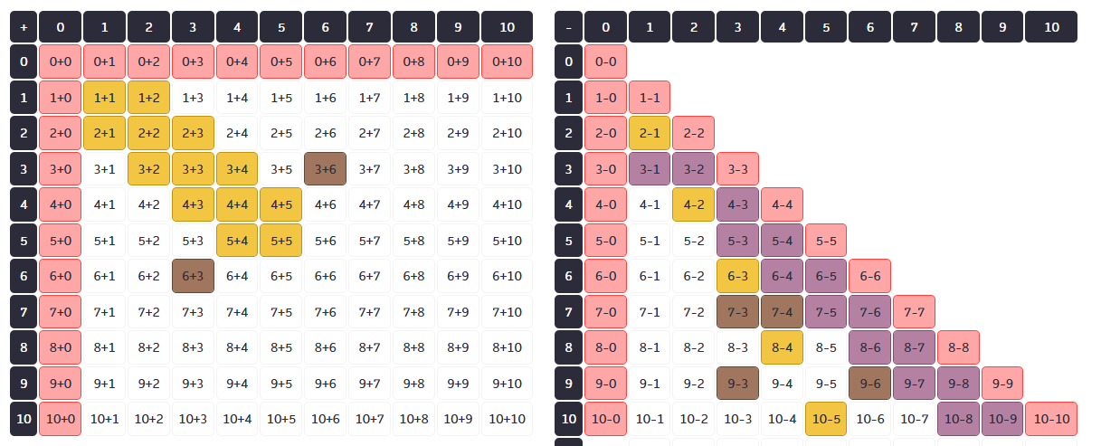
Stage 4 | Using the generate number facts tool, select the highlighted facts taught to create a set of 30 questions. Give the children 3 minutes to answer the question sheet (6 seconds per question). All questions must be answered correctly within the allocated time to be fluent. | 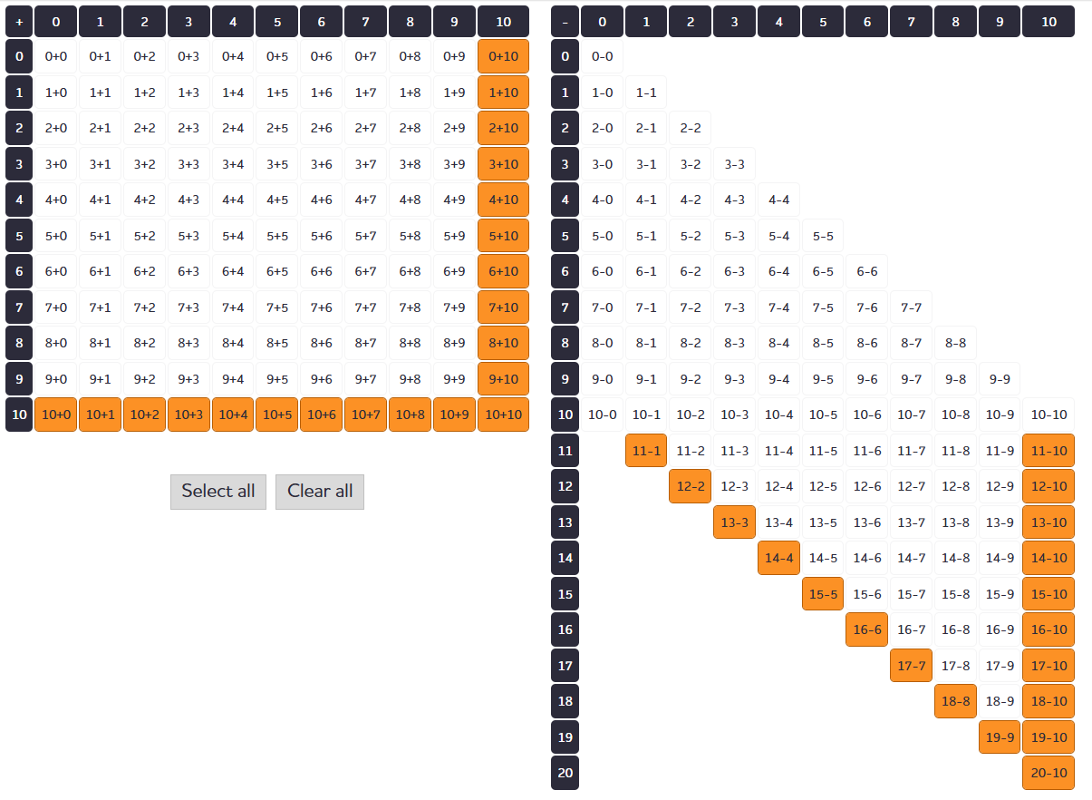
Stage 5 | Using the generate number facts tool, select the highlighted facts taught to create a set of 30 questions for both addition and subtraction. Give the children 3 minutes to answer the question sheet (6 seconds per question). All questions must be answered correctly within the allocated time to be fluent. | 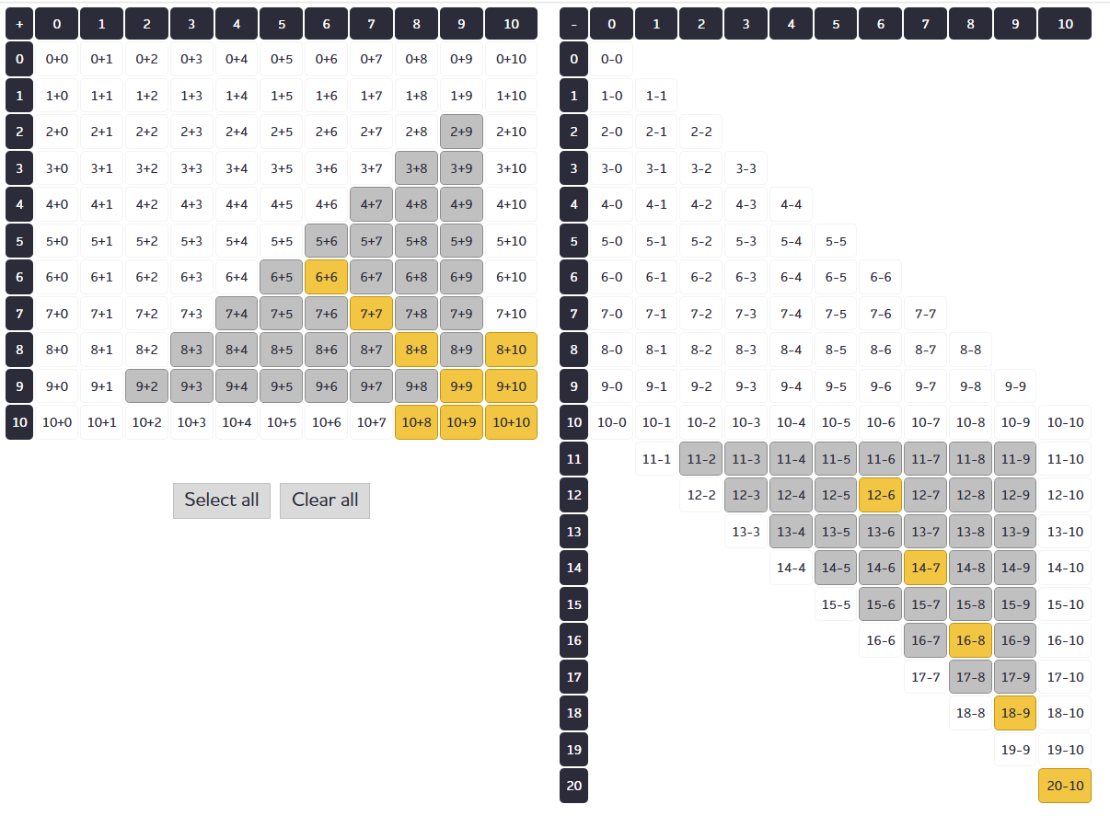
Stage 6 | Use the number fact checker tool to determine automaticity of number fact knowledge within all stages. This tool will give 6 seconds and full marks are required to determine full understanding of the highlighted facts. | 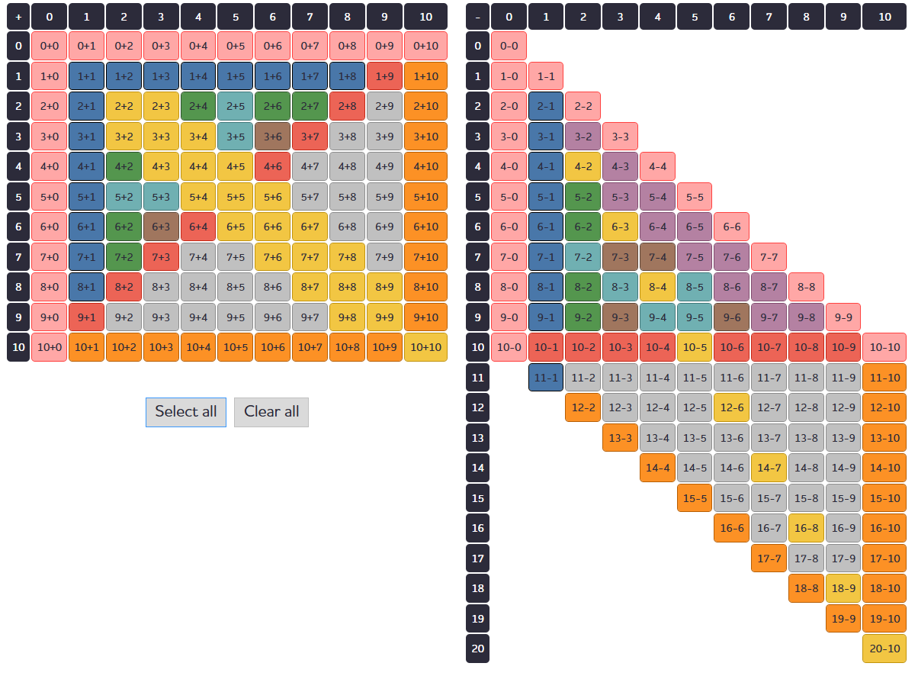

Name | S1 B1 |  | S1 B2 |  | S1 B3 |  | S2 B1-2 |  | S2 B3-4 |  | S2 B5-7 |  | S3 B 1-4 |  | S3 B 5-8 |  | S4 |  | S5 |  | S6
 | /18 |  | /18 |  | /36 |  | /30 |  | /30 |  | /30 |  | /30 |  | /30 |  | /30 |  | /30 |  | /25
 | /18 |  | /18 |  | /36 |  | /30 |  | /30 |  | /30 |  | /30 |  | /30 |  | /30 |  | /30 |  | /25
 | /18 |  | /18 |  | /36 |  | /30 |  | /30 |  | /30 |  | /30 |  | /30 |  | /30 |  | /30 |  | /25
 | /18 |  | /18 |  | /36 |  | /30 |  | /30 |  | /30 |  | /30 |  | /30 |  | /30 |  | /30 |  | /25
 | /18 |  | /18 |  | /36 |  | /30 |  | /30 |  | /30 |  | /30 |  | /30 |  | /30 |  | /30 |  | /25
 | /18 |  | /18 |  | /36 |  | /30 |  | /30 |  | /30 |  | /30 |  | /30 |  | /30 |  | /30 |  | /25
 | /18 |  | /18 |  | /36 |  | /30 |  | /30 |  | /30 |  | /30 |  | /30 |  | /30 |  | /30 |  | /25
 | /18 |  | /18 |  | /36 |  | /30 |  | /30 |  | /30 |  | /30 |  | /30 |  | /30 |  | /30 |  | /25
 | /18 |  | /18 |  | /36 |  | /30 |  | /30 |  | /30 |  | /30 |  | /30 |  | /30 |  | /30 |  | /25
 | /18 |  | /18 |  | /36 |  | /30 |  | /30 |  | /30 |  | /30 |  | /30 |  | /30 |  | /30 |  | /25
 | /18 |  | /18 |  | /36 |  | /30 |  | /30 |  | /30 |  | /30 |  | /30 |  | /30 |  | /30 |  | /25
 | /18 |  | /18 |  | /36 |  | /30 |  | /30 |  | /30 |  | /30 |  | /30 |  | /30 |  | /30 |  | /25
 | /18 |  | /18 |  | /36 |  | /30 |  | /30 |  | /30 |  | /30 |  | /30 |  | /30 |  | /30 |  | /25
 | /18 |  | /18 |  | /36 |  | /30 |  | /30 |  | /30 |  | /30 |  | /30 |  | /30 |  | /30 |  | /25
 | /18 |  | /18 |  | /36 |  | /30 |  | /30 |  | /30 |  | /30 |  | /30 |  | /30 |  | /30 |  | /25
 | /18 |  | /18 |  | /36 |  | /30 |  | /30 |  | /30 |  | /30 |  | /30 |  | /30 |  | /30 |  | /25
 | /18 |  | /18 |  | /36 |  | /30 |  | /30 |  | /30 |  | /30 |  | /30 |  | /30 |  | /30 |  | /25
 | /18 |  | /18 |  | /36 |  | /30 |  | /30 |  | /30 |  | /30 |  | /30 |  | /30 |  | /30 |  | /25
 | /18 |  | /18 |  | /36 |  | /30 |  | /30 |  | /30 |  | /30 |  | /30 |  | /30 |  | /30 |  | /25
 | /18 |  | /18 |  | /36 |  | /30 |  | /30 |  | /30 |  | /30 |  | /30 |  | /30 |  | /30 |  | /25
 | /18 |  | /18 |  | /36 |  | /30 |  | /30 |  | /30 |  | /30 |  | /30 |  | /30 |  | /30 |  | /25
 | /18 |  | /18 |  | /36 |  | /30 |  | /30 |  | /30 |  | /30 |  | /30 |  | /30 |  | /30 |  | /25
 | /18 |  | /18 |  | /36 |  | /30 |  | /30 |  | /30 |  | /30 |  | /30 |  | /30 |  | /30 |  | /25
 | /18 |  | /18 |  | /36 |  | /30 |  | /30 |  | /30 |  | /30 |  | /30 |  | /30 |  | /30 |  | /25
 | /18 |  | /18 |  | /36 |  | /30 |  | /30 |  | /30 |  | /30 |  | /30 |  | /30 |  | /30 |  | /25
 | /18 |  | /18 |  | /36 |  | /30 |  | /30 |  | /30 |  | /30 |  | /30 |  | /30 |  | /30 |  | /25
 | /18 |  | /18 |  | /36 |  | /30 |  | /30 |  | /30 |  | /30 |  | /30 |  | /30 |  | /30 |  | /25
 | /18 |  | /18 |  | /36 |  | /30 |  | /30 |  | /30 |  | /30 |  | /30 |  | /30 |  | /30 |  | /25
 | /18 |  | /18 |  | /36 |  | /30 |  | /30 |  | /30 |  | /30 |  | /30 |  | /30 |  | /30 |  | /25
 | /18 |  | /18 |  | /36 |  | /30 |  | /30 |  | /30 |  | /30 |  | /30 |  | /30 |  | /30 |  | /25
 | /18 |  | /18 |  | /36 |  | /30 |  | /30 |  | /30 |  | /30 |  | /30 |  | /30 |  | /30 |  | /25
 | /18 |  | /18 |  | /36 |  | /30 |  | /30 |  | /30 |  | /30 |  | /30 |  | /30 |  | /30 |  | /25
E/GD score | 14 | 16 | 14 | 16 | 27 | 32 | 23 | 27 | 23 | 27 | 23 | 27 | 23 | 27 | 23 | 27 | 23 | 27 | 23 | 27 | 19 | 23
75%=Expected
90%= Greater depth

