Cross-Curricular Links
- Physical Development - Games/ Gymnastics– Travelling/ Movement/ Climbing
- PSED/PSHE – Getting on and falling out
- Mathematics- 2d/3d shapes, ordering items by height or length, matching numbers to quantities, addition and subtraction, ordering and sequencing familiar events
- Understanding the World- Showing care and concern for living things and the environment. Developing an understanding of growth, decay and changes over time. Makes observations of animals and plants and explains why some things occur, and talk about changes (ELG). Grow your own bean plant.
- Expressive Arts and Design – Beanstalk art, colour mixing, printing with different vegetables.
- Communication and Language – Listening to the story/ retelling the story through the use of small world and role play.
Writing
- Hears and says the initial sound in words.
- Children can segment the sounds in simple words and blend them together.
- Links sounds to letters, naming and sounding the letters of the alphabet.
- Uses some clearly identifiable letters to communicate meaning, representing some sounds correctly and in sequence.
- Writes own name and other things such as labels, captions.
- Attempts to write short sentences in meaningful contexts.
- Uses their phonic knowledge to write words in ways which match their spoken sounds (ELG)
- Writes some irregular common words (ELG)
- Writes simple sentences which can be read by himself/herself and others (ELG)
- Spells some words correctly and others are phonetically plausible (ELG)

Genres / Writing focuses
- Writing a simple sentence with phonetically plausible words.
- Descriptive writing (Wanted posters, character descriptions etc.)
- Continuation of phase 2 and phase 3 Letters and Sounds
- Labels/ Captions
- Story map including talk for writing words and actions whilst sequencing events

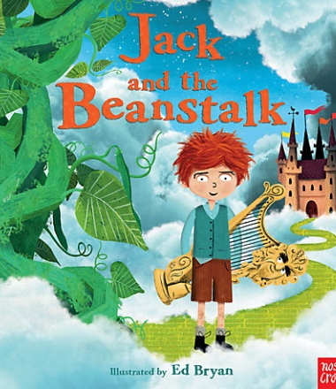
Stories with a similar theme
Jasper and the beanstalk, The smartest giant in town, Jim and the Beanstalk, The Princess and the Giant, In Wibbly’s Garden, Ben plants a butterfly garden, Titch, The Tiny Seed, The enormous turnip.
Traditional tale or fairy stories/ Stories related the growing.
Jack and the Beanstalk

Reception – Spring 1

