Why does Easter matter to Christians?

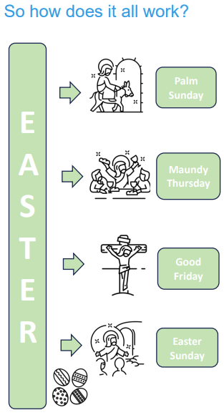 | Vocabulary
 |  | God | The all loving and powerful being that  Christians believe created the world and  everything in it.
 | 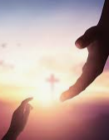 | Salvation | Being saved or rescued so that  humans are no longer separated from God.
 | 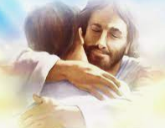 | Saviour | Jesus came to save or rescue people  e.g. by showing them how to live.
 | 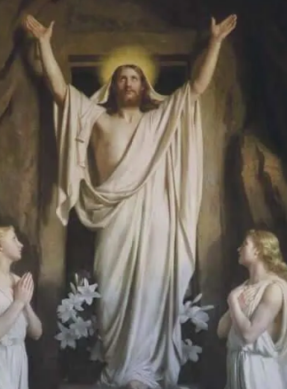 | Resurrection | Jesus’ return to life after  dying.
 |  | Eternal Life | The belief that through Jesus’  death Christians can go to Heaven to be  with God for eternity.
 | 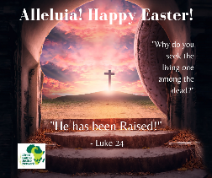 | Easter | The Christian festival which  remembers the resurrection of Jesus.
 |  | Worship | To praise and follow God.

