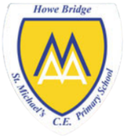
Year 2
What makes some places special to believers?

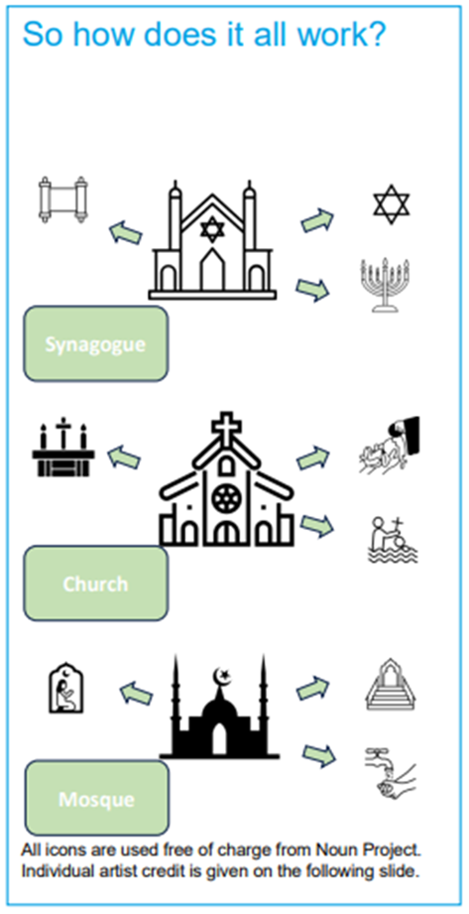 | Vocabulary
 | 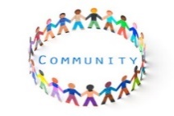 | Community | A group of people who have something in common.
 | 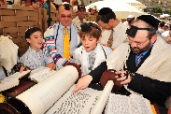 | Jewish | Relating to the religion of Judaism.
 | 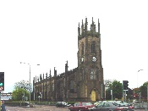 | Church | The Christian place of worship
 | 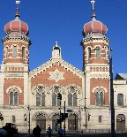 | Synagogue | The Jewish place of worship, sometimes called a shul.
 | 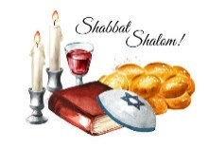 | Shabbat | A day of rest for Jewish people, the seventh day of the week
 | 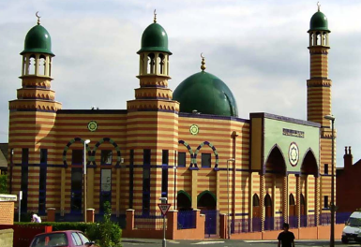 | Mosque | The Muslim place of worship
 | 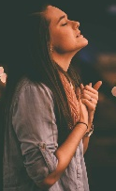 | Worship | To praise and follow God
 | 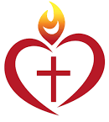 | Sacred | Something connected with God or dedicated to a religious purpose

