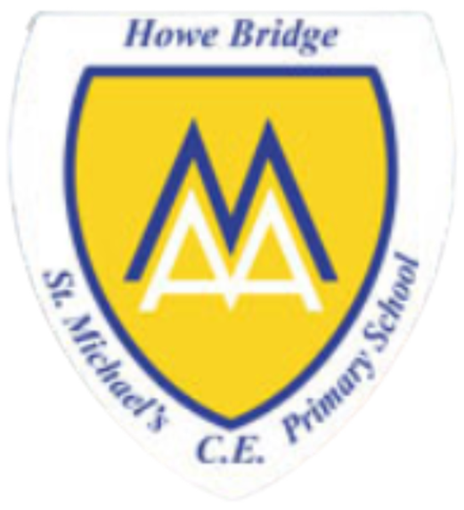
Year 1

Who is Jewish and how do they live?
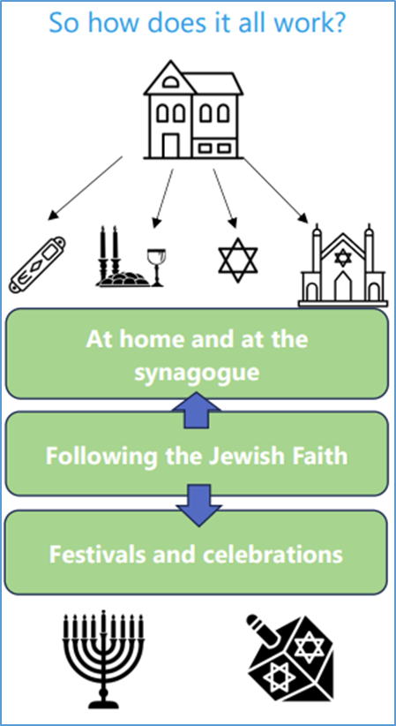 | Vocabulary
 | 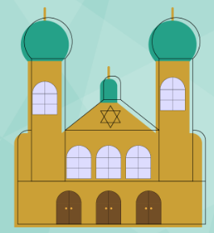 | Synagogue | A Jewish place of worship
 | 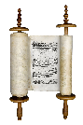 | Torah | Jewish holy book.
 |  | God | All powerful being who Jewish people believe created the world.
 |  | Mezuzah | A small scroll with words from the Torah written on it
 | 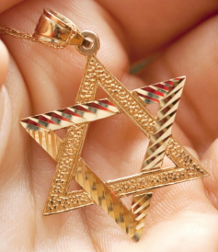 | Star of David | A symbol of Judaism
 | 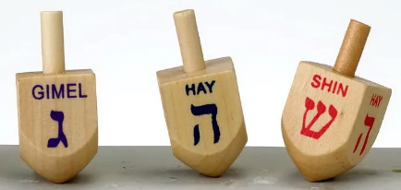 | Dreidel | Four-sided spinning top played during the festival of Chanukah
 |  | Chanukah  Hannukah | Jewish festival
 | 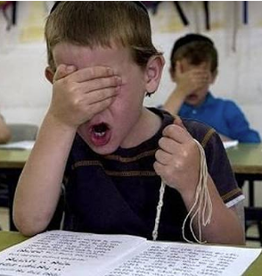 | Shema | A Jewish prayer
 | 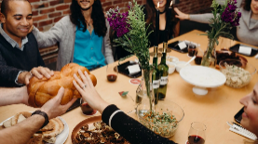 | Shabbat | A day of rest for Jewish people, the seventh day of the week.

