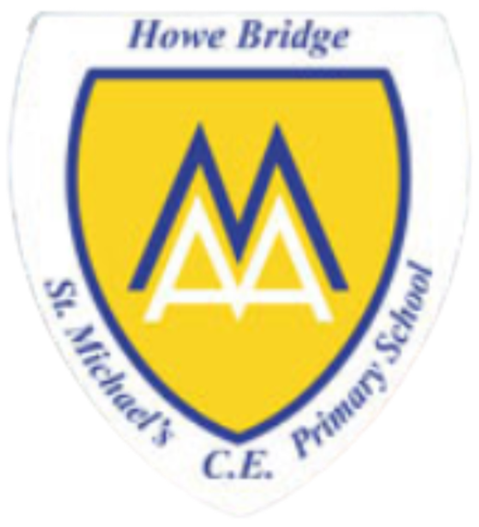
Year 1

Who do Christians say made the world?
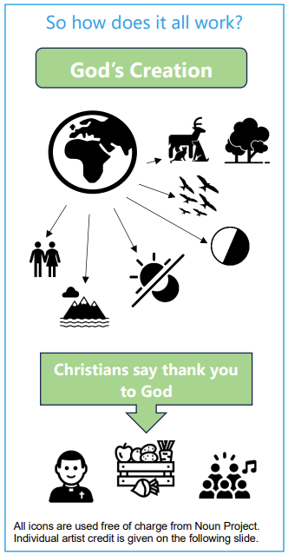 | Vocabulary
 | 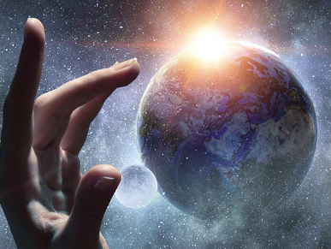 | creation | the act of God creating the world and everyone in it
 | 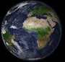 | World | the planet and everything and everyone in it
 | 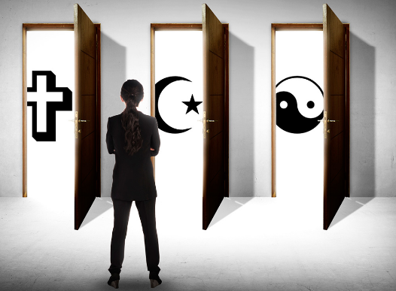 | belief | trust or confidence in something
 | 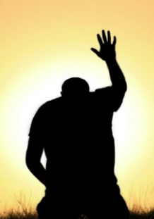 | praise | how Christians show and express gratitude and thanks to God
 | 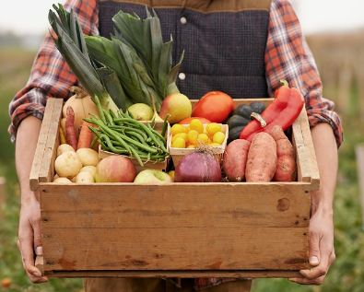 | Harvest | to gather in crops  a Christian celebration
 |  | God | all powerful being that Christians believe created the world
 | 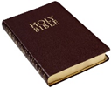 | Bible | the holy book for Christians, comprising of the Old Testament and the New Testament
 | 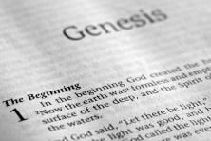 | Genesis | the first book of Moses for Jewish people  the first book of the Old Testament for Christians

