
Year 1

What does it mean to belong to a faith community?
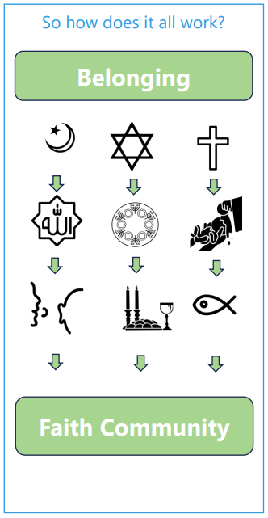 | Vocabulary
 | 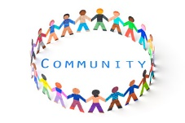 | community | a group of people who have something in common
 |  | Muhammad | Messenger or the Prophet of Allah
 |  | Allah | God
 | 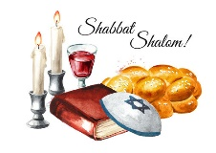 | Shabbat | a day of rest for Jewish people, the seventh day of the week
 | 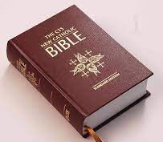 | parable | a story Jesus told that has a special meaning, found in the bible
 |  | wedding | a marriage ceremony as a legal union of two people
 | 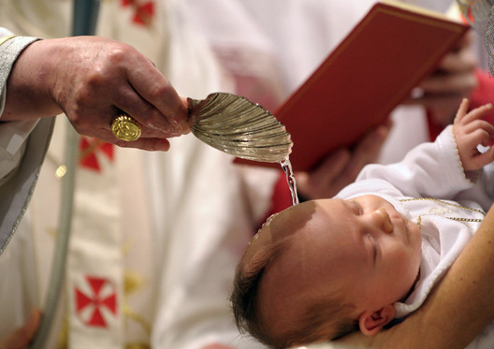 | baptism | a ceremony that welcomes someone into the Christian Church
 | 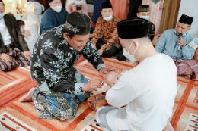 | Aqiqah | a ceremony to welcome a baby into the world in Islam

