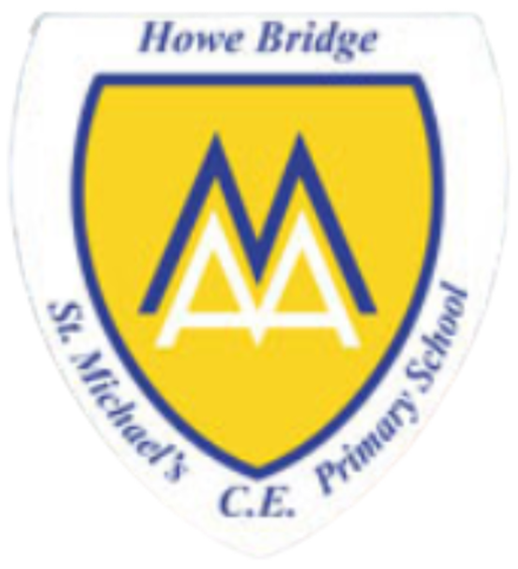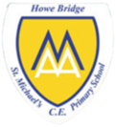
Year 1
What do Christians believe God is like?
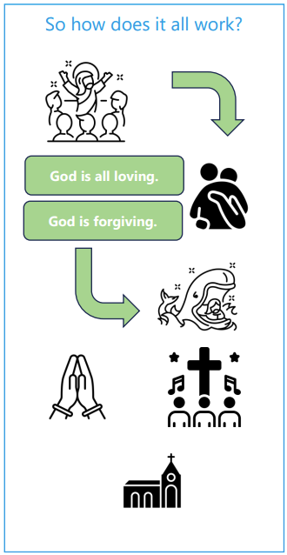 | Vocabulary
 | 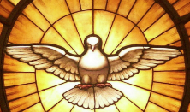 | holy | something that is considered to be good because it relates to religion
 |  | forgiving | stopping blaming or punishing someone for that they have done
 |  | prodigal | spending lots of money in a way that is not very good
 |  | worship | to praise and follow God
 |  | loving | the act of taking care of something or someone because of a strong attachment
 | 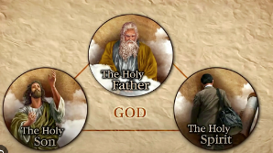 | Father | the first person of the Trinity, who created everything
 | 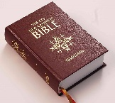 | parable | a story Jesus told that has a special meaning, found in the bible
 | 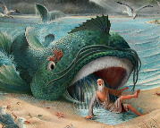 | Jonah | a messenger sent from God to the people of Nineveh
 |  | God | the all loving and all powerful being that Christians believe created the world and everything in it

