
Year 1

How should we care for the world and for others, and why does it matter?
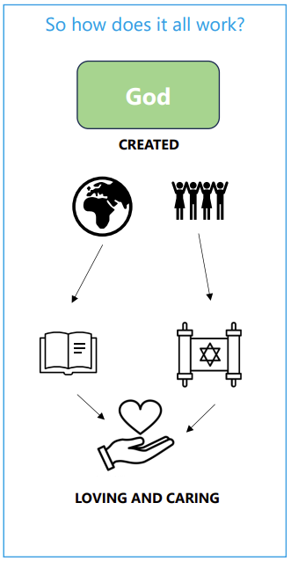 | Vocabulary
 | 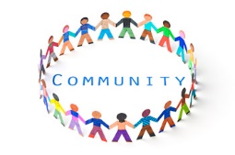 | community | a group of people who have something in common
 | 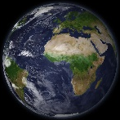 | World | the planet and everything and everyone in it
 | 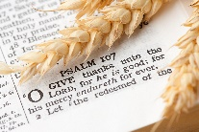 | psalm | a sacred song or hymn, often used in Christian and Jewish worship
 | 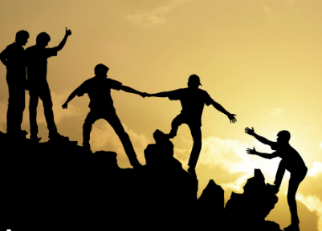 | stewardship | the act of looking after and caring for something
 |  | loving | the act of taking care of something or someone because of a strong attachment
 | 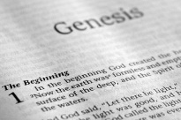 | Genesis | the first book of Moses for Jewish people and the first book of the Old Testament for Christians
 | 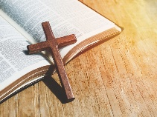 | Christian | anything that is part of, or someone who follows Christianity
 | 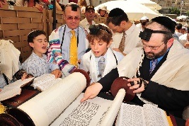 | Jewish | anything that is part of, or someone who follows Judaism

