
St Michael’s CE Primary School

Collective Worship Policy
Our Vision.
Inspired by our heritage and the teachings of Jesus, St Michael’s is a community of love where everyone belongs, is nurtured and is empowered to flourish
Our Inspiration
“For I know the plans I have for you,” declares the LORD,” plans to prosper you and not to harm you, plans to give you hope and a future.”
Jeremiah 29:11
"And now these three remain: faith, hope and love. But the greatest of these is love."
1 Corinthians 13:13
Our Values
Mission, Integrity, Compassion, Honesty, Appreciation, Encouragement, Love
Member of Staff Responsible: | Sarah Dring
Chair of Governors | Debra Wailes
Headteacher: | Sarah Dring
Date Policy Adopted: | September 2026
Policy Review Date: | September 2027

Our Foundation as a Church School
St Michael’s Church of England Primary School is a Voluntary Aided Church of England school, established in 1878 to provide education within the framework of the principles of the Established Church.
Our historic Christian foundation remains central to the identity and life of our school. Collective Worship is provided in accordance with our Trust Deed and the rites, practices and doctrines of the Church of England.
Our close relationship with St Michael and All Angels Church is an important expression of our Christian foundation. We seek to work in partnership with the parish, clergy and wider church community so that worship is not simply something that happens in school, but forms part of the wider Christian life of our community.
Our worship is rooted in our school vision:
“Inspired by our heritage and the teachings of Jesus, St Michael’s is a community of love where everyone belongs, is nurtured and is empowered to flourish.”
Our vision shapes the purpose, content and impact of Collective Worship. Worship enables us to explore what it means to belong, to be nurtured and to flourish, and challenges us to live this out in our relationships with one another and in the wider community.
Our seven Christian values provide a framework for our worship:
- M – Mission
- I – Integrity
- C – Compassion
- H – Honesty
- A – Appreciation
- E – Encouragement
- L – Love
These values are not simply displayed or taught as concepts. Through worship, we explore how they are rooted in the life and teachings of Jesus and consider how they should shape our choices, relationships and actions.
Collective Worship at St Michael’s
Collective Worship is at the heart of the life of St Michael’s.
It provides a regular opportunity for the whole school community to:
- gather together;
- encounter the Christian story and the teachings of Jesus;
- explore the Bible and the Christian understanding of God;
- reflect on important questions about life, faith and human experience;
- experience stillness, prayer and wonder;
- celebrate the gifts, achievements and contributions of members of our community;
- consider the needs of others and the wider world;
- develop spiritually, morally, socially and culturally;
- respond to the Christian message through thought, prayer and action;
- consider how our vision and values can influence the way we live.
Collective Worship is therefore more than an assembly or a time for communicating information. It is a distinct opportunity to worship, reflect, wonder, question, respond and grow.
We recognise that worship contributes to the spiritual flourishing of pupils and adults. It should provide opportunities to explore questions of meaning and purpose and to encounter the Christian faith in ways that are age-appropriate, authentic and relevant to the lives of our children.
Manchester Diocese identifies Collective Worship as an opportunity to gather as a community, give thanks, be still, explore big questions, consider the character of God, explore Jesus' teaching, engage with Scripture, affirm Christian values and celebrate the Christian year.
Our Approach: Inspirational, Invitational and Inclusive
At St Michael’s, Collective Worship is inspirational, invitational and inclusive.
Inspirational
Worship should inspire children and adults to:
- think deeply;
- ask significant questions;
- encounter the Christian faith;
- consider their own beliefs and convictions;
- recognise the dignity and worth of every person;
- make positive choices;
- become courageous advocates for others and for the common good;
- live differently as a result of what they have encountered.
We want children to leave worship with something to think about, feel, question or do.
Worship should therefore be formational and transformational. It should not simply communicate information but should encourage reflection and positive action.
Invitational
Worship is authentically and distinctly Christian while remaining genuinely invitational.
We recognise that members of our school community come from a range of faith backgrounds, worldviews and family circumstances, including those who profess no religious faith.
Everyone is welcome to participate in worship, but no individual is compelled to:
- pray;
- sing;
- make a particular declaration of faith;
- adopt a particular belief;
- participate in a particular activity.
When prayer is offered, pupils and adults are invited to pray if they wish, or alternatively to use the time for personal reflection, stillness or contemplation.
Inclusive
Worship will be accessible to all pupils, including those with SEND and those who may find particular sensory, emotional, physical or communication demands challenging.
We will consider:
- age and developmental stage;
- SEND and additional needs;
- language and communication needs;
- cultural and family backgrounds;
- pupils' prior experiences;
- individual circumstances.
We recognise that children and adults will be at different points in their spiritual journeys. Worship therefore provides space to participate, question, wonder, reflect, disagree respectfully or simply be still.
Collective Worship and Spiritual Development
Collective Worship is a significant part of our approach to spiritual development.
At St Michael’s, spirituality is not confined to a particular activity or definition. Worship creates regular opportunities for pupils to explore:
- who they are;
- what gives life meaning and purpose;
- their relationships with themselves, others, the world and God;
- questions of right and wrong;
- experiences of awe and wonder;
- beauty, creativity and mystery;
- suffering, loss, death and hope;
- forgiveness, reconciliation and transformation;
- how they can contribute to the flourishing of others.
We encourage children to develop the confidence to ask difficult questions and recognise that not every question has an immediate or simple answer.
Worship should create a culture in which it is safe to wonder, question, reflect and explore.
Windows, Mirrors and Doors
Our Collective Worship uses the Windows, Mirrors and Doors approach to support meaningful spiritual reflection and response.
Windows – Seeing the world differently
Windows provide opportunities to look beyond ourselves.
Children may:
- hear a Bible story;
- encounter the life of Jesus;
- learn about Christian belief;
- hear about the experiences of others;
- consider events in the world;
- explore the beauty and complexity of creation;
- encounter different perspectives;
- wonder at things that amaze or challenge us.
Key question:
What can we see, learn or discover?
Mirrors – Looking within
Mirrors provide opportunities for personal reflection.
Children may:
- consider their own experiences;
- reflect on their choices;
- explore their feelings;
- consider important questions;
- examine their beliefs and values;
- reflect on how a Bible story or Christian teaching relates to their lives.
Key question:
What does this make me think about myself, my relationships or my life?
Doors – Responding and acting
Doors provide opportunities to respond.
Children may:
- pray;
- make a commitment;
- change a behaviour;
- encourage someone;
- show compassion;
- serve their community;
- take action for others;
- respond creatively;
- consider how they can live out the school's Christian vision.
Key question:
What will I do differently because of what I have encountered?
This approach ensures that worship is not simply something children listen to. It provides a journey from encounter, to reflection, to response.
The Bible and Christian Theology
The Bible has a central place within Collective Worship at St Michael’s.
Children will encounter Bible stories, passages and teachings appropriate to their age and stage. Worship leaders will seek to handle Scripture accurately, sensitively and thoughtfully.
Across their time at St Michael’s, pupils will encounter:
- God as Father, Son and Holy Spirit;
- the nature and character of God;
- creation and humanity's place within it;
- Jesus as the Son of God;
- Jesus' life, teachings, death and resurrection;
- forgiveness and reconciliation;
- love and compassion;
- justice and service;
- hope and redemption;
- prayer;
- Christian discipleship and mission;
- the Church and Christian community;
- the significance of Christian festivals and the Church year.
We will avoid reducing Christian teaching to a list of moral messages. Children should have opportunities to explore what Christians believe, why Christians believe it and how Christian beliefs influence the way Christians live.
Where appropriate, worship will acknowledge that Christians may interpret particular issues in different ways. Language such as “Christians believe…”, “Some Christians understand this as…” and “This raises the question…” will support thoughtful exploration.
Our MICHAEL Values in Worship
Our values are explored throughout the year through worship and through the wider life of the school.
Mission
We are called to make a difference.
Children explore Jesus' call to his followers and consider how they can serve others and contribute to the common good.
Integrity
We do what is right, even when it is difficult.
Children explore honesty, courage, responsibility and making good choices when nobody is watching.
Compassion
We notice others and respond with kindness.
Children explore Jesus' compassion for others and consider how they can respond to people experiencing difficulty or injustice.
Honesty
We tell the truth and build trust.
Children explore truthfulness, forgiveness and the importance of trustworthy relationships.
Appreciation
We recognise the gifts, people and world around us.
Children develop gratitude and learn to recognise the value and contribution of others and the wonder of creation.
Encouragement
We build others up and help them to flourish.
Children explore how words and actions can give hope, confidence and courage to others.
Love
We love God, ourselves, our neighbours and our world.
Children explore Jesus' command to love and consider what selfless, practical love looks like in everyday life.
Worship and the Christian Year
Collective Worship will reflect the Anglican tradition and the rhythm of the Christian year.
Children will encounter and celebrate significant occasions including:
- Advent;
- Christmas;
- Epiphany;
- Lent;
- Holy Week;
- Easter;
- Pentecost;
- Trinity;
- Harvest;
- Remembrance;
- Saints' days, including St Michael's Day;
- other significant events in the Anglican calendar.
Worship will also draw upon the rich variety of Anglican and wider Christian traditions, including traditional prayers, hymns, contemporary Christian music, Scripture, liturgy, storytelling, drama, art and silence.
Prayer
Prayer is an important part of the worship life of St Michael’s.
Children will encounter a range of Christian prayers and forms of prayer, including:
- the Lord's Prayer;
- traditional Anglican prayers;
- prayers of thanksgiving;
- prayers of confession and forgiveness;
- prayers for others;
- prayers for the world;
- prayers of intercession;
- children's own prayers;
- silent and reflective prayer.
Children will be taught that prayer can take many forms, including:
- speaking;
- listening;
- being still;
- giving thanks;
- asking for help;
- saying sorry;
- praying for others.
When prayer is offered, pupils and adults are invited to participate if they wish, with an alternative opportunity for quiet reflection always available.
Prayer should be meaningful rather than routine. Children should understand that Christian prayer is about relationship with God rather than simply reciting words.
Music in Collective Worship
Music plays an important role in the worship life of St Michael’s.
We will use a balance of:
- traditional hymns;
- Anglican hymnody;
- contemporary Christian worship songs;
- songs appropriate for children;
- instrumental music;
- music that supports stillness and reflection.
Music will be selected carefully to support the theme and purpose of worship and to expose children to the richness and diversity of Christian worship.
Participation in singing will remain invitational. Pupils and adults will not be required to sing words that constitute a personal profession of faith.
Worship Leaders
Collective Worship will be led by a range of members of the St Michael’s community, including:
- the Headteacher;
- members of the Senior Leadership Team;
- teachers and support staff;
- pupils;
- clergy;
- representatives from St Michael and All Angels Church;
- other appropriate members of the Christian community.
Pupil leadership is an important part of our approach.
Children will be given meaningful opportunities to:
- plan worship;
- read Scripture;
- lead prayers;
- introduce themes;
- lead songs;
- present drama;
- share reflections;
- interview others;
- evaluate worship;
- contribute to worship planning.
Pupil involvement should move beyond simply carrying out a predetermined role. Children should increasingly have genuine ownership of aspects of worship.
A Typical Act of Collective Worship
There is no single required format for worship. Worship leaders should select elements that serve the purpose and theme of the worship.
A typical act may include:
- Music and gathering
- Welcome
- Lighting of the candle
- Introduction to the theme
- Bible reading
- Story, teaching or reflection
- Windows
- Mirrors
- Doors
- Song or hymn
- Prayer or opportunity for reflection
- Closing response or blessing
The traditional Anglican response:
“The Lord is here.”
“His Spirit is with us.”
may be used where appropriate.
Worship should not become formulaic. The structure should serve the purpose of worship and be adapted according to the needs of pupils and the theme.
Worship Resources and Environment
Our Collective Worship space should communicate that worship is a significant part of school life.
Where appropriate, the worship table may include:
- a cross;
- a Bible;
- a candle;
- a cloth reflecting the Church season;
- symbols linked to the current theme;
- the current MICHAEL value;
- children's prayers;
- children's reflections;
- objects or artefacts that encourage curiosity and interaction.
Displays should support reflection rather than simply provide decoration.
Children's questions, prayers, artwork and reflections should be used to demonstrate that worship is a shared experience belonging to the whole community.
Organisation of Collective Worship
A programme of Collective Worship is planned annually and reviewed throughout the year.
The programme will include:
- the school's Christian vision;
- the MICHAEL values;
- the Church year;
- Bible stories and Christian teaching;
- significant national and local events;
- Big Picture News
- themes arising from the life of the school;
- issues relevant to children's lives;
- opportunities for service and mission;
- opportunities for reflection and spiritual development.
Where appropriate, themes will be developed over a sequence of worship rather than treated as isolated weekly topics.
This will allow children to revisit ideas, deepen understanding and consider how their thinking and actions develop over time.
Manchester Diocese's RIPPLE approach similarly encourages schools to take children and adults on a journey through a Christian value over a half term, developing understanding and leading towards change. St Michael’s will use this principle when planning sequences of worship around our MICHAEL values.
Worship in Church and Partnership with St Michael and All Angels
Our relationship with St Michael and All Angels Church is central to our Christian identity.
Collective Worship will take place in church on appropriate occasions throughout the year, alongside worship taking place in school.
These opportunities may include:
- Harvest;
- Christmas;
- Easter;
- St Michael's Day;
- end-of-year celebrations;
- special services;
- other significant occasions in the life of the school or parish.
Clergy will be invited to contribute to the planning and delivery of worship and to support the spiritual development of the school community.
The school and parish will seek to work together to ensure that children experience a meaningful relationship between school, church, worship and Christian service.
Worship and Mission
Mission is an important expression of our Christian vision.
Collective Worship will encourage pupils to look beyond themselves and consider how they can serve others and contribute to the common good.
This may include:
- supporting local charities;
- responding to community need;
- caring for creation;
- acts of kindness;
- fundraising;
- service to others;
- prayer for people experiencing difficulty;
- supporting local and global communities;
- opportunities to work with the parish.
Children should increasingly understand that Christian faith is not simply something we learn about, but something that can influence the way we live.
The question “What will we do differently?” should therefore be a regular feature of worship.
Worship and the Wider World
Worship provides opportunities for children to consider local, national and global events through a Christian lens.
We will encourage children to:
- celebrate good news;
- respond appropriately to suffering;
- consider issues of justice;
- develop empathy;
- pray for others;
- recognise their responsibilities as members of a wider community;
- consider how Christian values can influence responses to contemporary issues.
Sensitive issues will be handled appropriately for pupils' ages and individual circumstances.
Accessibility and Inclusion
Worship will be planned so that all pupils can participate meaningfully.
Reasonable adjustments will be made where necessary.
This may include:
- visual timetables;
- visual prompts;
- accessible seating;
- adapted language;
- sensory considerations;
- alternative ways of responding;
- additional preparation for pupils who require it;
- opportunities for movement where appropriate;
- consideration of pupils' emotional wellbeing.
Our aim is not simply that every child is physically present at worship, but that every child has a genuine opportunity to engage with it.
Legal Requirements and Right of Withdrawal
Collective Worship at St Michael’s is provided in accordance with the statutory requirements for Church of England schools and the school's Trust Deed.
All registered pupils are expected to take part in the daily act of Collective Worship unless their parents exercise their legal right to withdraw them.
The daily act of Collective Worship must be:
- broadly and mainly Christian in character;
- conducted in accordance with the school's Trust Deed;
- consistent with the beliefs and practices of the Church of England;
- appropriate to pupils' age, aptitude and family backgrounds.
The governing body is responsible for determining arrangements for Collective Worship in consultation with the Headteacher.
Parents have the legal right to withdraw their child from Collective Worship. Parents wishing to exercise this right are encouraged to discuss this with the Headteacher.
Where a pupil is withdrawn, the school will make appropriate arrangements in accordance with statutory requirements.
Leadership and Governance
The Headteacher has overall responsibility for ensuring that Collective Worship is planned, delivered and evaluated effectively.
The Headteacher will work with:
- staff;
- governors;
- pupil leaders;
- clergy;
- the parish;
- the Manchester Diocesan Board of Education where appropriate.
The Governing Body will ensure that Collective Worship reflects the school's Church of England foundation and Trust Deed.
Governors will receive appropriate information about the quality, impact and development of Collective Worship as part of their monitoring of the school's Christian distinctiveness.
Staff Development
All staff contribute to the worship life of St Michael’s.
Staff will receive appropriate professional development to support them in:
- understanding the purpose of Collective Worship;
- planning engaging and theologically appropriate worship;
- using Scripture effectively;
- supporting spiritual development;
- facilitating questioning and reflection;
- leading prayer sensitively;
- ensuring worship is invitational and inclusive;
- evaluating the impact of worship.
Staff will be encouraged to share effective practice and access relevant Manchester Diocese training and resources.
Manchester Diocese provides training and support in Collective Worship, church school self-evaluation and Christian distinctiveness and offers support to schools preparing for SIAMS.
Monitoring and Evaluation
At St Michael’s, monitoring Collective Worship is not simply about checking whether worship has taken place.
We evaluate its quality, impact and contribution to our Christian vision.
This reflects the current SIAMS emphasis on evidence of the impact of a school's Christian vision and context-specific actions rather than simply demonstrating that particular activities have taken place.
Monitoring will consider:
Quality
- Is worship authentically Christian?
- Is it rooted in Scripture and Christian theology?
- Is it appropriate for the age and needs of pupils?
- Is it engaging and well prepared?
- Does it provide meaningful opportunities for prayer, reflection and response?
- Is it inspirational, invitational and inclusive?
- Is there a balance between participation, listening, reflection and action?
Spiritual impact
- Do pupils have opportunities to wonder and ask significant questions?
- Are pupils able to reflect deeply?
- Does worship develop spiritual awareness?
- Are pupils increasingly able to articulate their own responses?
- Does worship help pupils explore questions of meaning and purpose?
- Do pupils recognise opportunities to encounter God?
Transformational impact
- What difference does worship make?
- Do pupils make changes to their attitudes, choices or behaviour?
- Do pupils demonstrate the MICHAEL values in practice?
- Are pupils motivated to serve others?
- Do pupils increasingly demonstrate compassion, integrity and love?
- Does worship contribute to the flourishing of pupils and adults?
Pupil voice
Pupils will regularly be asked:
- What do you enjoy about worship?
- What have you learned?
- What has made you think?
- What questions has worship made you ask?
- Have you ever changed something because of worship?
- Which worship helps you remember something important?
- How does worship help us live out our values?
- How does worship help people to flourish?
- How could worship be improved?
Evidence
Evidence may include:
- pupil voice;
- staff voice;
- governor discussion;
- worship observations;
- worship planning;
- pupil-led worship;
- children's prayers;
- children's reflections;
- class floor books;
- photographs where appropriate;
- worship evaluations;
- questionnaires and surveys;
- evidence of pupil action;
- examples of service and mission;
- discussion with clergy and parish representatives;
- links between worship and the wider life of the school.
Evidence will be proportionate and will not create unnecessary workload.
The Impact of Worship
We recognise that the impact of worship cannot always be measured immediately or through quantitative data.
We will therefore look for evidence of depth, progression and lasting influence.
Over time, we want pupils to demonstrate that they:
- understand key elements of Christian belief;
- are increasingly confident in discussing faith and spirituality;
- can ask thoughtful and challenging questions;
- can reflect on their own lives and choices;
- demonstrate the MICHAEL values;
- show greater empathy and compassion;
- recognise the needs of others;
- take opportunities to serve;
- understand that they can make a difference;
- develop a growing sense of purpose and responsibility;
- can explain how worship has influenced their thinking or actions.
We will also consider the impact of worship on adults, recognising that staff and governors are members of the worshipping community and should also have opportunities for reflection, spiritual development and flourishing.
Evaluation Cycle
Collective Worship will form part of St Michael’s wider school self-evaluation and improvement cycle.
The Headteacher will review worship regularly throughout the year.
A more formal evaluation will take place at least termly, drawing upon:
- worship observations;
- pupil voice;
- staff feedback;
- worship leader reflection;
- evaluation of the worship programme;
- evidence from class reflections;
- feedback from clergy and governors.
An annual review will consider:
- How well does Collective Worship reflect our Christian vision?
- How well does worship embody our MICHAEL values?
- What impact is worship having on pupils and adults?
- How effectively are pupils involved?
- How effectively does worship support spiritual development?
- How well does worship contribute to mission and service?
- How strong is our partnership with St Michael and All Angels Church?
- What evidence demonstrates that worship is inspirational, invitational and inclusive?
- What should we develop next?
Findings will inform the following year's worship programme and, where appropriate, the School Improvement Plan.
Complaints
The school hopes that any concern regarding Collective Worship can be resolved informally through discussion with the Headteacher.
Where appropriate, the Headteacher will consult with the Chair of Governors, the relevant Foundation Governor and/or the Manchester Diocesan Board of Education.
If a complaint cannot be resolved informally, the school's formal complaints procedure will apply.
Review
This policy will be reviewed annually.
The review will consider:
- changes to statutory requirements;
- Church of England and National Society guidance;
- Manchester Diocesan Board of Education guidance;
- developments in SIAMS;
- feedback from pupils, staff, governors and clergy;
- evidence of impact;
- the effectiveness of the worship programme;
- the continuing relevance of St Michael's Christian vision and MICHAEL values.
The Governing Body will approve the policy in accordance with its delegated responsibilities.

Appendix 1
St Michael’s Collective Worship Reflection
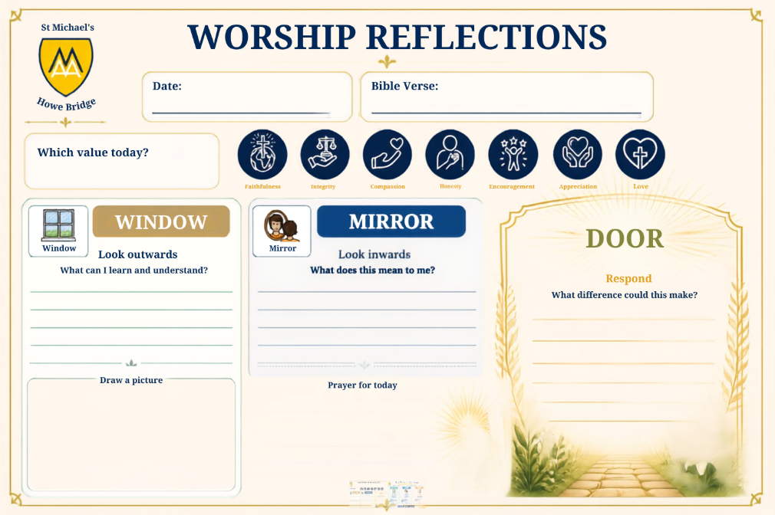

Appendix 2
Windows, Mirror, Door visual
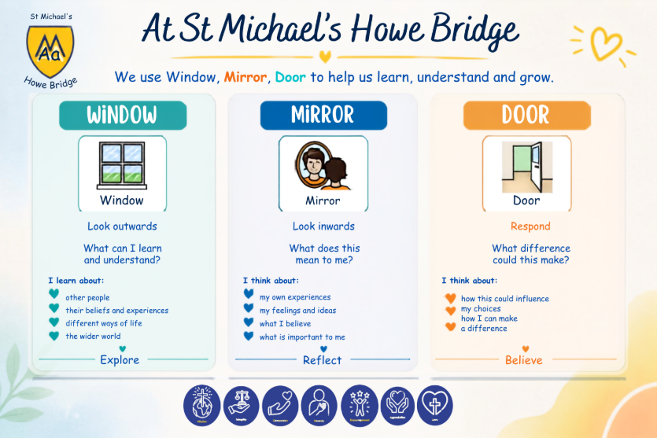

Appendix 3
St Michael’s Worship Principles

At St Michael’s, every act of Collective Worship should seek to be:

Christian – rooted in Scripture, the person and teachings of Jesus and the wider Christian tradition.

Inspirational – encouraging children and adults to think deeply, wonder, question and respond.

Invitational – offering genuine opportunities to participate without requiring a profession of faith.

Inclusive – ensuring everyone can participate with dignity and integrity.

Relevant – connected to the lives and experiences of our children and community.

Reflective – creating space for stillness, prayer and thoughtful questioning.

Transformational – encouraging changes in attitudes, choices and actions.

Contextual – rooted in the distinctive identity, history, community and Christian foundation of St Michael’s.

Participatory – giving pupils and adults meaningful opportunities to contribute.

Mission-focused – encouraging us to look beyond ourselves and serve the common good.

Above all, Collective Worship at St Michael’s should help us live our vision:

Inspired by our heritage and the teachings of Jesus, St Michael’s is a community of love where everyone belongs, is nurtured and is empowered to flourish.

