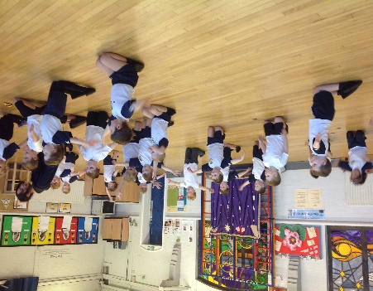
On Monday, we performed a Horrid Henry dance to ‘revolting children’!
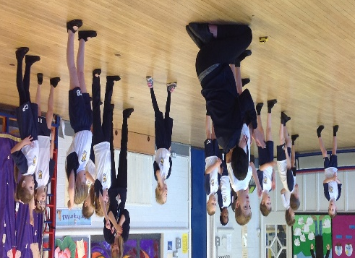
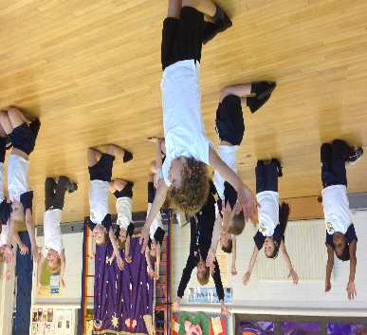

On Monday and Tuesday, we looked at Horrid Henry play scripts and acted out the character’s. We played a game of ‘guess the character’ to see if we could use our actions and the tone and pitch of our voices to get into character.
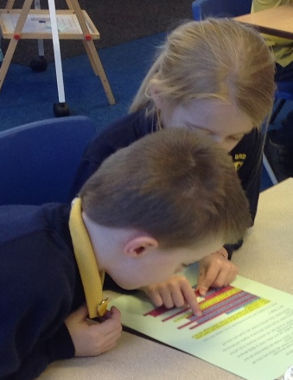
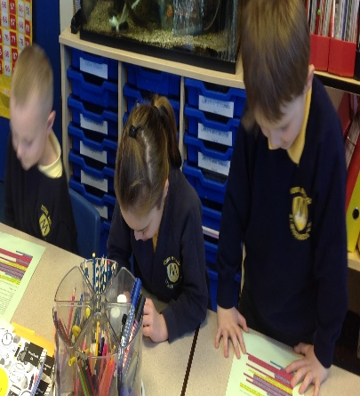
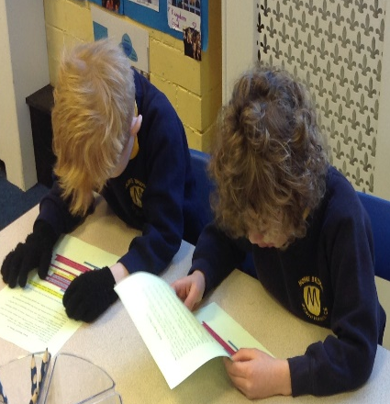
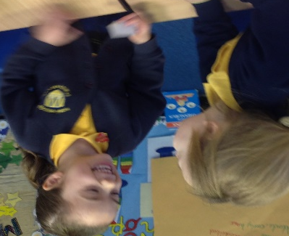
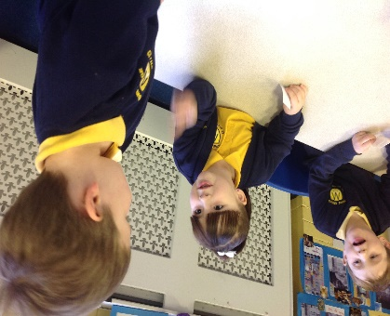

On Thursday and Friday we rehearsed Horrid Henry’s favourite poem to perform. On Friday, we performed the poem to the whole school!


