St Michael’s C E Primary School
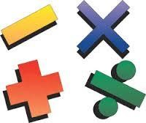
Mathematics Calculation Policy


Our vision: Immersed in a Christian Community, each individual is encouraged, challenged and nurtured to learn and grow to achieve their full potential.

Our Inspiration: “For I know the plans I have for you,” declares the LORD,” plans to prosper you and not to harm you, plans to give you hope and a future.”
Jeremiah 29:11

Our School Values: Love, Hope, Joy, Faith

Last updated: January 2020
Next review: January 2021

At St Michael’s CE Primary we believe that children should be introduced to the processes of calculation through practical, pictorial, written and mental activities. As children begin to understand the underlying ideas they develop ways of recording to support their thinking and calculation methods and learn to interpret and use the signs and symbols involved.

Written methods are complementary to mental methods and should not be seen as separate from them. The aim is that children use mental methods when appropriate, but for calculations that they cannot do in their heads they use an efficient written method accurately and with confidence. It is important children acquire secure mental methods of calculation and one efficient written method of calculation for addition, subtraction, multiplication and division which they know they can rely on when mental methods are not appropriate.

The below policy is guidance for all stakeholders to ensure that children progress their written methods for addition, subtraction, multiplication and division. This document identifies the progression in methods throughout the year groups with a clear focus on what method the children should be able to calculate with by the end of that year. By having this expectation in place, the teacher in the next year group has a solid understanding of the standard the children should be working at. In a scenario where a child has not grasped the method from the previous year group, it can be re-taught and children can be given opportunity to catch up.

By the end of Year 6, children should be able to choose the most appropriate approach to solve a problem: making a choice between using jottings (an extended written method), an efficient written method or a mental method.

This policy contains the key pencil and paper procedures that will be taught within our school alongside practical resources. It has been written to ensure consistency and progression throughout the school and reflects a whole school agreement.

 | ST MICHAEL’S CE PRIMARY CALCULATION POLICY
Objectives | ADDITION
Objectives | EYFS
Objectives | Method | Example/Representation
Say which number is one more or one less than a given number  Using quantities and objects, they add two single-digit numbers and count on to find the answer.  Using quantities and objects, they subtract two single-digit numbers and count on or back to find the answer. | Using a range of practical resources and real life contexts, pupils develop their understanding of the concept of addition through counting activities | How many dinosaurs are there?  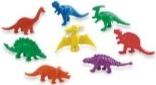  What about if I give you two more? How many are there now?  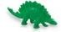
 | Children are introduced to the addition symbol (+) and use pictures/diagrams to represent the calculation | There are 2 birds. Another bird flies in. How many are there altogether?  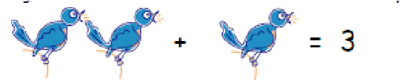
 | Store the larger number mentally and use fingers to count on | Count on from the larger number. A child will choose the larger number, even when it is not the first and count on from there; (5 in your head) ‘six, seven, eight’ using their fingers:  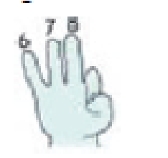  3 + 5 = 8
 | Children represent an addition number sentence in picture form and are able  to solve simple addition number sentences using objects or fingers  Children will begin to explain their reasoning and also look at how swapping hands can show the opposite calculation but give the same answer.  e.g. 2 + 5=7  5 + 2=7 |   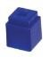  5 + 2 = 7  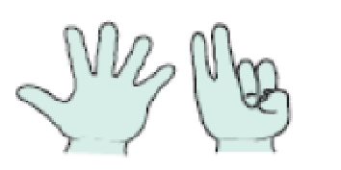  5 + 2 = 7
 | Diagrams like ‘Adam the Adder’ can be used as an early introduction to a number track  This will help children develop their understanding of addition | 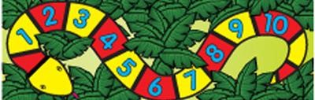
 | Part-Part-Whole models will be introduced in reception for children to use for addition but also be able to discuss the connection with subtraction.  This can also be represented using counters or any other object if working practically. | 5  8  3
 | A bar model will also be introduced to children to demonstrate a model for addition but also used to represent the relationship between addition and subtraction. | 5  3  8
 | A numbered number line will be used for both addition and subtraction.  e.g. 2 + 4 =6  6 -4 = 2 | 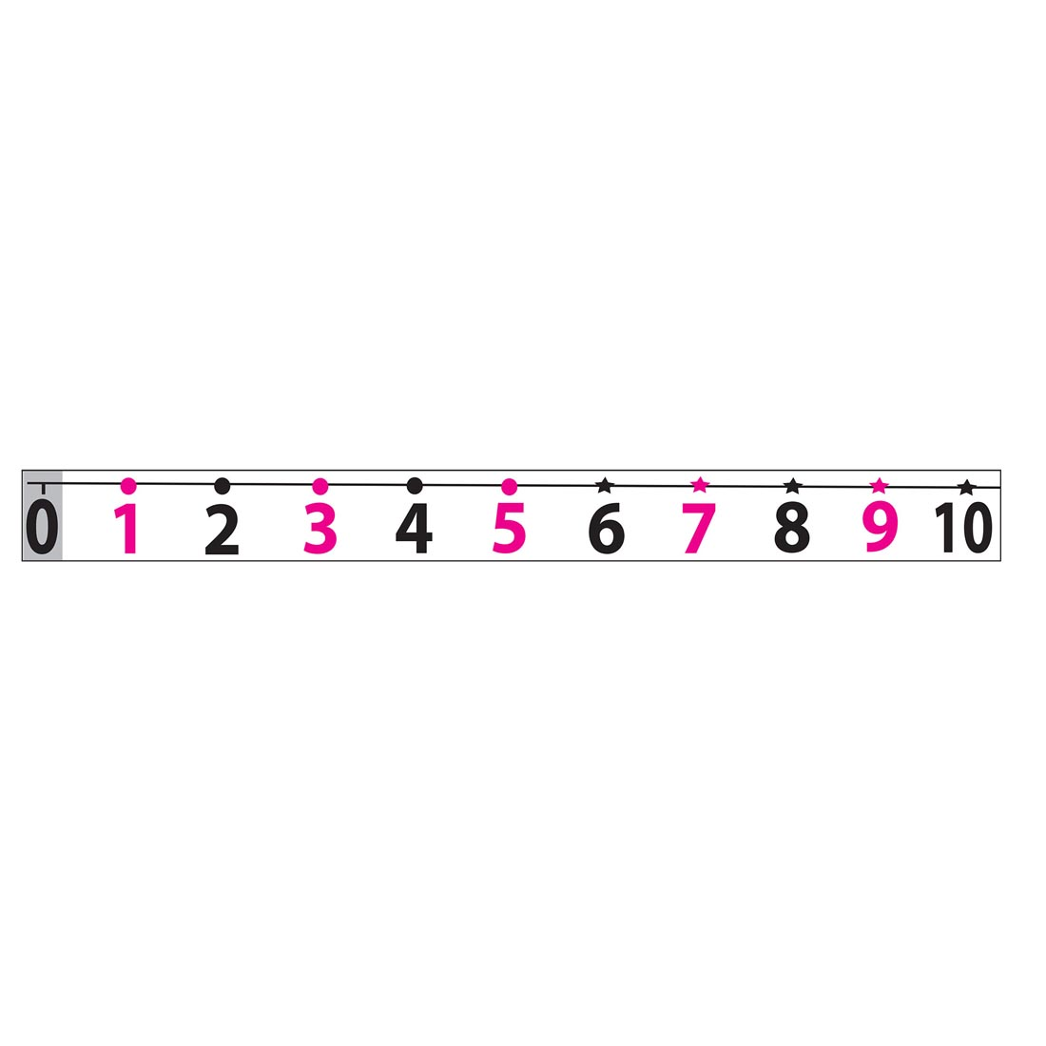

 | YEAR 1
Objectives | Method: | Example/Representation:
Read, write and interpret mathematical statements involving addition (+), subtraction (–) and equals (=) signs  Represent and use number bonds and related subtraction facts within 20  Add and subtract one-digit and two-digit numbers to 20, including zero  Solve one-step problems that involve addition and subtraction, using concrete objects and pictorial representations, and missing number problems such as 7 = □ – 9. | Children will be taught to use a range of strategies to represent number bonds. Including the part-part-whole method and bar model.  This can be completed using practical equipment as well as a written method. | 11  18  7  18  7  11
 | Children will use a tens frame to add numbers including crossing a tens boundary. | 6 + 4
  O | O
  O | O
  O | O
  O | O
  O | O
 | Children will be taught to use a number track to support addition | 4 + 2 = 6o  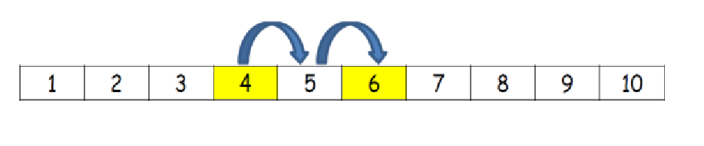
 | Bead strings and counting sticks will be used to support addition | 5 + 3 = 8  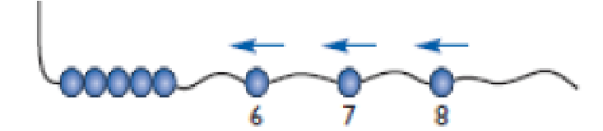
 | Children will use a prepared number line to solve simple addition stories and number sentences | 2 + 5 = 7  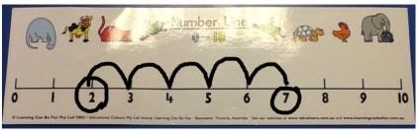
 | Children will be taught how to solve simple addition stories with the support of a 100 number square | 11 + 7 = 18 | 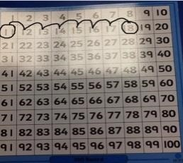
 | Children are taught how to use a blank number line for addition and then encouraged to draw their own number line to help solve problems | 12 + 7 = 19 | 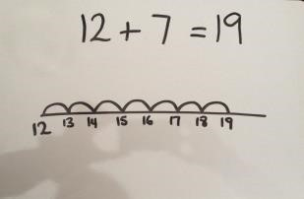
 | 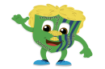  Children will partition numbers into tens and units when adding two 2-digit numbers that lie within the tens boundary | 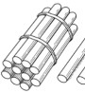  10 | 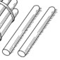  1  10  2
 |  | 11 | +  12  =  23  =  23
 | Children will solve one-step addition problems using concrete objects and/or pictorial representations | I have 5 sweets and I am given 3 more. How many do I have altogether?  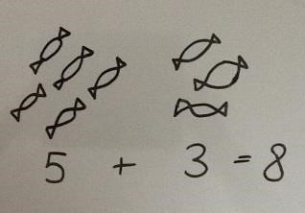

 | YEAR 2
Objectives | Method: | Example/Representation:
 | Children will be taught to use both number lines for addition as well as other written methods. The knowledge of bonds to 10 crucial to children when using this method. | 34 + 8  +2  +6  40  42  34
. Show that addition of two numbers can be done in any order (commutative) and subtraction of one number from another cannot  Recall and use addition and subtraction facts to 20 fluently, and derive and use related facts up to 100  Add and subtract numbers using concrete objects, pictorial representations, and mentally, including:  ▪ a two-digit number and ones  ▪ a two-digit number and tens  ▪ two two-digit numbers  ▪ adding three one-digit numbers  Solve problems with addition and subtraction:  ▪ using concrete objects and pictorial representations, including those involving numbers, quantities and measures  ▪ applying their increasing knowledge of mental and written methods  Recognise and use the inverse relationship between addition and subtraction and use this to check calculations and solve missing number problems. | Children will still be taught to use part-part-whole model to add and understand the relationship between addition and subtraction. | 21  23  44
 | Children will use concrete and pictorial representations to add a 2 digit number and units, three 1 digit numbers and a 2 digit number and multiuples of 10 | 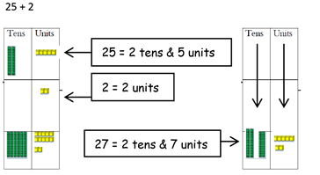
 | This is developed further when children need to cross the tens boundary. They will learn to exchange 10 ones for 1 ten. | 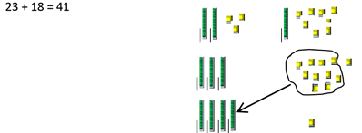
 | Children will begin to set addition calculations out in columns and record as expanded column addition. | 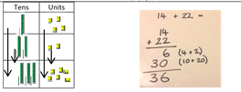
 | Children will use the expanded column method and cross over tens boundaries. | 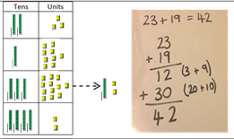
 | Children will use the expanded column method and cross over hundreds boundaries. | 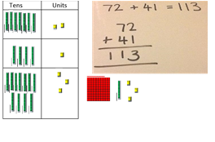
 | Children will use the methods from above to solve problems  Including the use of bar models. These will be encouraged to display the relevant information allowing children to organise the information. | 26  14  12  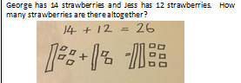

 | YEAR 3
Objectives | Method: | Example/Representation:
Add and subtract numbers with up to three digits, using formal written methods of columnar addition and subtraction  Estimate the answer to a calculation and use inverse operations to check answers  Solve problems, including missing number problems, using number facts, place value, and more complex addition and subtraction. | Children calculate HTU + U without crossing boundaries. They are supported by the use of multibase and dienes equipment. | 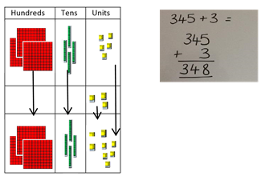
 | Children calculate HTU + TU without crossing boundaries. They are supported by the use of multibase and dienes equipment. | 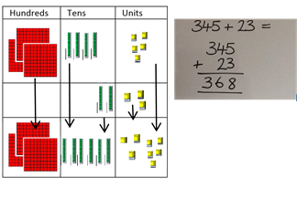
 | Children calculate HTU + TU and cross the tens boundary. They are supported by the use of multibase and dienes equipment. | 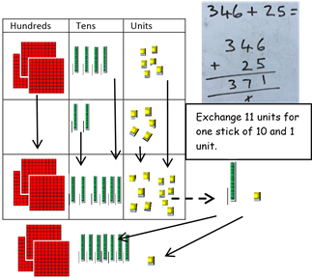
 | Children calculate HTU + TU and cross the tens boundary for both parts of the calculation.. They are supported by the use of multibase and dienes equipment. | 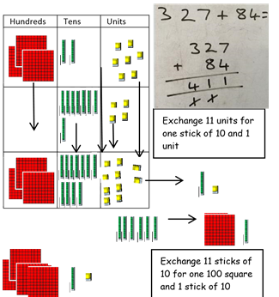
 | Children use the formal written method of column addition. | 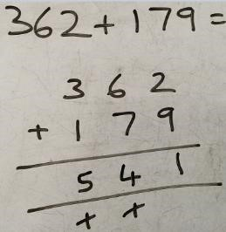  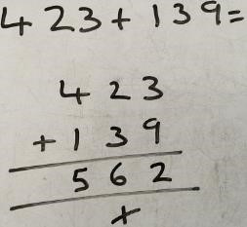
 | Bar modelling should be used for children to represent a calculation | 94  132 | 38

 | YEAR 4
Objectives | Method: | Example/Representation:
Add and subtract numbers with up to 4 digits using the formal written methods of columnar addition and subtraction where appropriate (So mental strategy as appropriate)  Add and subtract numbers with up to 4 digits using the formal written methods of columnar addition and subtraction where appropriate  Estimate and use inverse operations to check answers to a calculation  Solve addition and subtraction two-step problems in contexts, deciding which operations and methods to use and why. | Children will add numbers with up to 4-digits using the formal written method of column addition.  This can be supported with practical equipment if needed, for example multilink or dienes as used in previous year groups. | 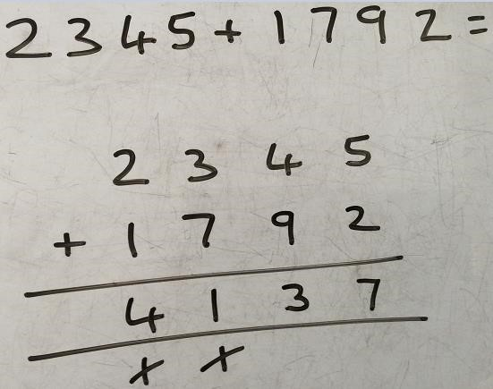
 | Solve two-step problems using formal jottings and explaining reasoning behind their calculations (Bar model) | Seb has 77 cubes. He builds two towers.  One tower uses 18 cubes and one tower uses 35 cubes. How many cubes does he have left over?  53  35  ??  18  77

 | YEAR 5
Objectives | Method: | Example/Representation:
Add and subtract whole numbers with more than 4 digits, including using formal written methods (columnar addition and subtraction)  Use rounding to check answers to calculations and determine, in the context of a problem, levels of accuracy  Solve addition and subtraction multi-step problems in contexts, deciding which operations and methods to use and why. | Children will add numbers with more than 4-digits using the formal written method of column addition  This can be supported using practical resources if needed. | 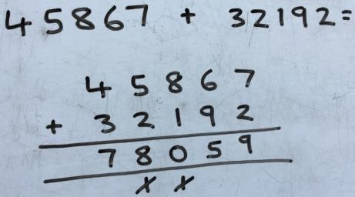
 | Children will add decimal numbers with the same number of decimal places using the formal written method column addition | 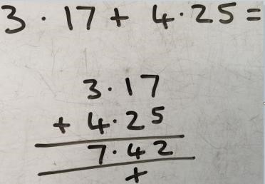
 | YEAR 6
Objectives | Method: | Example/Representation:
Use estimation to check answers to calculations and determine, in the context of a problem, an appropriate degree of accuracy.  Solve addition and subtraction multi-step problems in contexts, deciding which operations and methods to use and why  Solve problems involving addition, subtraction, multiplication and division | Children will add several numbers of increasing complexity | 81,059 + 3,668 + 15,301 + 20,551 = 120,579  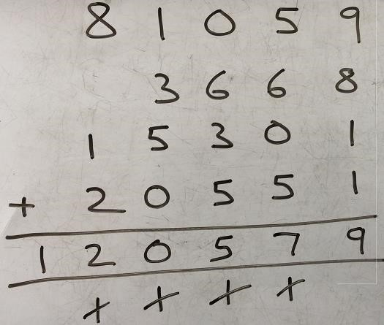
 | Children will add several decimals numbers with a different number of decimal places | 23.361 + 9.08 + 59.77 + 1.3 = 93.511  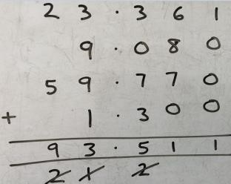  Zero used as  a place value  holder.

 | SUBTRACTION
 | EYFS
Objectives | Method | Example/Representation
Say which number is one more or one less than a given number  Using quantities and objects, they add two single-digit numbers and count on to find the answer.  Using quantities and objects, they subtract two single-digit numbers and count on or back to find the answer. | Using a range of practical resources and real life contexts, pupils develop their understanding of the concept of subtraction as taking away through counting activities | I had 9 sweets and I ate 2. How many have I got left? There was 9 but after taking 2 away there are 7 left  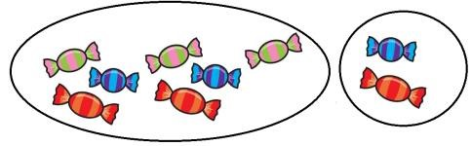
 | Children will use counting objects, toys or their fingers to answer simple subtraction number sentences | (e.g. 5-2= 3)  
 | Children will listen to a subtraction story and draw a set of objects (jottings) on whiteboards and cross some off - drawing a picture helps children to visualise the subtraction
 | Children will use their fingers to help with subtraction, e.g. 5 – 2 = 3. A child will start with the biggest number in their head ‘5’ and hold 5 fingers up  They will count back saying ‘5’ (touching their head) ‘4, 3’ (curling one finger  down at a time), then count how many fingers are left | 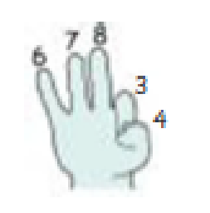
 | Children can use characters like ‘Suzie the Subtractor’ to help develop their understanding of subtraction | 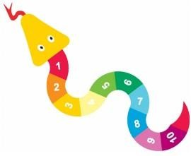
 | Children will be introduced to numbered number lines and be shown how to subtract by moving backwards. | -1 -1  6-2=4
  1 | 2 | 3 | 4 | 5 | 6 | 7 | 8 | 9 | 10

 | YEAR 1
Objectives | Method: | Example/Representation:
Represent and use number bonds and related subtraction facts within 20  Add and subtract one-digit and two-digit numbers to 20, including zero  Solve one-step problems that involve addition and subtraction, using concrete objects and pictorial representations, and missing number problems such as 7 = □ – 9. | Children will be taught to use a number track to support subtraction by counting backwards | 6 – 2 = 4  -1 -1
 | Bead strings and counting sticks will be used to support subtraction by counting backwards | 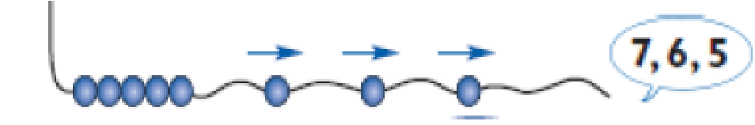  8 – 3 = 5
 | Children will use a prepared number line to solve simple subtraction stories and number sentences by counting backwards | 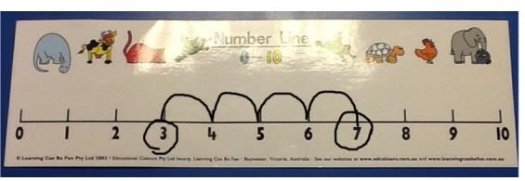  7 – 4 = 3
 | Children will be taught how to solve simple subtraction stories with the support of a 100 number square | 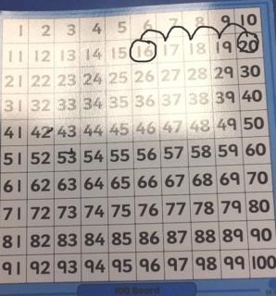  20 – 4 = 16
 | Children are taught how to use a blank number line for subtraction  (counting backwards) and then encouraged to draw their own number line to help solve problems  Children will begin with TU – U that lie within the tens boundary then move onto TU – U that cross the tens boundary | 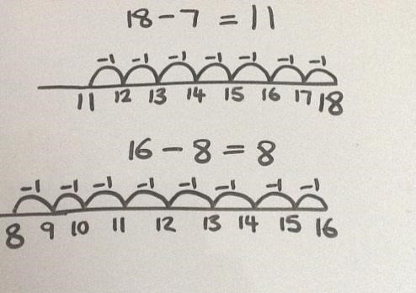
 | Children will solve one-step subtraction problems (including missing number problems) using concrete objects and pictorial representations | 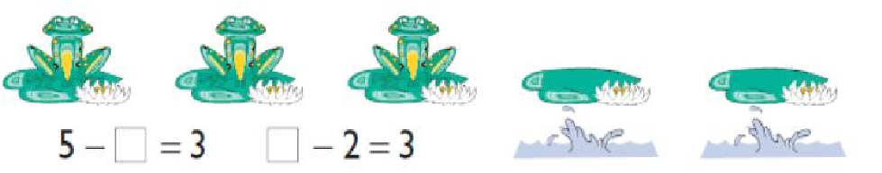
 | Children will use tens frames and the partitioning method to subtract across the tens boundary. | 12 – 6 = 6  12 is partitioned to 10 and 2. 6 is subtracted from 10 to give 4. 4 and 2 are then combined back together to make 6.
  0 | 0
  0  10 – 6 = 4 | 0
  0 | 0
  0 | 0
  0 | 0
  0 | 0
  4 + 2 =6

YEAR 2
Objectives | Method: | Example/Representation:
Show that addition of two numbers can be done in any order (commutative) and subtraction of one number from another cannot  Recall and use addition and subtraction facts to 20 fluently, and derive and use related facts up to 100  Add and subtract numbers using concrete objects, pictorial representations, and mentally, including:  ▪ a two-digit number and ones  ▪ a two-digit number and tens  ▪ two two-digit numbers  ▪ adding three one-digit numbers  Solve problems with addition and subtraction:  ▪ using concrete objects and pictorial representations, including those involving numbers, quantities and measures  ▪ applying their increasing knowledge of mental and written methods  Recognise and use the inverse relationship between addition and subtraction and use this to check calculations and solve missing number problems. | Children are encouraged to use a blank number line to solve TU – TU and count back in tens and then units by:  - Positioning the first number in the number sentence at the end of the number line.  - Partitioning the second number into tens and units  - Counting back in tens (or multiples of 10)  - Counting back in units | 34 – 16 = 18  -4  -2  -10  24  20  34  18
 | Children will use their knowledge of difference to use a blank number line to count on from the smallest number to the largest number (in tens and units) to solve subtraction number sentences (TU – TU)  Children will use the above strategies to draw their own number lines and decide which method is more efficient.  Recognise and use inverse relationship between addition and subtraction and use this to check calculations and solve missing number problems. | Difference between 21 and 46 is 25  + 5  46  41  + 20  21
 | Children will solve TO – O calculations. They will use practical/concrete resources appropriately. Children will need to exchange 1 ten for ten ones to ensure the calculation can be carried out.  e.g. 22-7=15 | Exchange One Ten for Ten Ones.  Then subtract 7 from 12 to leave 5.  This then leaves 10 and 5 which gives the answer 15
 | Children will solve TO – O calculations. They will use practical/concrete resources appropriately. Children will need to exchange 1 ten for ten ones to ensure the calculation can be carried out.  e.g. 43 – 25=18 | Exchange One Ten for Ten Ones.  Then subtract 5 from 13 to leave 8.  Then subtract  2 Tens from 3 Tens to leave 1 Ten  So 1 Ten and 8 Ones is 18
 | Children will solve one and two-step subtraction problems using concrete objects and pictorial representations including those involving number, quantities and measures. Bar models can be used to sort information as well as highlight the connection between addition and subtraction. | 36  ??  14  A man has 36 plants in his garden. The slug eats 14 of them. How many plants are left?

 | YEAR 3:
Objective | Method: | Example/Representation:
Add and subtract numbers mentally, including:  ▪ a three-digit number and ones  ▪ a three-digit number and tens  ▪ a three-digit number and hundreds  Two 2-digit numbers across 100 (non-statutory guidance)  Add and subtract numbers with up to three digits, using formal written methods of columnar addition and subtraction  Estimate the answer to a calculation and use inverse operations to check answers  Solve problems, including missing number problems, using number facts, place value, and more complex addition and subtraction. | Children begin to set out TU - TU (that lie within the tens boundary) in columns and record as column subtraction | 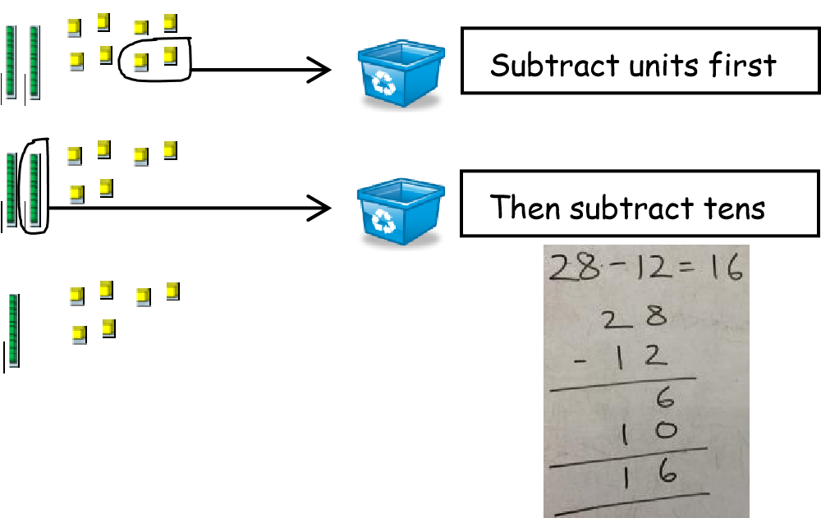  Children will remove the number being subtracted so they are left with the correct answer.
 | Children begin to set out TU - TU (that cross the tens boundary) in columns and record as column subtraction with decomposition | 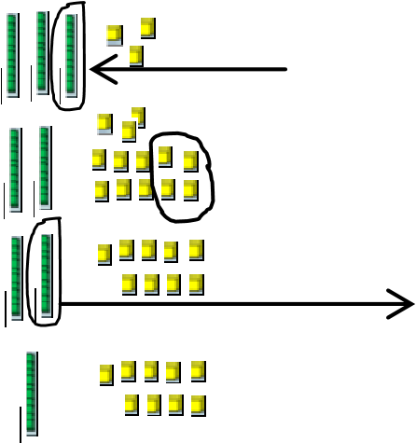 | 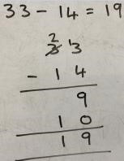  Children will remove the number being subtracted so they are left with the correct answer.  Subtract the units  Subtract the tens
  Exchange 1 stick of 10 for 10 units
 | Children begin to set out HTU - TU (that lie within the tens boundary) in columns and record as column subtraction |  | 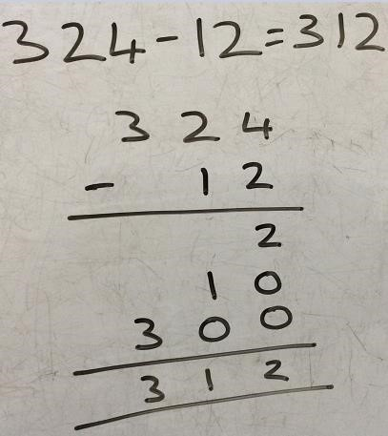
 | Children begin to set out HTU - TU (that cross the tens boundary) in columns and record as column subtraction with decomposition |  | 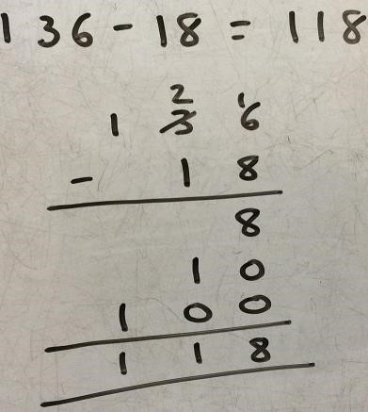
 | Children set out HTU-TU (crossing the hundreds boundary) using multibase.  This is then extended to written column method | 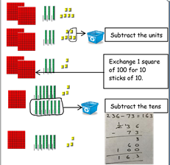
 | Children complete HTU-HTU including the crossing the tens and hundreds boundary. | 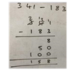
 | Same difference method-when calculating numbers that are multiples of 10 children can subtract 1 from each number to make the column subtraction more straightforward. |  | -1  3 0 0 2 9 9  - 1 7 8 - 1 7 7  1 2 2
 | Children will solve problems, including worded problems and missing number calculations. Bar models can be used here to allow children to set work out correctly. This will also allow children to see the link between addition and subtraction | 34 – ?? = 15  ??  34 | 15

 | YEAR 4
Objectives | Method: |  | Example/Representation:
Add and subtract numbers with up to 4 digits using the formal written methods of columnar addition and subtraction where appropriate  Estimate and use inverse operations to check answers to a calculation  Solve addition and subtraction two-step problems in contexts, deciding which operations and methods to use and why. | Children will subtract numbers with up to 4-digits using the formal written method of column subtraction with decomposition. They use of multibase or Dienes equipment can be used here to support children should they require it. | 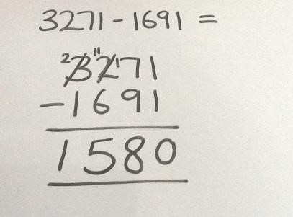
 | Bar modelling can be used to represent a calculation and display information-especially when problem solving. | ??  1975  2632
 | The same difference can be used up to 4 digits subtracting using a number that is a multiple of 1000. | -1  3 0 0 0 2 9 9 9  - 1 7 8 6 - 1 7 8 5  1 2 1 4

 | YEAR 5
Objective | Method: | Example/Representation:
Add and subtract whole numbers with more than 4 digits, including using formal written methods (columnar addition and subtraction)  Use rounding to check answers to calculations and determine, in the context of a problem, levels of accuracy  Solve addition and subtraction multi-step problems in contexts, deciding which operations and methods to use and why. | Children will subtract numbers with more than 4-digits using the formal written method of column subtraction with decomposition |  | 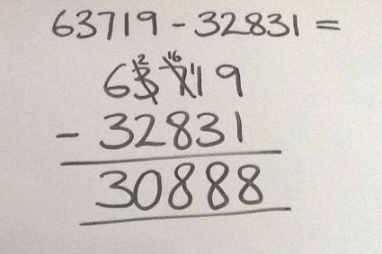
 | Children will subtract decimal numbers with the same number of decimal places with decomposition |  | 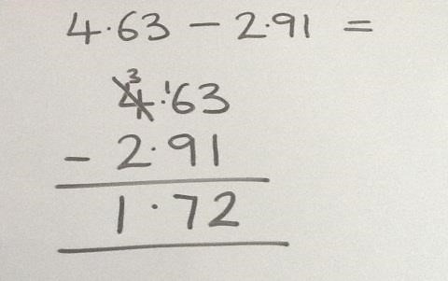
 | Same difference method can be used to find answers where the number being taken away from is a multiple of 10, 100, 1000, 10,000 etc |  | -1  3 0 0 0 0 2 9 9 9 9  - 1 1 7 8 6 - 1 1 7 8 5  1 8 2 1 4

 | YEAR 6
Objective | Method: | Example/Representation:
Use their knowledge of the order of operations to carry out calculations involving the four operation  Use estimation to check answers to calculations and determine, in the context of a problem, an appropriate degree of accuracy.  Solve addition and subtraction multi-step problems in contexts, deciding which operations and methods to use and why  Solve problems involving addition, subtraction, multiplication and division | Children will subtract numbers of increasing complexity. Children will learn to combine numbers in order to make calculations simpler. |  | 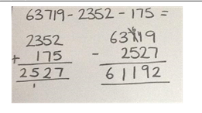
 | Children will subtract decimal numbers with different values. They will use place holders to represent missing values. |  | 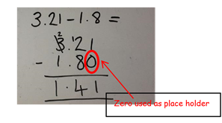
 | Where children are required to subtract using calculations using 3 or more numbers, they may combine numbers two numbers to make the calculation simpler. |  | 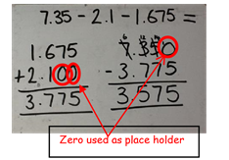
 | The same difference method can be used for calculations involving whole numbers and decimals.  e.g. 3-1.78=1.22 |  | -0.01  3 2. 9 9  - 1. 7 8 - 1. 7 7

Multiplication
objective | EYFS
 | Children will count groups of the same number of objects and add them together  The children learn about grouping in practical contexts and through pictorial representations | 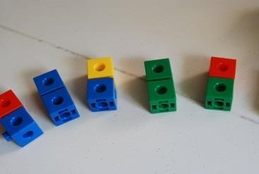  Count groups of 2 and then count all objects to add them together.
 | Children will solve simple problems involving doubling | 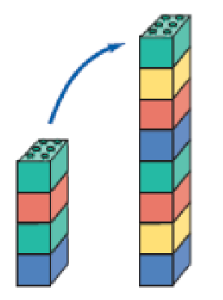  Double 4 is 8

 | YEAR 1
Objective | Method: |  | Example/Representation:
Solve one-step problems involving multiplication and division, by calculating the answer using concrete objects, pictorial representations and arrays with the support of the teacher. | Children will count groups of the same number of objects and add them together.  The children learn about grouping in practical contexts, through pictorial representation  Bead strings and counting sticks will be used to support counting in sequences of 2s, 5s and 10’s |  | 1) I have 5 pairs of socks in the bag. How many socks are there?  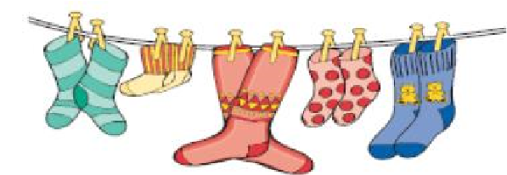
 | Children will recognise and complete patterns and sequences involving multiples of 2, 5 and 10 |  | 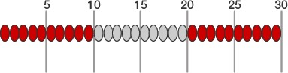
 | Children will be given one-step word problems to solve, involving counting in multiples of 2, 5 and 10 and doubles. Children will use concrete objects and pictorial representations to support their ideas |  | Alfie, Joseph and Ben all have a pair of socks. How many socks are there altogether?  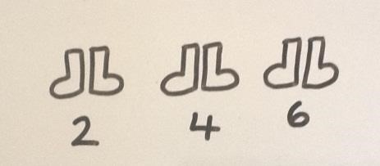
 | Children will be introduced to an array to support multiplication and to support the understanding that multiplication is repeated addition |  | 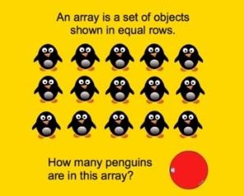  5 + 5 + 5 = 15
 | YEAR 2
Objective | Method: | Example/Representation:
Show that multiplication of two numbers can be done in any order (commutative) and division of one number by another cannot  Recall and use multiplication and division facts for the 2, 5 and 10 multiplication tables, including recognising odd and even numbers  Calculate mathematical statements for multiplication and division within the multiplication tables and write them using the multiplication (×), division (÷) and equals (=) signs  Solve problems involving multiplication and division, using materials, arrays, repeated addition, mental methods, and multiplication and division facts, including problems in contexts. | Children will be able to recognise and write the multiplication symbol (x) in mathematical statements
 | Children will understand the operation of multiplication as repeated addition on a blank number line and will use practical resources to support this | 4 x 5 = 15  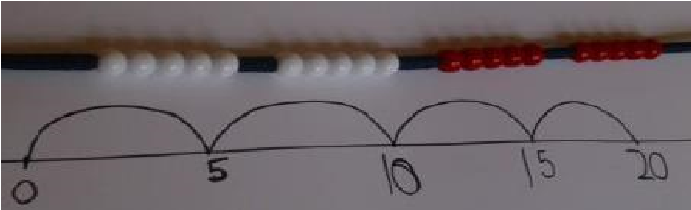
 | Children will be able to represent a multiplication calculation using an array and write the multiplication symbol within a number sentence. Children will also understand that multiplication can be carried out in any order (commutative) | 3 x 5 = 15  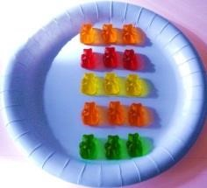  5 x 3 = 15
 | Children will solve one-step multiplication problems (including missing number problems) using concrete objects and pictorial representations | I have 3 ladybirds with 5 spots each. How many spots do they have altogether?  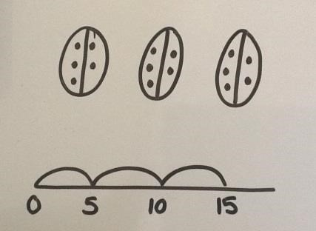
 | Children can represent a multiplication using a bar model and see the link between multiplication and repeated addition. | 5 x 5 = 25
  25
  5 | 5 | 5 | 5 | 5

 | YEAR 3:
Objective | Method: | Example/Representation:
Recall and use multiplication and division facts for the 3, 4 and 8 multiplication tables  Write and calculate mathematical statements for multiplication and division using the multiplication tables that they know, including for two-digit numbers times one-digit numbers, using mental and progressing to formal written methods  Solve problems, including missing number problems, involving multiplication and division, including positive integer scaling problems and correspondence problems in which n objects are connected to m objects. | Children will learn to calculate doubles of 2-digit numbers through partitioning | Double 24 = 24 + 24 = 48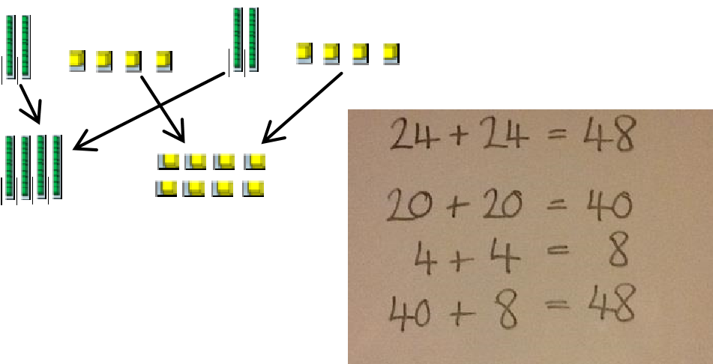
 | Children will be taught to multiply numbers (TU x U) through partitioning and the formal written method of grid multiplication  This method can be supported with multibase equipment. | 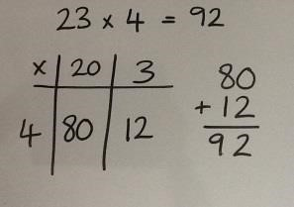
 | Children will be taught to multiply numbers (TU x U) using the formal written method of expanded column multiplication and make the link to grid method | 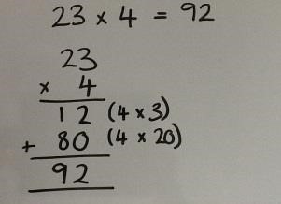
 | Children will solve problems involving multiplication, including scaling | 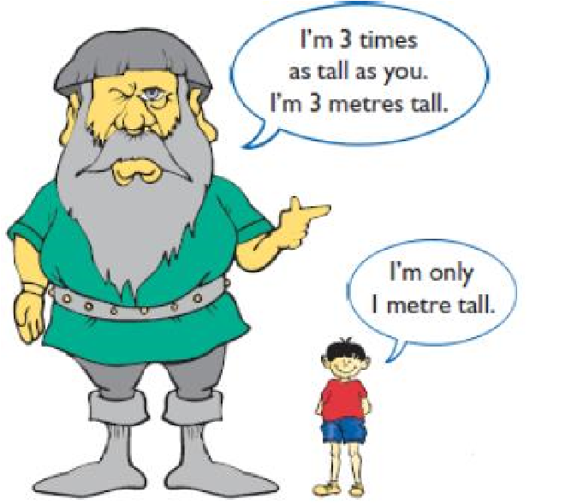  I’m 3 times as tall as you.  How tall am I?

 | YEAR 4
Objective | Method: | Example/Representation:
Recall multiplication and division facts for multiplication tables up to 12 × 12 (facts for 6,7,9,11,12 are new)  Use place value, known and derived facts to multiply and divide mentally, including: multiplying by 0 and 1; dividing by 1; multiplying together three numbers  Recognise and use factor pairs and commutativity in mental calculations  Multiply two-digit and three-digit numbers by a one-digit number using formal written layout  Solve problems involving multiplying and adding, including using the distributive law to multiply two digit numbers by one digit, integer scaling problems and harder correspondence problems such as n objects are connected to m objects. | Children will be taught to multiply numbers (TU x U) by partitioning the 2digit number and using two short multiplications along with addition to solve the problem (Distributive Law)  Throughout teaching this method the use of multibase equipment can be used to support children.  Grid method can also be used as an alternative method. | 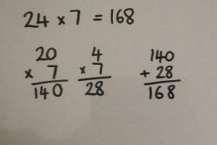
 | Children will be taught to multiply numbers (TU x U) using the formal written method of short multiplication and will link with the Distributive Law method | 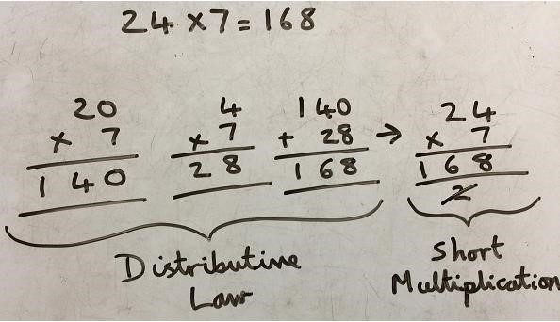
 | Children will be taught to multiply numbers (HTU & U) by partitioning the 3digit number and using two short multiplications along with addition to solve the problem | 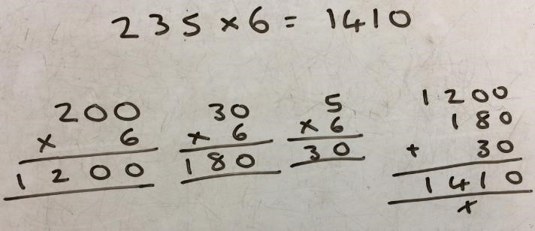
 | Children will be taught to multiply numbers (HTU x U) using the formal written method of short multiplication and will link with the Distributive Law method | 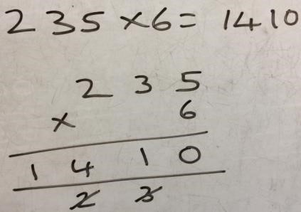
 | Solve problems involving multiplying and adding to multiply two or three digit numbers by one digit | 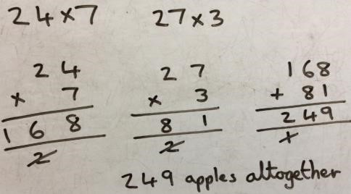  Harriet has 7 friends who each have 24 apples. Joseph has 3 friends who each have 27 apples. How many apples do Harriet and Joseph’s friends have altogether?  Representations of the problem can be made using a bar model or diagram if required by a child to help visualise the problem.    27 27 27 27 27 27 27

 | YEAR 5
Objective | Method: | Example/Representation:
 | Children will be taught to multiply numbers (TU x TU) using the formal written method of long multiplication. Before this, If children need further support.  Children then add the numbers together. | 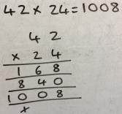
   | 40 | 2
  20 | 800 | 40
  4 | 160 | 8
 | Children will be taught to multiply numbers (HTU x TU) using the formal written method of long multiplication | 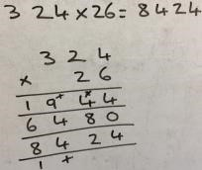
 | Children will be taught to multiply numbers (ThHTU x U) using the formal written method of short multiplication | 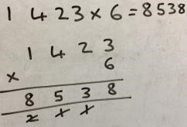
 | Children will be taught to multiply numbers (ThHTU x TU) using the formal written method of long multiplication | 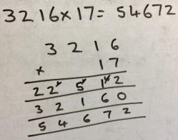
 | Children will learn to multiply whole numbers and those involving decimals by 10, 100 and 1000 by moving the digits around the fixed decimal on a place value grid | 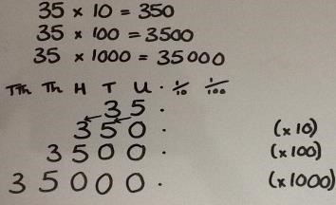
 | Children will solve problems involving multiplication, including scaling | Alfie runs 3400m on Sports Day. His friend, Harry, runs three times as far. How far does Harry run?  3400m  3400m  3400m  3400m  3 times greater than 3400m is 3 x 3400m
 | YEAR 6
 | Method: | Example/Representation:
 | Multiply numbers by 10, 100 and 1000 where the answers are up to three decimal places | 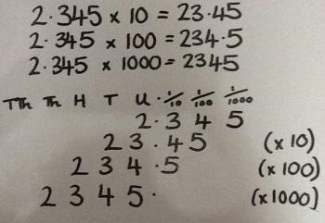 place value charts should be used to support children in with this method.
 | Multiply one-digit numbers with up to two decimal places by whole numbers using:  - Short multiplication when multiplying by a single digit  - Long multiplication when multiplying by a 2-digit number | 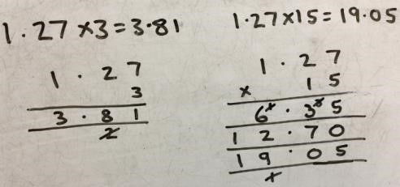
 | Multiply multi-digit numbers up to 4 digits by a 2-digit whole number using the formal written method of long multiplication | 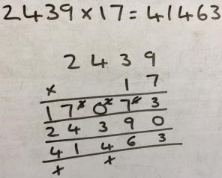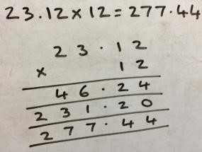



Division

DIVISION
EYFS
Objective | Method: | Example/Representation:
They solve problems, including doubling, halving and sharing. | Children experience early division by sharing objects and counting how many in each group. They can do this in a series of play scenarios.  Teachers to make sure that children are absolutely clear about the word share and equally.  A range of practical resources can be used to do this and show children the concept of sharing equally.  e.g. share 8 circles between 4 people.
 | Children will solve problems including halving and sharing.  A range of practical resources can be used to do this including shapes. | 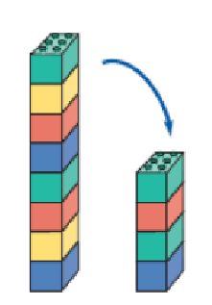  What is half of 8?  Half of 8 is 4

 | YEAR 1
Objective | Method | Example/Representation:
Solve one-step problems involving multiplication and division, by calculating the answer using concrete objects, pictorial representations and arrays with the support of the teacher. | Children will understand equal groups and share items out in play scenarios | Share 12 cakes between 3 people equally:  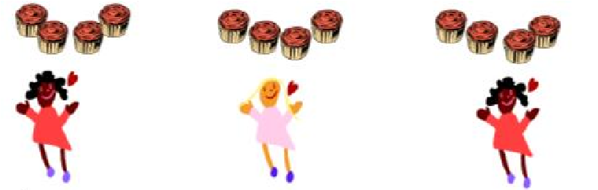
 | Children will be taught to associate ‘half’ with dividing by two and recognise, find and name a half as one of two equal parts | Can you cut the pizza in half?  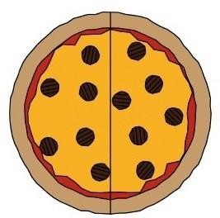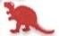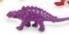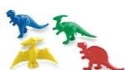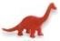  What is half of 12?
 | Children will be given a word problem to complete either practically or using pictorial representations | Can you share 6 apples between 3 plates?  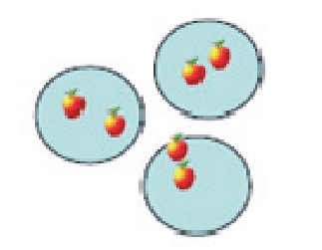
 | Children will recognise and write the division symbol (÷) in mathematical statements, calculating the answer with the teacher using concrete objects | 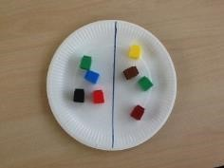  8 ÷ 2 = 4
 | YEAR 2
Objective | Method: | Example/Representation:
Show that multiplication of two numbers can be done in any order (commutative) and division of one number by another cannot  Recall and use multiplication and division facts for the 2, 5 and 10 multiplication tables, including recognising odd and even numbers  Calculate mathematical statements for multiplication and division within the multiplication tables and write them using the multiplication (×), division (÷) and equals (=) signs  Solve problems involving multiplication and division, using materials, arrays, repeated addition, mental methods, and multiplication and division facts, including problems in contexts. | Children will understand the operation of division as grouping using repeated subtraction on a prepared number line or using appropriate practical equipment. E.g. bead strings. | -3  -3  -3  -3  -3  15 ÷ 3 = 5  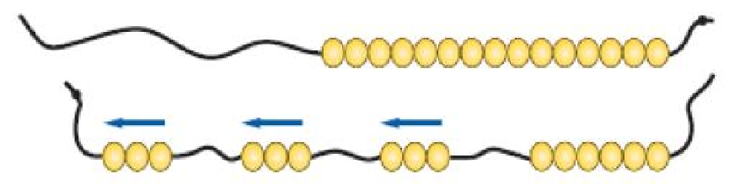  -3 -3 -3
 | Children will be able to represent a division calculation using an array and write the division within a number sentence.  They will link this to their understanding of division and see the inverse with multiplication. | How many groups of 3 are in 12?  12 ÷ 3 = 4  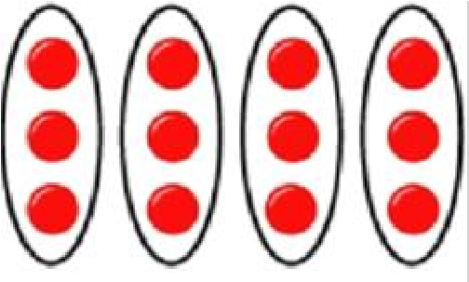
 | Children will use a blank number line to carry out repeated subtraction to solve a division number sentence | 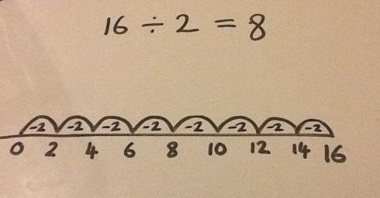
 | Children will be taught to understand the difference between sharing and grouping. Children will also connect unit fractions to equal sharing and grouping | If 6 sweets are shared between 2 people, how many do they get each?    Grouping  Sharing  If there are 6 sweets, how many people can have 2 sweets each  ?  v  v  v  v  v  v  v  v  v  v  v  v
 | Children will solve one-step division problems (including missing number problems) using concrete objects and pictorial representations.  They will also be taught to know that some groupings are incorrect and explain why. | 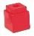  12 ÷ = 6

 |  | YEAR 3:
Objective |  | Method: | Example/Representation:
Recall and use multiplication and division facts for the 3, 4 and 8 multiplication tables  Write and calculate mathematical statements for multiplication and division using the multiplication tables that they know, including for two-digit numbers times one-digit numbers, using mental and progressing to formal written methods  Solve problems, including missing number problems, involving multiplication and division, including positive integer scaling problems and correspondence problems in which n objects are connected to m objects. |  | Children will use practical resources to support the short division method and will be encouraged to use multiples of the divisor to assist (TU ÷ U) | 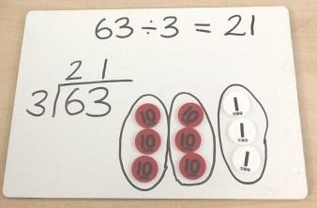  The quotient can be seen across the groups.
   | 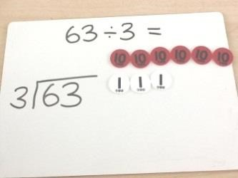
    Create the dividend using Place Value counters.
  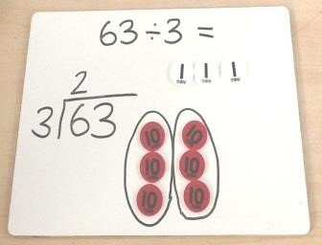
    Group the tens counters according to the divisor and write the number of groups above the line in the tens column.
  Group the tens counters according to the divisor and write the number of groups above the line in the tens column.
 |  | Children will use practical resources to support the short division method and will be encouraged to use multiples of the divisor to assist (HTU ÷ U) | The quotient can be seen across the groups.
  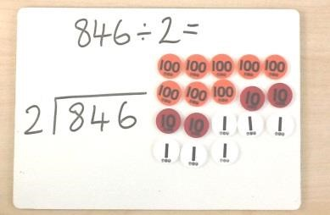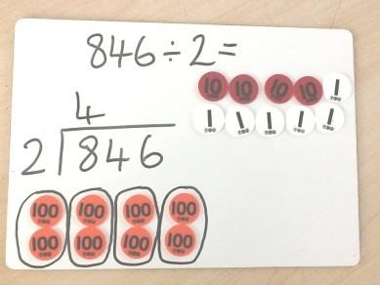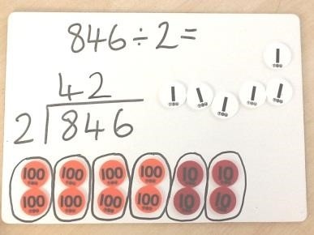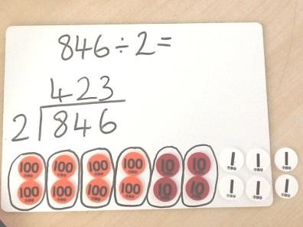
    Create the dividend using Place Value counters.
  Group the 100s counters according to the divisor.
  Write the number of groups above the line in the hundreds column.
  Next, group the 10s counters according to the divisor.
  Write the number of groups above the line in the tens column.
    Next, group the units counters according to the divisor. Write the number of groups above the line in the units column.
 |  | Children will use practical resources to support solving division number sentences with remainders (TU ÷ U)
  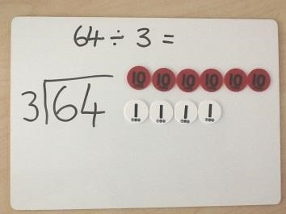
    Create the dividend using Place Value counters.
  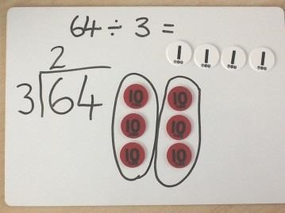
    Starting with tens counters, group them according to the divisor. Write the number of groups in the tens column above the line.
   | 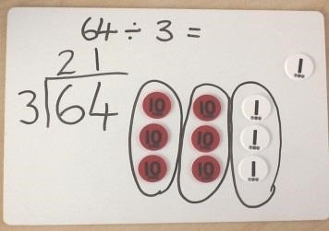
    Next, group the units according to the divisor and arrange next to the groups of ten. Write the number of groups above the line in the units column.
 |  |  | 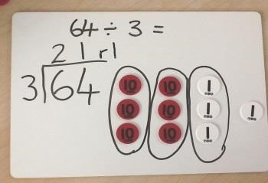  As you look across each group, the q | Any counters that cannot be grouped are the remainder. Write this at the end as ‘r1’.
 |  |  |  | uotient can be seen.
 |  | Pupils connect tenths to place value, decimal measures and that tenths is to divide by 10 | 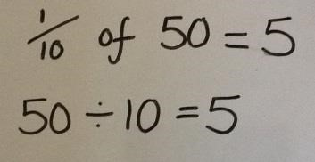
  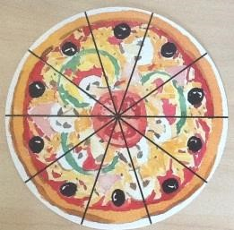 |  | 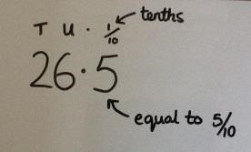
    1
    10

 | YEAR 4
Objective | Method: | Example/Representation:
 | Children will use practical resources to support solving division number sentences with remainders (HTU ÷ U) | 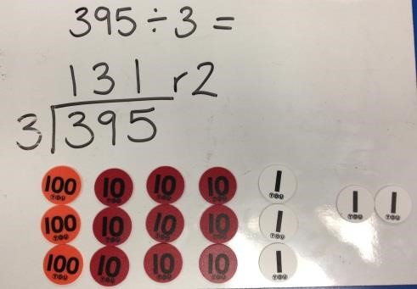
Recall multiplication and division facts for multiplication tables up to 12 × 12 (facts for 6,7,9,11,12 are new)  Use place value, known and derived facts to multiply and divide mentally, including: multiplying by 0 and 1; dividing by 1; multiplying together three numbers  Recognise and use factor pairs and commutativity in mental calculations  Multiply two-digit and three-digit numbers by a one-digit number using formal written layout  Solve problems involving multiplying and adding, including using the distributive law to multiply two digit numbers by one digit, integer scaling problems and harder correspondence problems such as n objects are connected to m objects. | Children will use practical resources to support the short division method where exchange across place value columns occurs. (HTU ÷ U) | 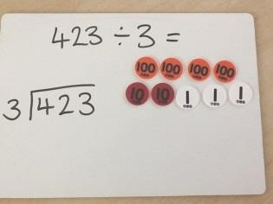  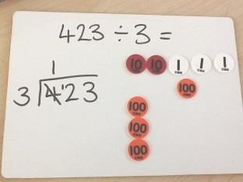  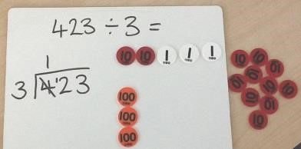  The quotient can be seen across each group.
  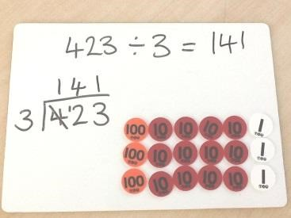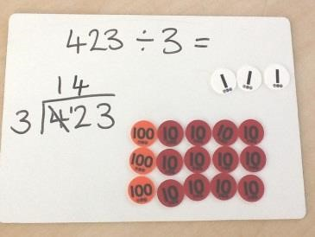
    Next, group the 10s counters according to the divisor and write the number of groups above the line in the tens column.
    Group the units counters according to the divisor and write the number of groups above the line in the units column.
  Create the dividend using Place Value counters.
  Group the hundreds counters according to the divisor. Write the number of groups above the line in the hundreds column.
  Exchange the left over 100s counter for ten 10s counters and represent this beneath the line in the tens column.

 | Children will use the short division method where exchange across the place value columns occurs. Pupils will be encouraged to use multiples of the divisor to assist (HTU ÷ TU) ????? Hannah | 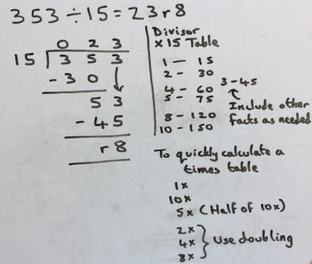
 | Find the effect of dividing a 1 or 2-digit number by 10 and 100; identifying the value of the digits in the answer as units, tenths and hundredths.  A place value chart will be used to show the movement of the numbers and explain that number become ‘ten/hundred times greater/smaller’ | 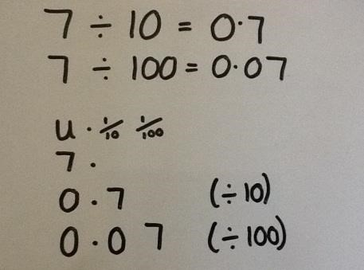
 | Count up and down in hundredths; recognise that hundredths arise when dividing an object by a hundred and dividing tenths by ten | 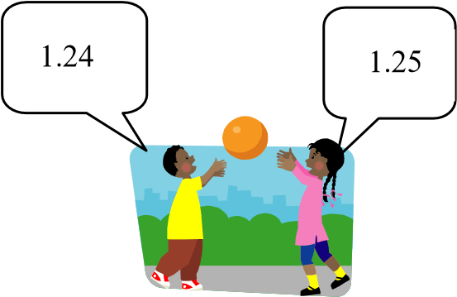  What should I cut my pizza into if I have 100 people to serve?

 | YEAR 5
 | Method: | Example/Representation:
identify multiples and factors, including finding all factor pairs of a number, and common factors of two numbers  know and use the vocabulary of prime numbers, prime factors and composite (non-prime) numbers  establish whether a number up to 100 is prime and recall prime numbers up to 19  recognise and use square numbers and cube numbers, and the notation for squared (²) and cubed (³)  multiply and divide numbers mentally drawing upon known facts  multiply and divide whole numbers and those involving decimals by 10, 100 and 1000  multiply numbers up to 4 digits by a one- or two-digit number using a formal written method, including long multiplication for two-digit numbers  divide numbers up to 4 digits by a one-digit number using the formal written method of short division and interpret remainders appropriately for the context  solve problems involving multiplication and division including using their knowledge of factors and multiples, squares and cubes  solve problems involving addition, subtraction, multiplication and division and a combination of these, including understanding the meaning of the equals sign  solve problems involving multiplication and division, including scaling by simple fractions and problems involving simple rates. | Children will use short division to solve division number sentences with remainders (HTU ÷ TU) | 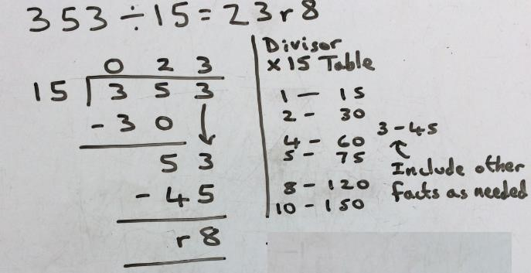
 | Children will use practical resources to support solving division number sentences with remainders (ThHTU ÷ U) | 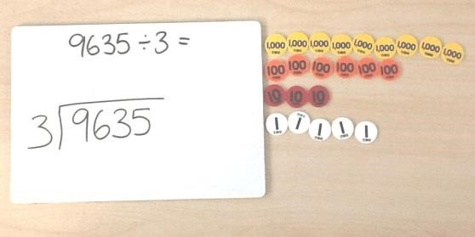  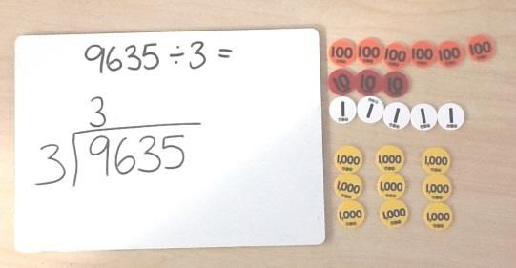  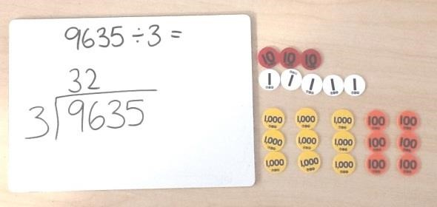  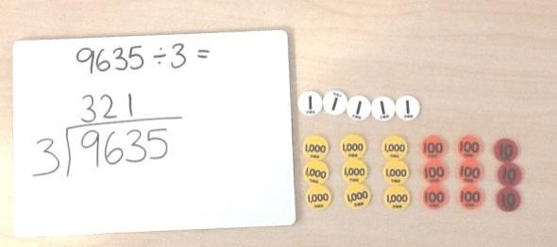
  Create the dividend using Place Value counters.
  Group the 1000s counters according to the divisor and
  write the number of groups above the line in the thousands column.
  Group the 100s counters according to the divisor and
  write the number of groups above the line in the hundreds column.
  Group the 10s counters according to the divisor and
  write the number of groups above the line in the tens column.
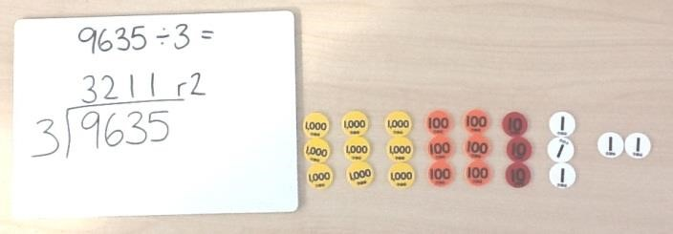
Group the units counters according to the divisor and write the number of groups about the line in the

units column. Express remainders as ‘r2’ as part of

the quotient.

 | Children will learn to divide whole numbers and those involving decimals by 10, 100 and 1000 by moving the digits around the fixed decimal | 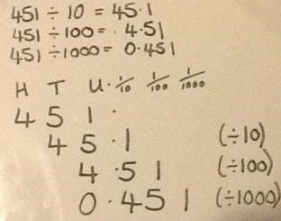
 | Children will solve problems involving division, including scaling.  Children will be able to understand the terms ‘times greater’ and ‘times smaller’ as well as other related vocabulary. | e.g. John has 244 toy soldiers. Sam has 4 times less. How many does Sam have?  e.g. Sam has 61 Toy soldiers. John has 4 times more/as many. How many does John have?

 | YEAR 6
 | Method: | Example/Representation:
 | Divide numbers up to 4 digits by a two-digit whole number using the formal written method of division | 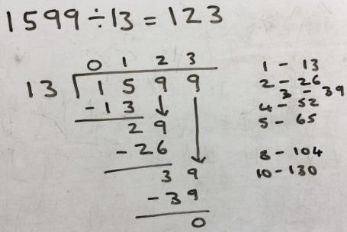  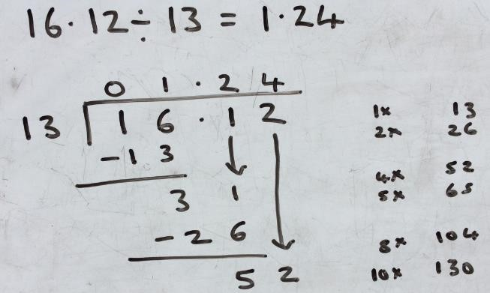
 | Interpret remainders as whole number remainders, fractions or decimals | 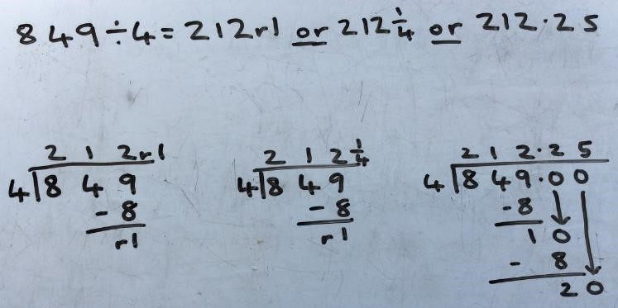
 | Divide numbers decimal numbers with up to 3 decimal places by 10, 100 and 1000 by moving the digits around a fixed decimal | 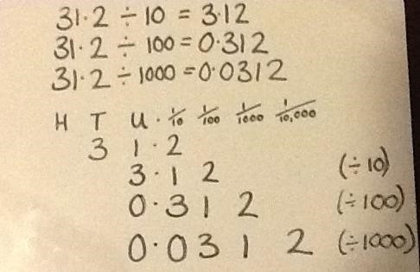
 | Children will be taught to recognise connections in larger numbers that will help them perform the calculation mentally. | e.g.  4 2 3 5 ÷ 7 =  4200 ÷ 7 = 600  35 ÷ 7 = 5  600 + 5 = 605

