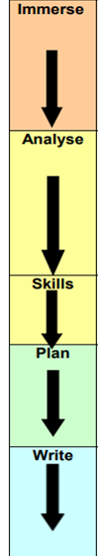
Immersion of text. (Lesson 1)
Hook Lesson - This is to generate interest from the children e.g. box of clues, children receive a letter, crime scene in classroom etc. Children to recount the hook.
Prediction (Lesson 2)
Children to make predictions using the front cover. (Observe, Infer, Wonder)

Short Term Outcome 1 (Fiction/Non-Fiction)
Please use opportunities for incidental writing in discussion with the English leader.
(Ideas for planning and teaching over 2 weeks)
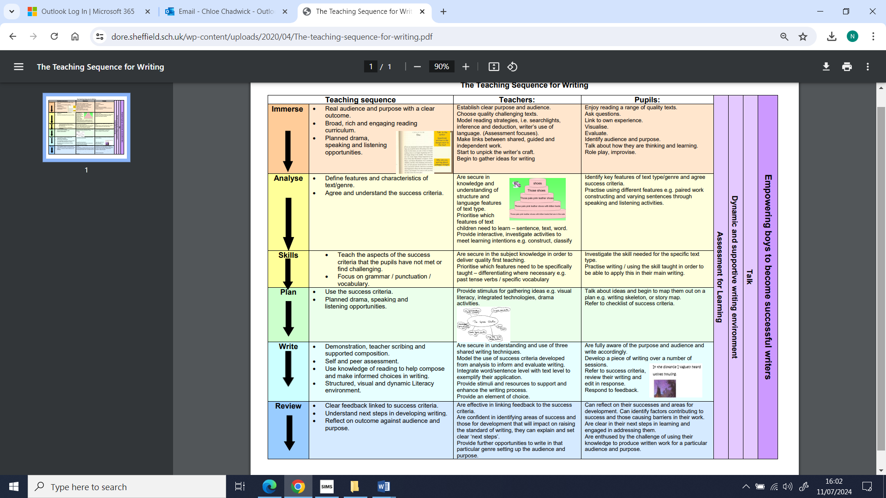
- Look at the features of the short term outcome.
(Use wrap around texts, poetry and digital literacy)
- Look at WAGOLLS of the short term outcome
(Identifying features).
- Look at the grammar needed in the short term outcome.
- Use the FANTATSICS to plan for the outcome.
(Focus on key vocabulary)
- Shared write for the outcome.
(Focus on audience and purpose)
- Plan and write their own short term outcome.
(Focus on handwriting, spelling and non-negotiables)

Short Term Outcome 2 (Fiction/Non-Fiction)
Please use opportunities for incidental writing in discussion with the English leader.
(Ideas for planning and teaching over 2 weeks)

- Immersion activity based on next short outcome.
- Look at the features of the short term outcome.
(Use wrap around texts, poetry and digital literacy)
- Look at WAGOLLS of the short term outcome
(Identifying features).
- Look at the grammar needed in the short term outcome.
- Use the FANTATSICS to plan for the outcome.
(Focus on key vocabulary)
- Shared write for the outcome.
(Focus on audience and purpose)
- Plan and write their own short term outcome. (Focus on handwriting, spelling and non-negotiables)
Long Term Outcome
(Ideas for planning and teaching over 1 week)
- Focus on the structure of writing - beginning, middle and end.
(Timeline strand from ‘Are you really reading?’)
- Use the short term outcomes to feed into the long term outcome.
- Plan long term outcome in sections.
(Focus on handwriting, spelling and non-negotiables)
- Write Long term outcome

Edit and improve
- KS1 – Focus on editing and improving their writing.
- KS2 – Edit, improve and publish long term outcome.
Children to publish their learning neatly using a line guide. Do not use twinkl publishing paper. Add published writing to the working wall/ displays to celebrate children’s learning.

Comprehension Lesson
Weekly comprehension lessons using a variety of question types. Children must respond to question in full sentences. Incorporate the ‘Are you really reading’ strands where possible. E.g. Impression and evidence stand and Sequencing events strand.
Rec – Verbal responses.
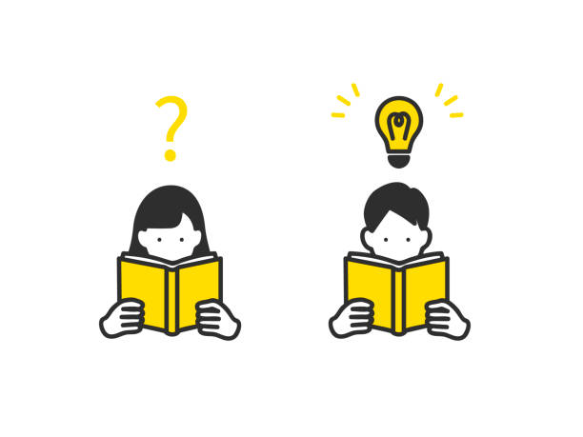
Year 1 – 3 questions.
Year 2 – 5 questions.
Year 3 – 6 questions.
Year 4 – 7 questions.
Year 5 – 10 questions.
Year 6 – 10 questions.

Grammar Lesson
*KS1 - Incorporate grammar within lessons.
*KS2 – Grammar lesson (Monday).
- Discuss concept (make use of grammar songs)
- Guided practice

- Independent practice using testbase questions.

