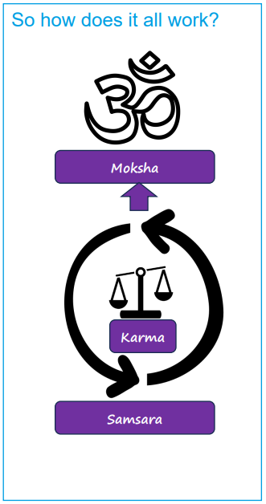  Brahman is a formless, ultimate reality, one energy or consciousness in the universe, the source of everything.  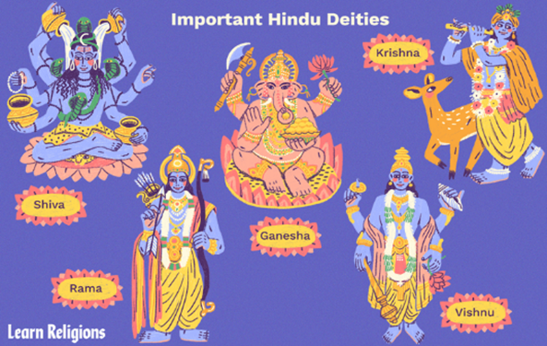    These deities are Brahman channelled into different forms | Vocabulary
 | 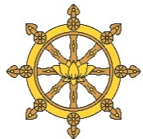 | dharma | 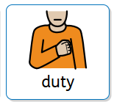  Meaning ‘duty’ (an obligation), by fulfilling their dharma Hindus believe they will attain moksha (the release from the cycle of life, death and rebirth)
 | 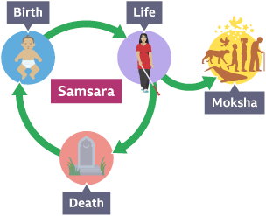 | samsara | the cycle of life, death and rebirth
 | 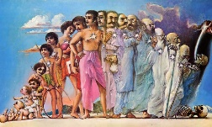 | reincarnation | the rebirth of the atman in another body
 | 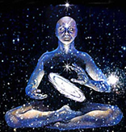 | Atman | 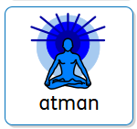  the spark of Brahman in every living creature
 | 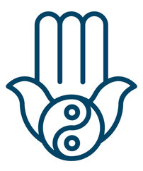 | karma | the total of all a person’s actions which decides their future existence
 | 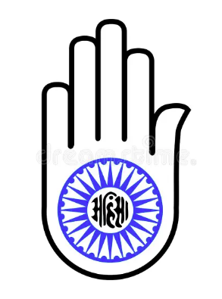 | ahimsa | the belief not to cause harm to any living creature

