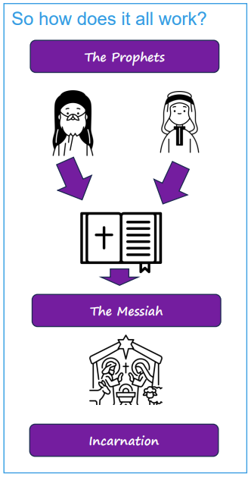   | Vocabulary
 |  | Messiah | 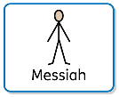  a saviour from God, promised in the Hebrew texts
 | 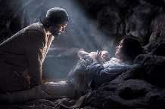 | incarnation |   ‘in the flesh’; Christians believe Jesus is God ‘in the flesh’, or God incarnated
 |  | saviour | 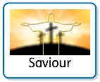  Jesus came to save or rescue people e.g., by showing them how to live
 |  | Immanuel/ Emmanuel |   a Hebrew name meaning God is with us
 |  | gospel |   the good news about Jesus, a book of the New Testament recounting Jesus’ life
 |  | theological |   about the study of God and religious belief
 |  |  | Isaiah was a prophet (messenger sent from God) who told of a rescuer and described what the Messiah would be like.  Micah was another prophet, also sent from God, who promised a rescuer.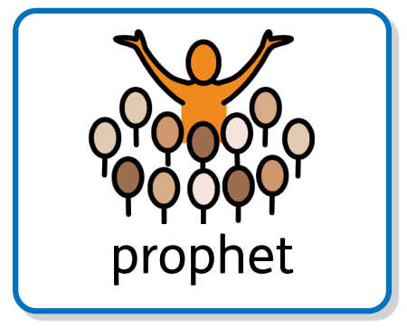  Both of these prophets told others of prophecies; a prediction of what will happen in the future.

