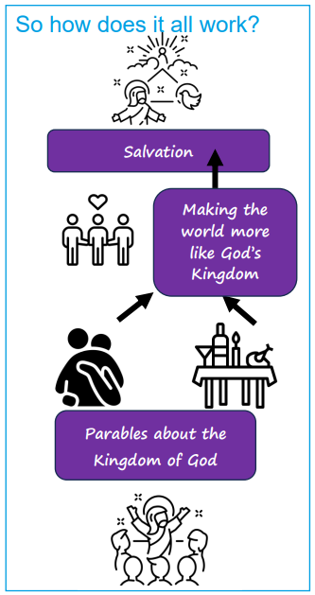 | Vocabulary
 |  | parable | a story Jesus told that has a special meaning
 |  | forgiving  unforgiving | stopping blaming or punishing someone for that they have done  to continue to blame someone for what they have done
 |  | salvation | being saved or rescued so that humans are no longer separated from God
 |  | banquet | a very large meal usually for a celebration
 | 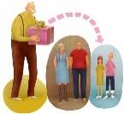 | inheritance | when something is passed on to someone else
 |  | biblical | relating to, or in the Bible
 |  | unjust | not behaving in a way that is morally right or fair
 |  | social | being part of society

