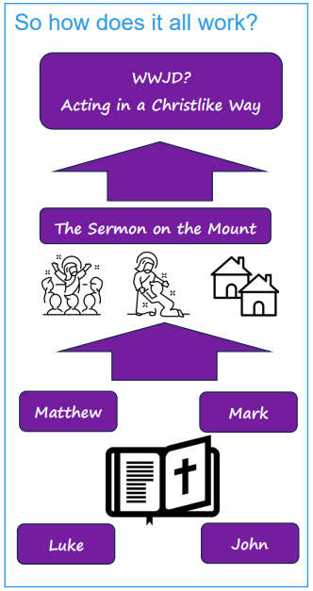   | Vocabulary
 | 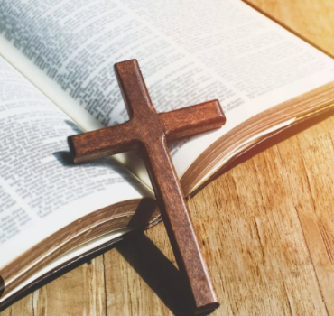 | gospel | means ‘Good news’ but also the title of the four books of the bible that tell the story of the life of Jesus.
 | 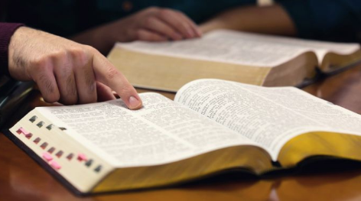 | theology | the study of God and religious belief or a set of beliefs
 | 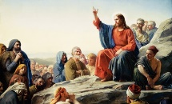 | parables | a story Jesus told that has a special meaning
 | 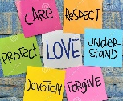 | Christ like | becoming more like Jesus by what people say and do in their daily actions
 | 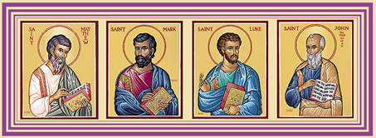 |  | Matthew, Mark, Luke and John: the name of different gospels, which are similar, in the New Testament.
 | 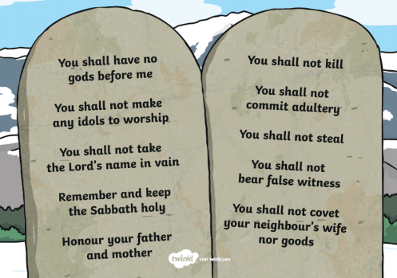 |  | Commandments are rules which have to be observed and followed by Christians.

