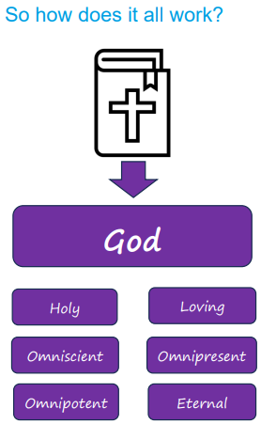 | Vocabulary
 |  | holy | meaning consecrated (blessed or sacred), e.g. the Holy Bible, the Holy Spirit
 | 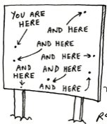 | omnipresent | God is everywhere
 |  | omniscient | God is all knowing
 |  | omnipotent | God is all powerful
 |  | believer | a person who believes and accepts the truth of something
 |  | eternal | God created time and is not limited by it – God is outside time
 | 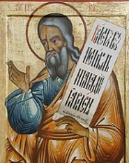 | Isaiah | an Old Testament prophet who speaks of the power and holiness of God
 |  | testament | statement of belief; one of the two sections of the Christian Bible

