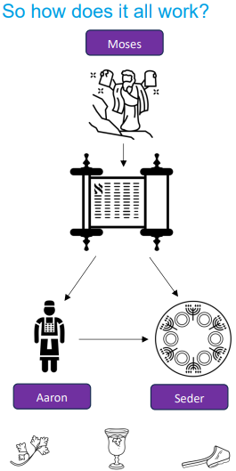 | Vocabulary
 | 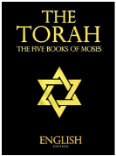 | Torah | the Jewish Holy Book made of the five books of law
 | 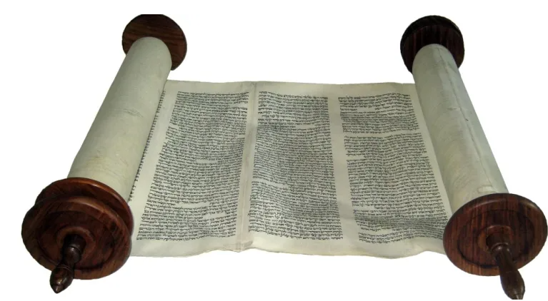 | Sefer Torah | the scrolls containing the Torah which are kept in the ark in the synagogue
 | 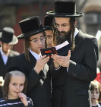 | Orthodox | a worldview in Judaism following the traditional interpretation of Jewish law
 | 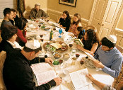 | Pesach (Passover) | the festival remembering the Israelites leaving slavery in Egypt
 | 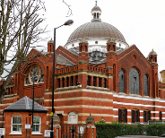 | Synagogue | the Jewish place of worship sometimes called shul
 | Some Jewish people have a progressive worldview in Judaism which says that the laws of the Torah should be interpreted for modern day life.
 | 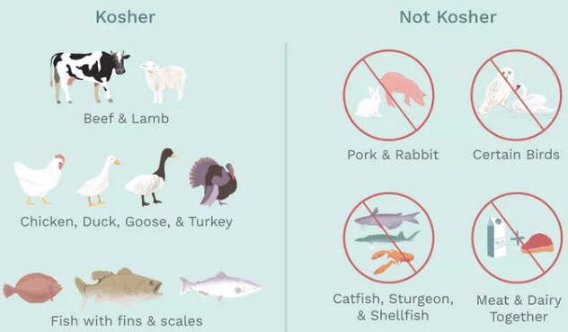 |  |  | Kosher means to follow the Jewish laws. Kosher diet rules are called Kashrut. The rules cover which foods to eat and how to prepare them, cook and store them correctly.

