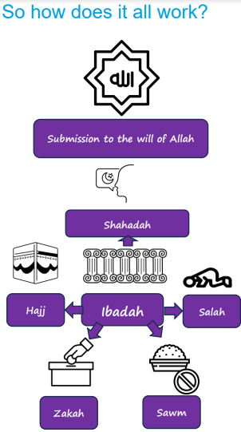  Ibadah is the word for worship in Arabic. | Vocabulary
 |  | Muslim | a follower of the religion of Islam, someone who submits to the will of Allah
 |  | submission | accepting a superior force and doing what they want
 |  | Ramadan | the month in the Muslim calendar when those who can fast do so
 | 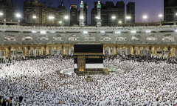 | Hajj | the pilgrimage (a journey taken for religious reasons) to Makkah during the month of Dhul Hijjah that all Muslims should make during their lives if they can
 | 

