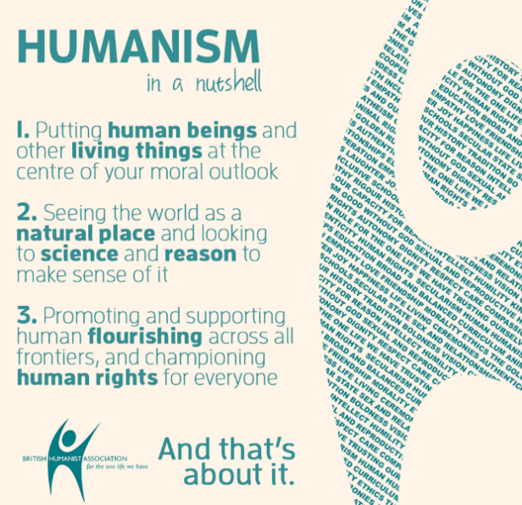  Humanism is a non-religious worldview of life and the world. Humanists seek natural explanations to answer life’s big questions and for events in the world.  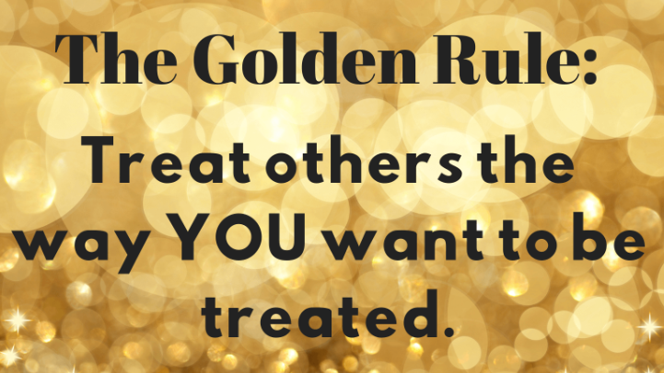 | Vocabulary
 | 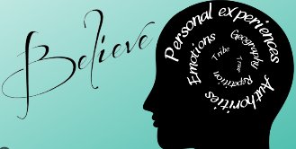 | belief | trust or confidence in something
 | 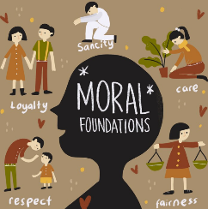 | moral | acting in the correct way
 | 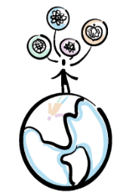 | worldview | a person’s view of the world
 |  | Christian | a person who follows Christianity and believes Jesus is the Saviour who healed the rift between humanity and God.
 | 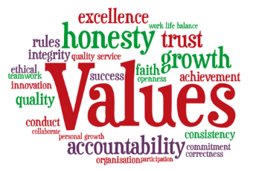 | values | something that is important in terms of what you believe or how you act
 |  | authority | having power over something or someone

