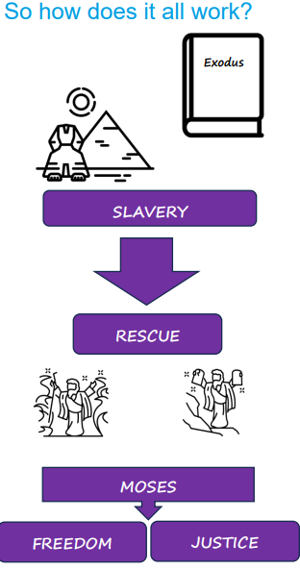  The ‘People of God’ are the Israelites who were chosen by God.  The ‘Children of Israel’ are the Israelites who were the descendants of Jacob. | Vocabulary
 | 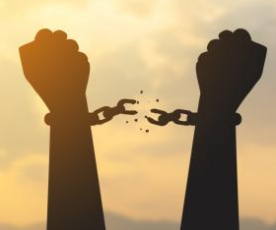 | freedom | not being in prison or in slavery, being able to do what you want
 | 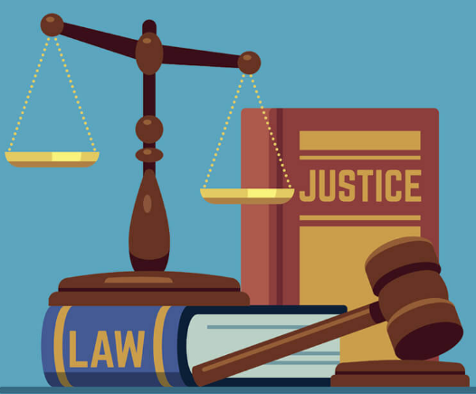 | justice | to treat people equally according to God’s law
 | 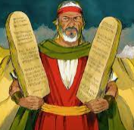 | Moses | a Hebrew prophet who was given the Torah by God
 | 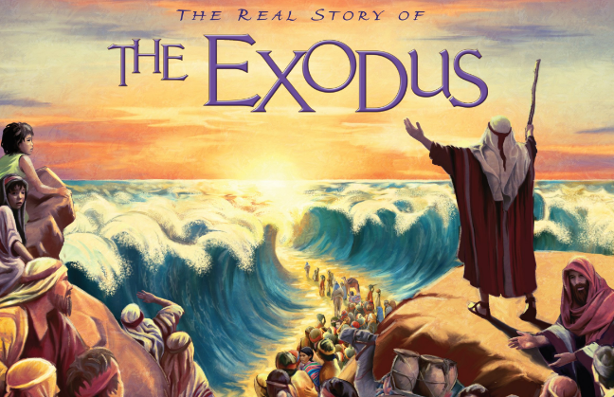 | Exodus | a book in the Torah and the story of the People of God leaving Egypt
 | 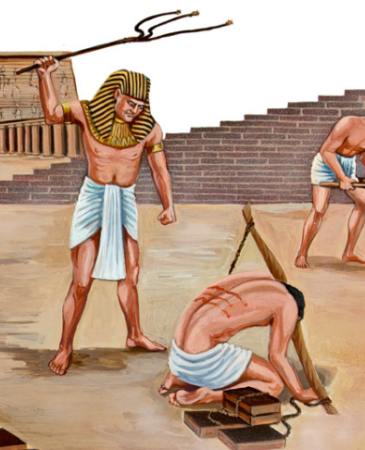 | slavery | owning people who are forced to work for you
 | 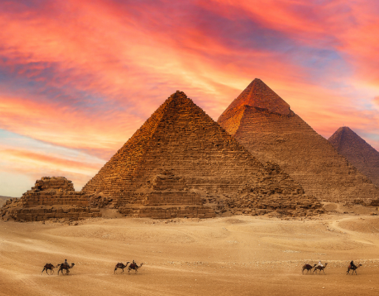 | Egypt | the country in North Africa where the Children of Israel were slaves
 |  | rescue | to save someone from a difficult or dangerous situation
 | 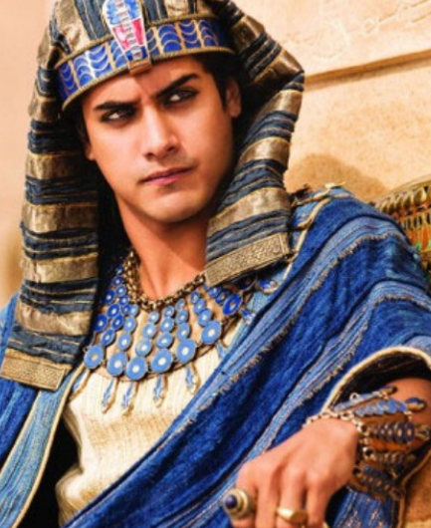 | Pharoah | the leader of the ancient country of Egypt

