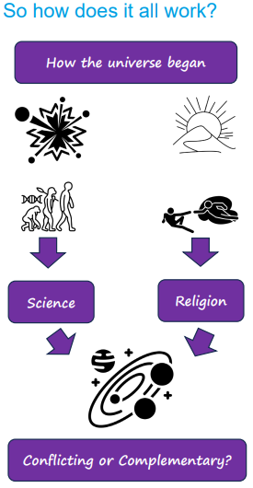 | Vocabulary
 | 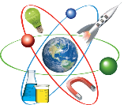 | science | the study of the structure and behaviour of the natural and physical world
 | 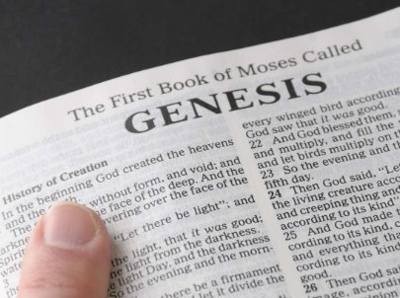 | Genesis | the first book of the Bible and Torah which includes God creating the world
 | 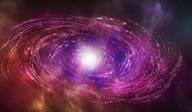 | Big Bang Theory | the belief that the universe began with a large explosion of matter
 |  | complementary | when a number of things work well together and help explain each other
 |  | conflicting | no agreement or support for different ideas or views
 |  | interpretation | an explanation of the meaning of something
 |  | theory | a set of ideas to attempt to explain something
 | 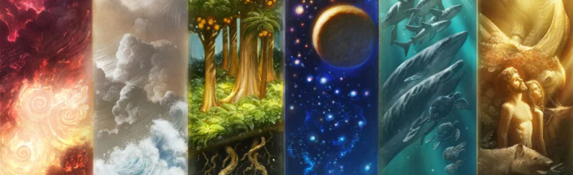 |  |  | Christians believe that God is the Creator (the being who created everything in the universe).

