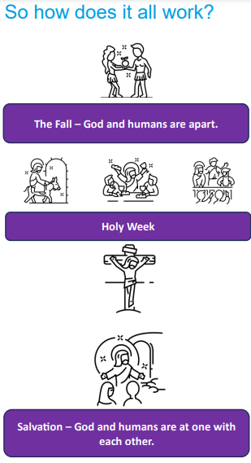 | Vocabulary
 | 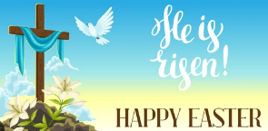 | Easter | the Christian festival which remembers the resurrection of Jesus
 | 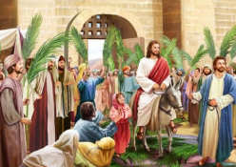 | Palm Sunday | the first day of Holy Week when Jesus rode into Jerusalem on a donkey
 | 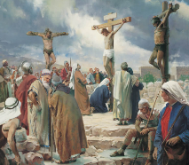 | crucifixion | The way Jesus was put to death by nailing him to a cross. This took place on Mount Calvary, a hill outside of Jerusalem
 | 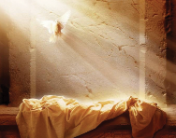 | resurrection | Jesus’ return to life after dying
 | 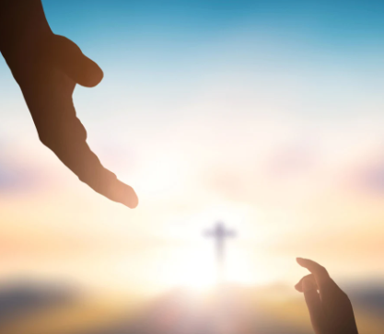 | salvation | being saved or rescued so that Christians are no longer away from God
 |  | sin | an act which goes against the God’s laws
 | 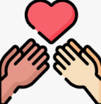 | forgiveness | when someone is stopped being blamed or punished for something they have done
 | 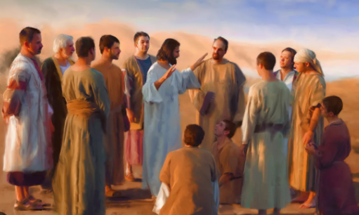 | disciples | the followers of Jesus

