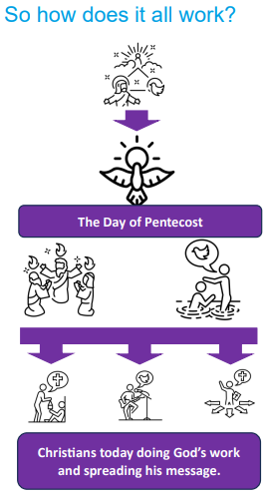  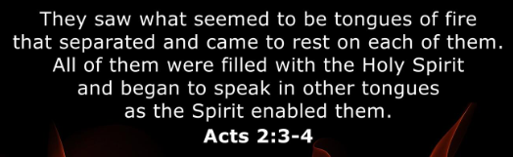 | Vocabulary
 | 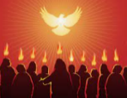 | Pentecost | the day when the Holy Spirit  came to earth
 | 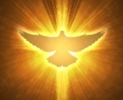 | Holy Spirit | the third person of the Trinity,  God spiritually active in the world
 | Our Father, | Lord’s Prayer | the prayer Jesus taught his disciples to use.
 | 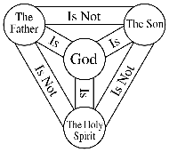 | Trinity | The Christian belief that God is Father, Son, and Holy Spirit; three in one
 | 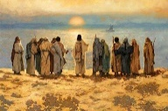 | disciples | the followers of Jesus
 | 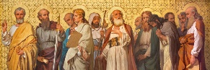 | Apostles | the twelve followers of Jesus who went with him during his earthly ministry
 | 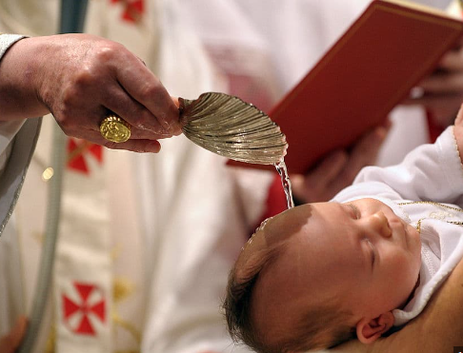 | baptised | the act of washing that welcomes a person into the Christian Church
 | 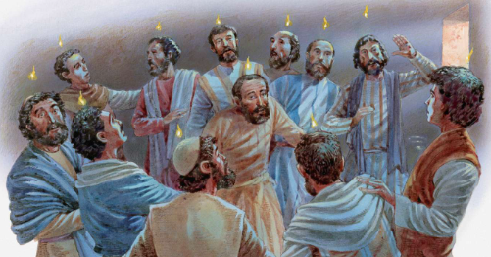 | Tongues | being able to speak different languages, a gift given to the disciples on Pentecost
 | 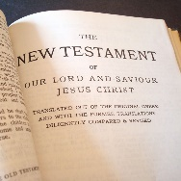 | Acts | the book in the New Testament that contains the story of the early Church and the spread of God’s message

