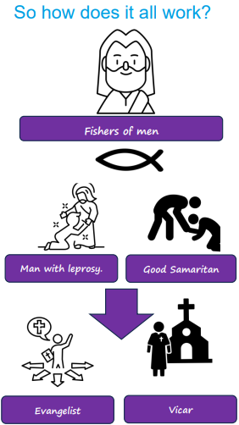 | Vocabulary
 |  | Jesus | the second person of the Trinity or the Son, God in the flesh
 | 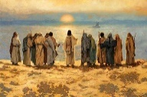 | disciples | the followers of Jesus
 |  | Samaritan | a person from the land of Samaria, a group of people whom the Jewish people disliked
 |  | vicar | a person in charge of a church
 | 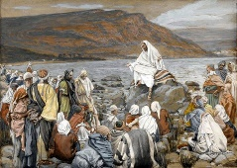 | parable | a story with a meaning
 |  | Galilee | a lake in Judea around which Jesus did much of his teaching
 |  | gospel | the good news about Jesus, a book of the New Testament recounting Jesus’ life
 |  | Evangelist | someone who shares the good news about Jesus through preaching and teaching
 |  | clergy | all of the people who are ordained for Christian ministry

