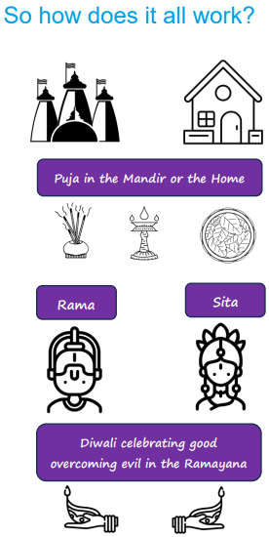  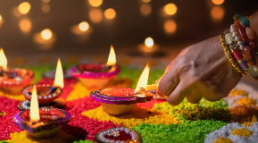 | Vocabulary
 | 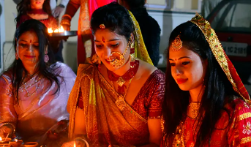 | Hindu | a follower of Hinduism
 | 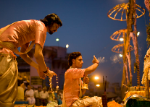 | Puja | ceremonial worship at home or in the Mandir
 | 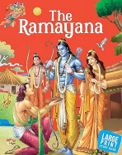 | Ramayana | one of the great stories of the Hindu Dharma
 | 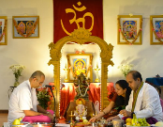 | Shrine | a place of worship for a Hindu either in the home or the mandir
 | 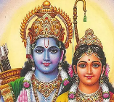 | Rama | A very important deity and the hero of the Ramayana. Sita is the wife of Rama
 |  | Dharma | Duty. By fulfilling their duty Hindus believe they will attain Moksha (freedom from the cycle of life and death)
 | 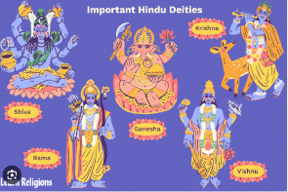 | Deity | Brahman channeled into different forms
 | 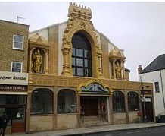 | Mandir | a place where Hindus go to worship.

