Brahman: formless, ultimate reality, one energy or consciousness in the universe, the source of everything  The deities represent Brahman channelled into different forms:  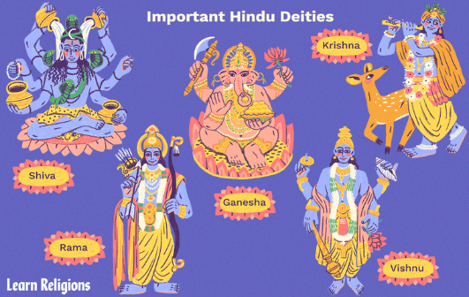  Shiva: the destroyer of things so new things can begin  Vishnu: the sustainer of all living things  Lakshmi: the deity of wealth and prosperity  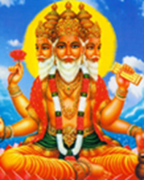  Brahma: the creator of things who created the universe, people and creatures | Vocabulary
 | 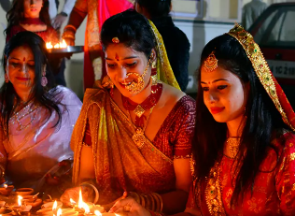 | Hindu | a follower of Hinduism
 | 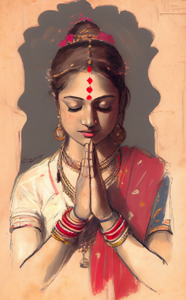 | Namaste | bowing slightly and putting hands together
 | 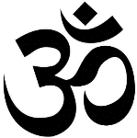 | Aum | the sacred symbol that describes Brahman; the first sound of creation
 | 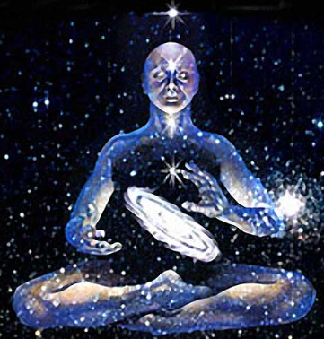 | Atman | the spark of Brahman in every living creature

