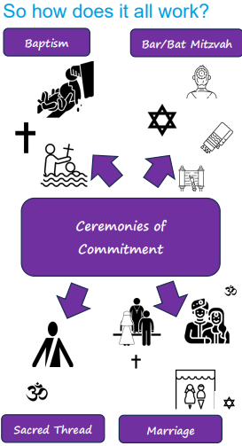  A commitment is a strong belief in something and a promise to do something.  When something is significant, it is very important to you. | Vocabulary
 |  | journey | a person’s experience of changing or travelling from one point to another point
 | 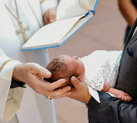 | Baptism | a ceremony that welcomes someone into the Christian church
 |  | marriage | a legal union between two people that usually involves a wedding ceremony, where people make promises to be married and promises to God
 |  | Bar Mitzvah | a joining ceremony when a Jewish boy takes on the responsibilities of his religion
 | 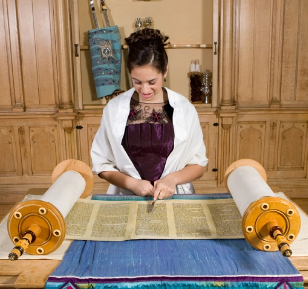 | Bat Mitzvah | a joining ceremony when a Jewish girl takes on the responsibilities of her religion.
 | 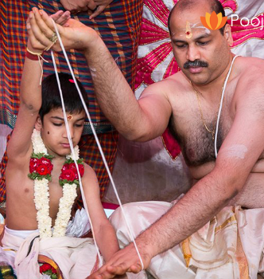 | Sacred Thread | a ceremony when a Hindu is ready to take responsibility for their religious life.
 |  | ceremony | a formal event linked to something special

