Year 3 What is the Trinity and why is it important for Christians?

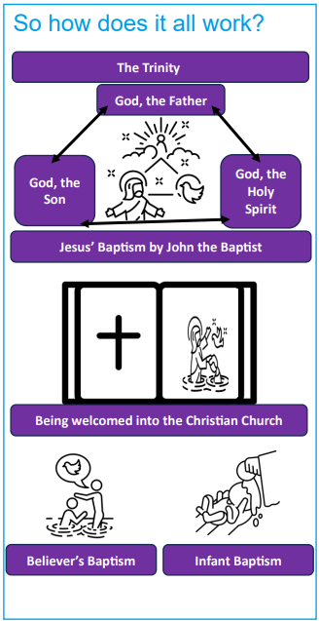 | Vocabulary
 | 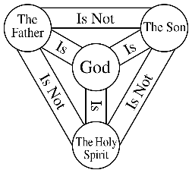 | Trinity | The Christian belief that God is the Father, Son (Jesus) and Holy Spirit; three in one  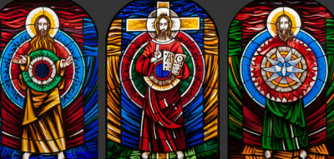
 | 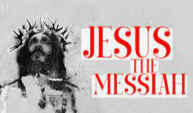 | Messiah | a saviour from God (Jesus), promised in the Hebrew texts
 | 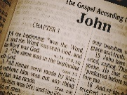 | Scripture | the title given to the writings of Christianity, the Bible
 | 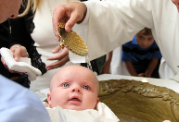 | Baptism | a ceremony that welcomes a young person or adult into the Christian Church.  (Infant Baptism- a baby)
 | 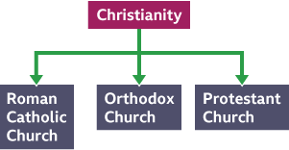 | Denomination | a branch of the Christian church
 | 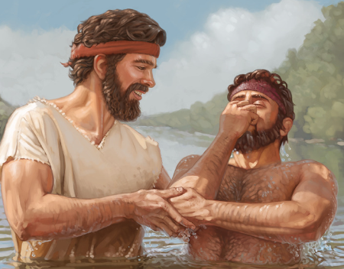 | John the Baptist | Jesus’ cousin, a prophet who foretold the coming Messiah and who baptised people in readiness for this.

