Year 3 What is it like for someone to follow God?

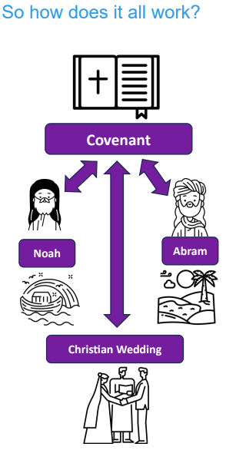 | Vocabulary
 | 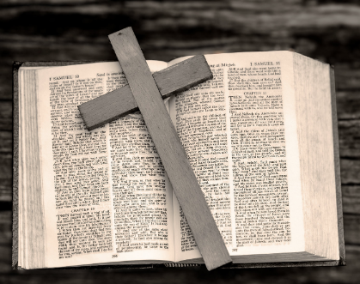 | Christians | religious people who believe Jesus is the Son of God who came to save them
 | 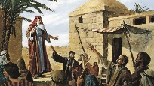 | Prophets | messengers sent from God
 | 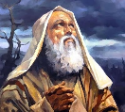 | Abram | the prophet who made a covenant with God. Later called Abraham
 | 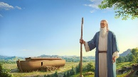 | Noah | the prophet who was told to build an Ark by God and who made a covenant with God
 |  | Wedding | ceremony when a couple make promises to be married and promises to God
 | 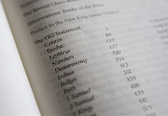 | Old Testament | the first 39 books of the Bible which tell about Creation and God’s covenant with his people
 |  | Promise | when you say you will do something
 |  | Righteous | something that is good with God
 |  | Covenant | a promise made between God and prophet Abraham, for the people

