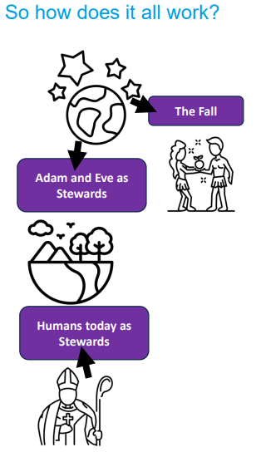 | Vocabulary
 | 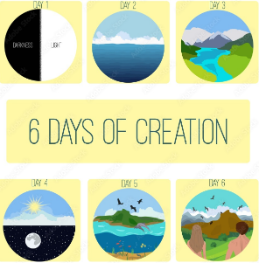 | Creation | The beginning of the world and everything in it a
 | 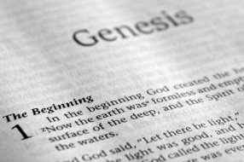 | Genesis | the first book in the Old Testament which contains the story of Creation and The Fall
 | 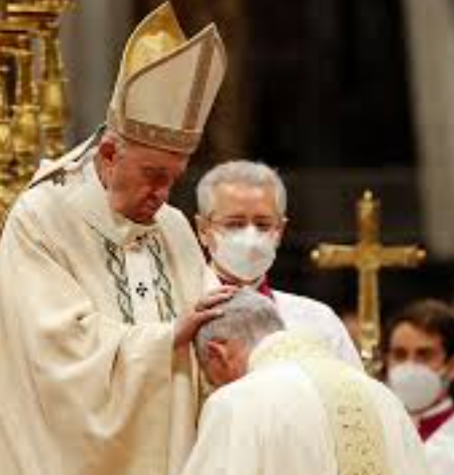 | Catholic | Christian denomination whose leader is called the Pope
 |  | Fall | when Adam and Eve sinned against God and fell from being close to God
 |  | Temptation | the feeling of wanting/having to do something you know you should not
 |  | Sin | to do something that goes against God’s law or an act which is against God’s law
 |  | Responsibility | a moral need to take care of something
 |  | Steward | a person who looks after something, in Christianity looking after God’s good earth

