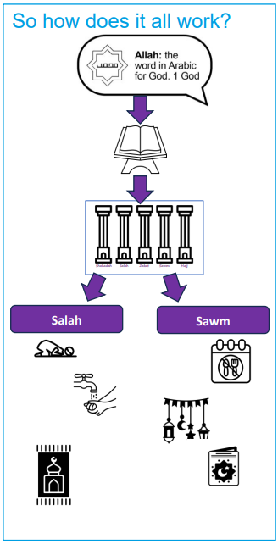 | Vocabulary
 |  | Prophet | a messenger sent from Allah
 |  | Muhammad | the Prophet who received Allah’s message to the world.
 |  | Allah | God
 |  | Fasting | giving up food and drink for a religious observance
 | 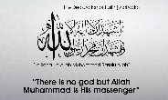 | Shahadah | The Muslim declaration of faith. It includes the beliefs that Allah is the only God, and that Muhammad is Allah’s messenger.
 | 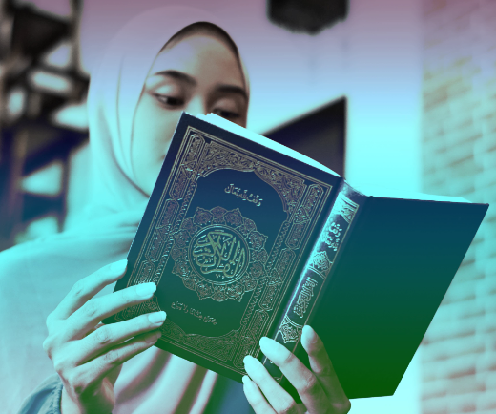 | Qur’an | the Muslim holy book, for Muslims the final revelation from Allah
 | 

