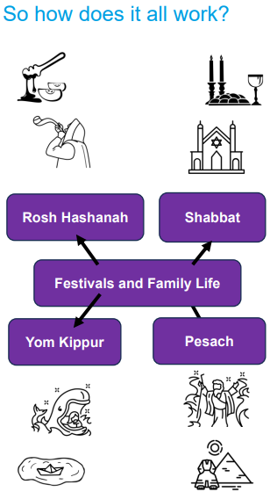 | Vocabulary
 | 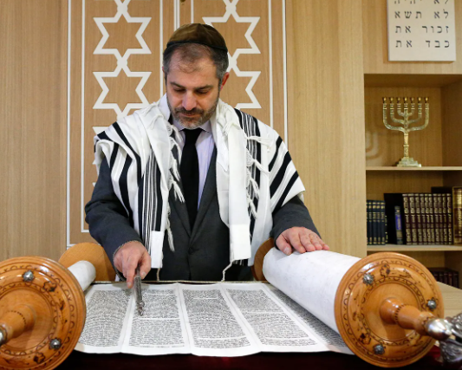 | Torah | the Jewish holy book made up of the five books of Law
 |  | Orthodox | a group of Jewish people who follow the Torah without changing it as it is given by God
 | 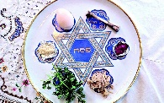 | Pesach | called Passover in English, a time when Jewish people remember their escape from slavery in Egypt
 | 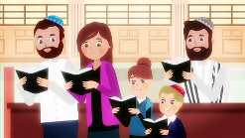 | Yom Kippur | the Day of Atonement (to ask for forgiveness for our sins)
 | 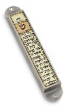 | Shema | a Jewish prayer, usually found in a Mezuzah (a case)
 |  | Shabbat | a day of rest for Jewish people, the seventh day of the week
 | 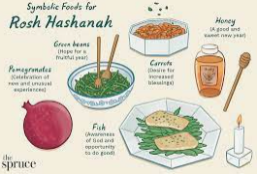 | Rosh Hashanah | literally means ‘Head of the Year’ and marks a new year in Judaism
 |  | Freedom | not being in prison or in slavery, being able to do what you want
 |  | Forgiveness | when someone is stopped being blamed or punished for something they have done

