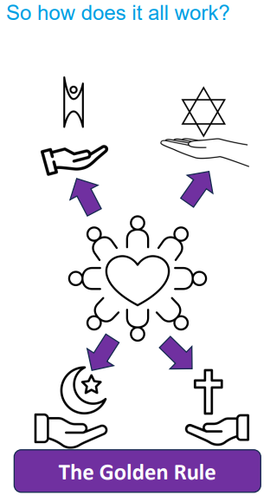 | Vocabulary
 | 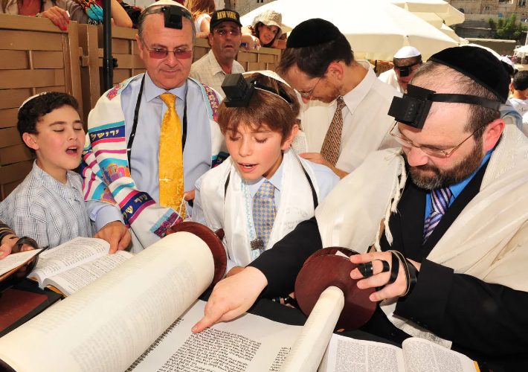 | Jewish | anything that is part of, or someone who follows Judaism
 | 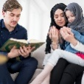 | Muslim | a person who submits to the will of Allah by following the religion of Islam
 | 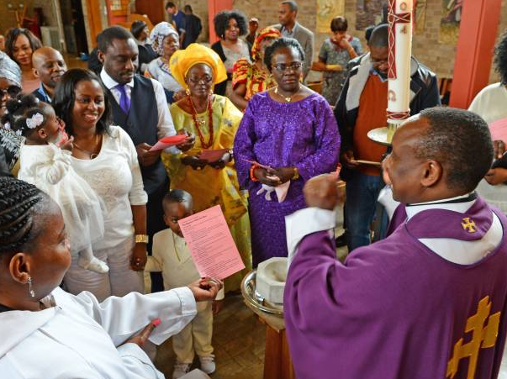 | Christian | anything that is part of, or someone who follows Christianity.
 | 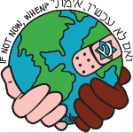 | Tikkun Olam | in Judaism it is any activity that repairs the world
 | 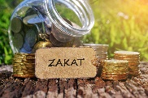 | Zakat | giving of charity usually 2.5% of income, this is the 2nd Pillar of Islam
 | 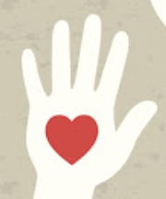 | Steward/  Stewardship | The act of looking after or caring for something (sometimes for someone else)
 | 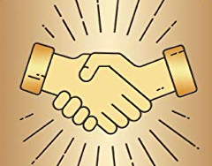 | Golden Rule | a belief that everyone should treat each other how they would like to be treated.
 | 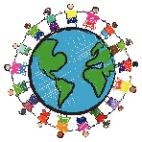 | Humanist | a person who does not believe in a god. They believe it is possible to live a good and fulfilling life without following a traditional religion
 | 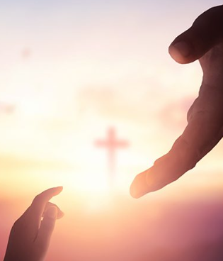 | Salvation | being saved or rescued so that humans are no longer separated from God

