
Year 2
What is the ‘good news’ that Christians say Jesus brings? Part 1
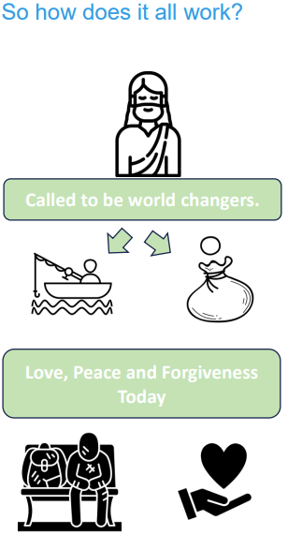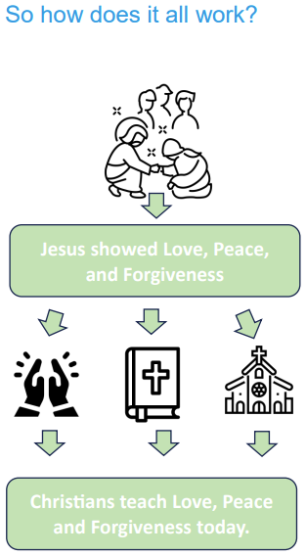 | Vocabulary
 |  | Christians | people who follow Christianity and believe Jesus is the Saviour who healed the rift between humanity and God
 |  | Jesus | a very important person for Christians; God in the flesh
 | 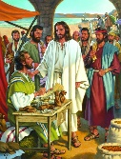 | Matthew | a tax collector who Jesus called to follow him and who left his job as a tax collector a follower of Jesus
 | 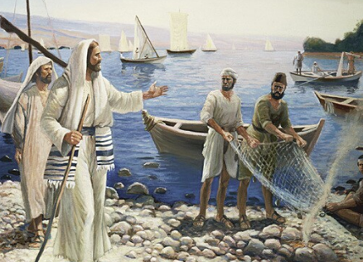 | fishermen | people who earn a living through fishing
 | 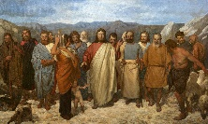 | disciple | A follower of Jesus
 |  | peace | freedom from conflict
 |  | forgiveness | when someone is stopped being blamed or punished for something they have done
 | 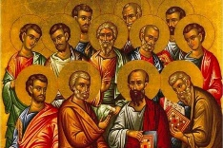 | apostles | the twelve followers of Jesus who became ‘messengers of God’

