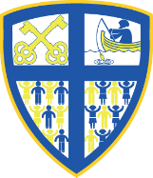
Year 1
Why does Christmas matter to Christians?

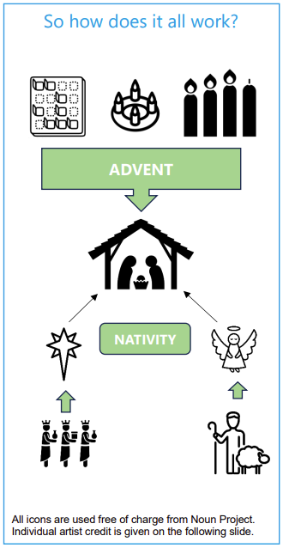 | Vocabulary
 | 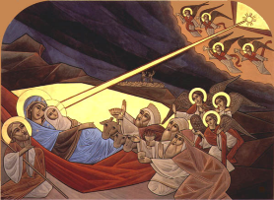 | incarnation | Christians believe Jesus is God ‘in the flesh’
 | 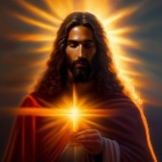 | Jesus | The second person of the Trinity or the Son
 | 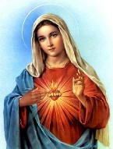 | Mary | the mother of Jesus
 | 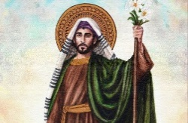 | Joseph | the husband of Mary
 | 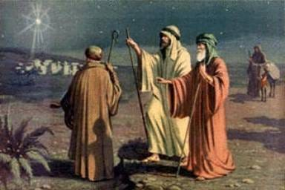 | shepherds | the first people to visit Jesus after he was born
 | 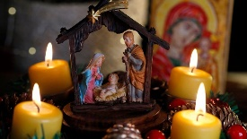 | Advent | the four Sundays leading up to Christmas
 | 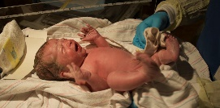 | birth | the arrival of a baby into the world

