Pupil premium strategy statement 2024-2025

This statement details our school’s use of pupil premium funding to help improve the attainment of our disadvantaged pupils.

It outlines our pupil premium strategy, how we intend to spend the funding in this academic year and the effect that last year’s spending of pupil premium had within our school.

School overview
Detail
School name | St Michael’s Church of England Primary school
Number of pupils in school | 30
Proportion (%) of pupil premium eligible pupils | £62,012
Academic year/years that our current pupil premium strategy plan covers | 2024-2025  This document also contains a review of the previous strategy from 2023-2024.
Date this statement was published | September 2024
Date on which it will be reviewed | September 2025
Statement authorised by | Fiona Quinlivan
Pupil premium lead | Fiona Quinlivan
Governor / Trustee lead | Debra Wailes
Funding overview
Detail | Amount
Pupil premium funding allocation this academic year
Pupil premium funding carried forward from previous years (enter £0 if not applicable) | £0.00
Total budget for this academic year
If your school is an academy in a trust that pools this funding, state the amount available to your school this academic year

Part A: Pupil premium strategy plan

Statement of intent
Our philosophy
We believe in maximising the use of the pupil premium grant (PPG) by utilising a long-term strategy aligned to the school improvement plan. This enables us to implement a blend of short, medium, and long-term interventions, and align pupil premium use with wider school improvements and improving readiness to learn.
Overcoming barriers to learning is at the heart of our PPG use. We understand that needs and costs will differ depending on the barriers to learning being addressed. As such, we do not automatically allocate personal budgets per pupil in receipt of the PPG. Instead, we identify the barrier to be addressed and the interventions required, whether in small groups, large groups, the whole school or as individuals, and allocate a budget accordingly. All interventions are based on research and evidence of best practice using the EEF guidelines.
A St Michael’s each child is supported as an individual so that support is often bespoke to the child. All children are supported to be the very best that they can be in all aspects of their education.
Our priorities
Setting priorities is key to maximising the use of the PPG. Our priorities are as follows:
- Ensuring quality first teaching in every class
- Closing the attainment gap between disadvantaged pupils and their peers
- Providing targeted academic support for pupils who are not making the expected progress
- Addressing non-academic barriers to attainment such as attendance, behaviour self-esteem and confidence
- Supporting Parents to work as effective partners
Our tiered approach
To prioritise spending, we have adopted a tiered approach to define our priorities and ensure balance. Our tiered approach comprises three categories:
- Teaching
- Targeted academic support.
- Wider strategies
Within each category, we have chosen interventions. This focussed approach ensures the best chance of success for each intervention.
Our review processes.
During whole school self-evaluation, priorities for school improvement are identified and the School Development Plan (SDP) is written.
The plan includes actions to improve the outcomes of pupils.
Barriers to learning for Disadvantaged pupils are identified.
The Pupil Premium Plan is written and approved by Governors.
Interventions and actions are put into place.
Individual targets are set for each pupil in receipt of the PPG and their progress towards achieving these targets is analysed each term.
The progress of pupils in receipt of the PPG is regularly discussed with subject teachers both informally and formally at Progress Meetings. Progress meetings follow assessments each term and provision maps are created for each class.
The Pupil Premium Strategy will be reviewed annually, and a new strategy will be created considering the lessons learned during the execution of the previous strategy, and with regard to any new guidance and evidence of best practice that becomes available. The Headteacher and PPG Governor is responsible for ensuring a pupil premium strategy is effective.

Challenges

This details the key challenges to achievement that we have identified among our disadvantaged pupils.
Challenge number | Detail of challenge
1 | Some children have limited / no parental support for homework, reading or academic study. As a result of limited reading support, children are often behind their peers and do not have access to high quality reading material and engagement to develop their vocabulary.
2 | Not all parents engage fully with school to support their child’s learning, this sometimes means that children are not prepared for school.
3 | Some PPG children have social and emotional needs requiring additional pastoral care and guidance. This can also include family difficulties and stability at home.
4 | Attendance and lateness have caused a significant loss of learning time for some pupils.
5 | Not all PPG boys reach their full academic potential.
6 | Some PPG children have limited experiences in which to draw upon to support their learning. This also limits their understanding of the possibilities for their future.
7 | There is some correlation with children who are PPG and SEND in school, including having and EHCP or needing one to one support. This means that some children are even more challenged due to multiple needs.
8 | Progress and attainment data in 2024 shows that some PPG children achieve less well than their peers. Some PPG children, especially boys and pupils who are also SEND make slower progress than their peers.

Intended outcomes
This explains the outcomes we are aiming for by the end of our current strategy plan, and how we will measure whether they have been achieved.
Intended outcome | Success criteria
Improve the outcomes for PPG children in reading, writing and mathematics. | Progress of PPG children by the end of Key Stage 2 compares favourably with other pupils nationally including those that are more able.  Boys will make strong progress from their starting points.  The progress of SEND coupled with PPG boys will be measured carefully and the provision will meet the needs of individuals showing progress from their starting points.  All teaching is at least good across the school.  Pupils have access to a range of reading materials in school and can take reading materials home.  Pupils have access reading support though interventions in a group or one to one.  Pupils received targeted and timely feedback in lessons.  Teachers do everything they can to reduce the barriers that pupils face, including additional support for homework and reading.  PPG children who are falling behind their peers receive intervention from Teachers.  Children are prioritised for one to one or guided reading support by teachers and teaching assistants.  Children have opportunities to enhance their learning through visits, experiences that are built into the curriculum.
PPG pupils are supported emotionally in school. | The use of a counsellor has a positive contribution to the wellbeing of pupils, their self-confidence and readiness to learn. The school prioritises children who are PPG for this support.  The Learning Mentor provides timely support through individual and small group interventions to ensure that children are supported, attend school and are confident.  Children know that they have someone that they can talk to in the setting if they are experiencing difficulties.  Class teachers are aware of the individual needs of PPG pupils and provide additional support where needed.
Attendance of the group of PPG/FSM children improves and the difference diminishes between this group and others. Punctuality also improves so that the children are not missing learning | Increase the % attendance for FSM and PPG pupils.  Attendance to be in line or improving with that of non-PPG pupils
Provide emotional and social support for PPG children and their family to enable families and children have access to support outside the school setting e.g., Start Well. | Parents feel supported and gain access to support if needed.  Pupils gain support to be able to support their child’s learning at home with reading and homework.  Children are more prepared for school and the school have effective engagement with parents.  Parental engagement will improve over time.

Activity in this academic year
This details how we intend to spend our pupil premium (and recovery premium funding) this academic year to address the challenges listed above.

Teaching (for example, CPD, recruitment and retention)
Activity | Evidence that supports this approach | Challenge number(s) addressed
High quality first teaching for all pupils | The best available evidence indicates that great teaching is the most important lever schools have to improve pupil attainment. Ensuring every teacher is supported in delivering high-quality teaching is essential to achieve the best outcomes for all pupils, particularly the most disadvantaged amount them EEF Tiered approach | 5,7.8
Promote high engagement in lessons for all children and reduce scaffolding to develop independence | The impact of collaborative approaches on learning is consistently positive, with pupils making an additional 5 months’ progress, on average, over the course of an academic year. | 5,6,8
Pupils received targeted and timely feedback in lessons. Children become more independent and show higher levels of engagement. They know what they need to improve and how to get better. | Meta-cognition and feedback to pupils  Metacognition and self-regulation approaches have consistently high levels of impact, with pupils making an average of seven months’ additional progress | 5,7,8
Children have opportunities to enhance their learning through visits, experiences that are built into the curriculum. Teachers to ensure that children do not miss out on experiences due to any financial costs | Studies of adventure learning interventions consistently show positive benefits on academic learning. On average, pupils who participate in adventure learning interventions make approximately four additional months’ progress. Arts participation- Improved outcomes have been identified in English, Mathematics, and Science learning-EEF +2months. The choices that schools make in allocating the money will be vital, so that the money can help raise children’s attainment and aspirations-Sutton Trust | 6

Targeted academic support (for example, tutoring, one-to-one support structured interventions)
Activity | Evidence that supports this approach | Challenge number(s) addressed
Reading is a high priority for all pupils but especially PPG children and Children who are PPG/ Boys and SEND  Pupils will receive one to one reading/ guided reading where needed to ensure that they are making good progress.  Pupils will receive high quality phonics to enable them to make strong progress- individuals and groups targeted for support | On average, reading comprehension approaches deliver an additional six months’ progress. Successful reading comprehension approaches allow activities to be carefully tailored to pupils’ reading capabilities, and involve activities and texts that provide an effective, but not overwhelming, challenge  The evidence base related to phonics is very secure. There have been a number of studies, reviews and meta-analyses that have consistently found that the systematic teaching of phonics is beneficial-EEF | 1,5,8
One to one or small group interventions will be used effectively to accelerate pupils learning.  Intervention will focus on the area of need for pupils | Evidence indicates that one to one tuition can be effective, delivering approximately five addition months progress on average | 5,7,8

Wider strategies (for example, related to attendance, behaviour, wellbeing)
Activity | Evidence that supports this approach | Challenge number(s) addressed
To ensure attendance is in line or exceeding national expectations.  Pupils with persistent absence improves rapidly  Weekly Attendance Meetings with HT and Learning Mentor  Employment of additional sessions with the attendance officer through the Wigan Education authority. School will get 3 free visits and has purchased an extra 10 sessions throughout the year.  Parent meetings and letters.  Support plans to support good attendance and provide family support.  Early Help Meetings  Awards for attendance  Clear communication with parents regarding the importance of attendance and punctuality. | In ‘Supporting the attainment of disadvantaged pupils; Articulating success and good practice’ the authors discuss the importance of robust attendance data tracking and monitoring systems in schools, to address attendance issues. This allows patterns of absence to be scrutinised and then targeted interventions to be put in place.  Parental engagement and improved attendance will result in. Children feeling more included in the life of their school and will experience academic and social success.  Incentives to parents and children shown to increase attendance. | 4
To continue to support pupils emotionally.  Pastoral Support/Interventions  Use of a counsellor to provide support to pupils.  Learning mentor to provide support to individuals or groups of pupils needing support.  Learning mentor to provide support to parents to need support.  Class teacher to work with parents to support pupils emotionally and to support parents to provide academic support at home.  SENDCO to use the services of the CAMHS link worker to provide timely support and refer children to main CAMHS if needed. | On average, SEL interventions have an identifiable and significant impact on attitudes to learning, social relationships in school, and attainment itself EEF +4mths  Two recent meta-analyses from the USA suggested that increasing parental involvement in primary and secondary schools had on average 2-3 months positive impact-EEF | 3

Part B: Review of outcomes in the previous academic year

Pupil premium strategy outcomes
This details the impact that our pupil premium activity had on pupils in the 2021 to 2022 academic year.
EYFS
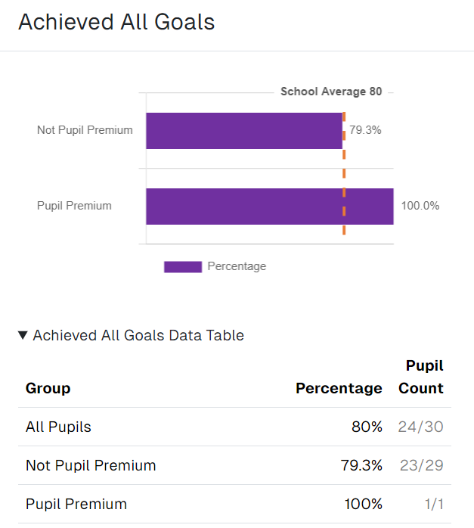
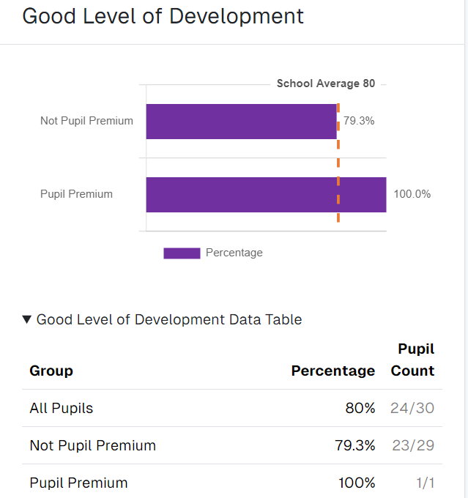

This data shows that the Pupil Premium Pupil achieved a Good Level of Development.

Reading and Phonics
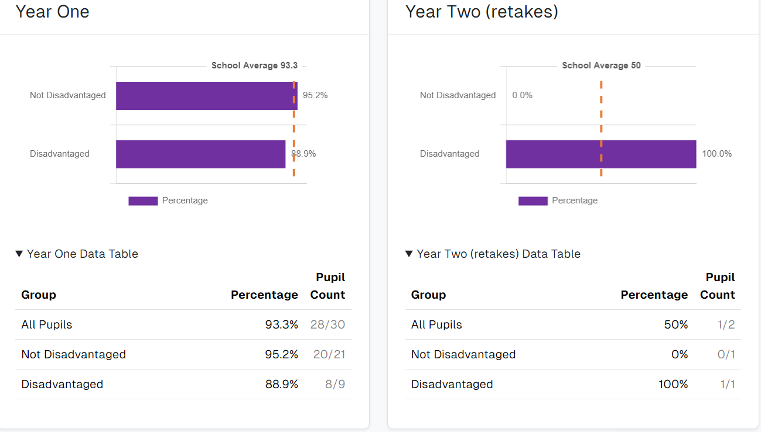
Lesson observations show that the quality of phonics teaching in EYFS and KS1 is consistently strong. Additional whole class phonic sessions were provided as well as group and individual intervention.

Phonics scores for PPG children show.
Year 1 9 8/9 children who were PPG reached the expected level in June 2024
Year 2 1 1/1 Children who did not pass the check in Year 1 reached the expected level in June 2024

Key Stage 1
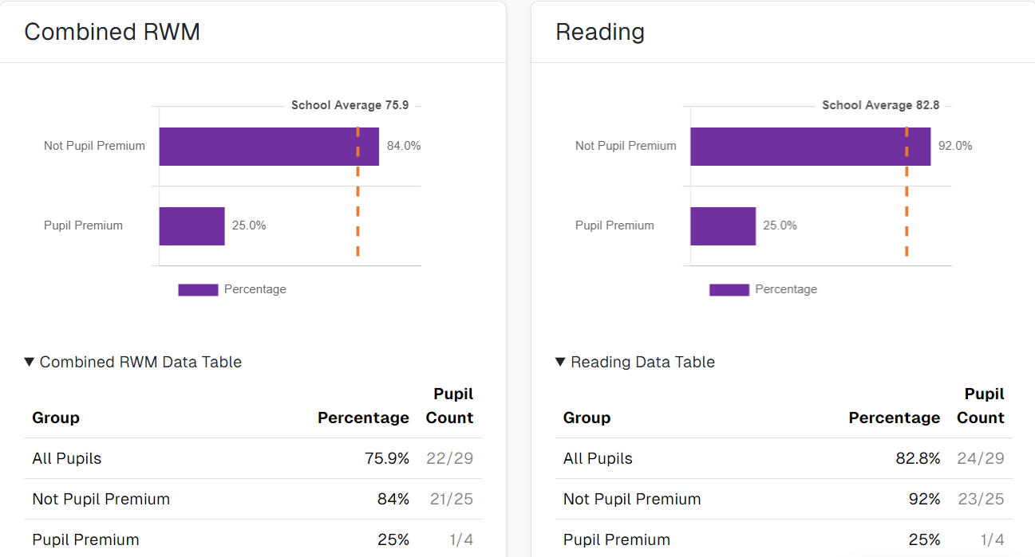

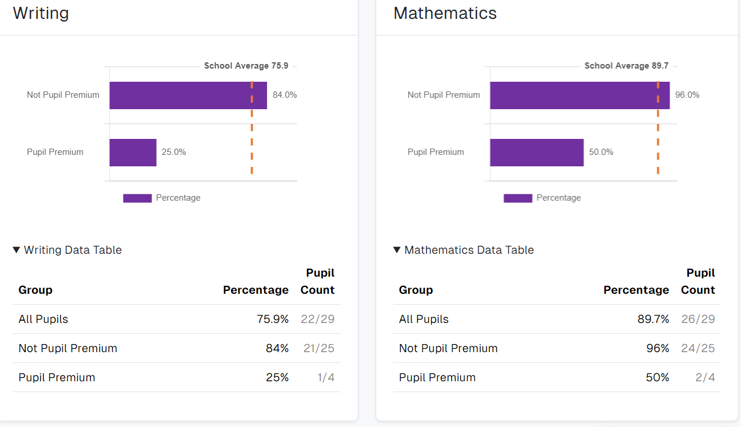

Please note that some children who are PPG are SEND.
Number of Pupils who are SEND and PPG in the cohort – three children out of the four are SEND with one pupil with an EHCP.

Multiplication check
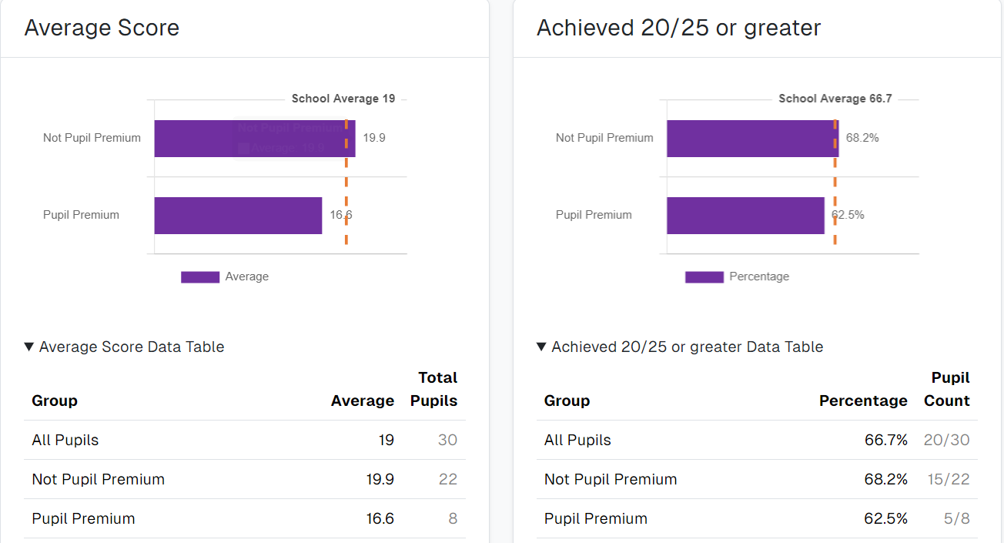

KS2
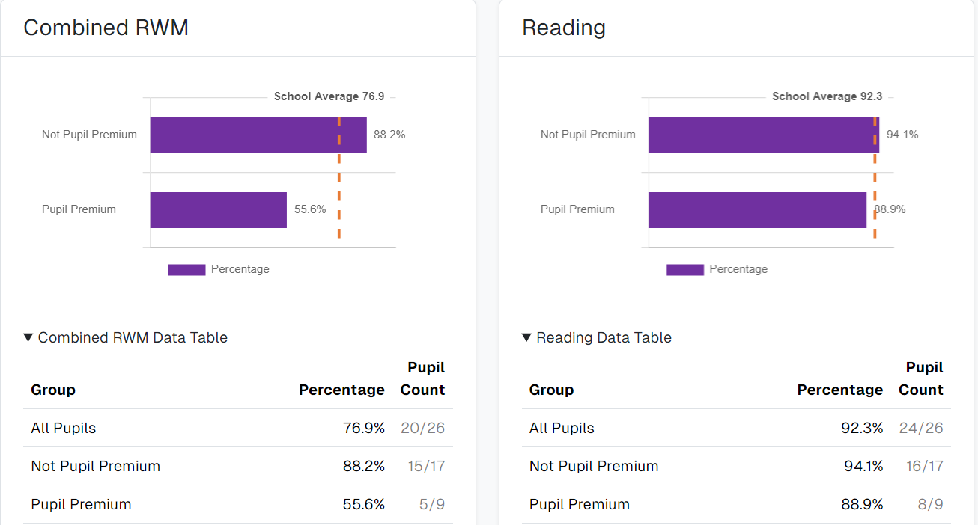
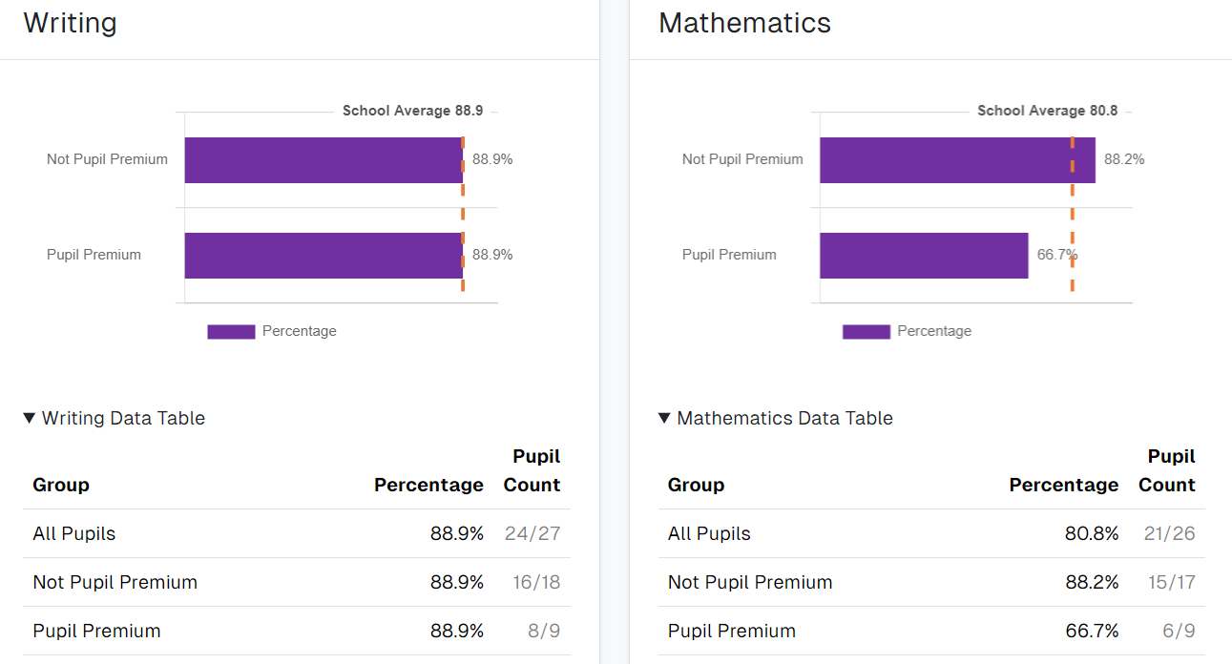
Number of Pupils who are SEND and PPG in the cohort 1.
Number of Pupils who joined in Year 6 in the cohort 1.

Reading Attainment
Reception 1/1 children reached Age related expectations.
Year 1 6/9 children reached Age related expectations.
Year 2 1/4 children reached Age related expectations.
Year 3 3/4 children reached Age related expectations.
Year 4 5/8 children reached Age related expectations.
Year 5 1/2 children reached Age related expectations.
Year 6 8/9 children reached Age related expectations.

Writing
Reception 1/1 children reached ARE.
Year 1 6/9 children reached Age related expectations.
Year 2 1/4 children reached Age related expectations.
Year 3 3/4 children reached Age related expectations.
Year 4 5/8 children reached Age related expectations.
Year 5 0/2 children reached Age related expectations.
Year 6 8/9 children reached Age related expectations.

Mathematics
Reception 1/1 children reached Age related expectations.
Year 1 6/9 children reached Age related expectations.
Year 2 2/4 children reached Age related expectations.
Year 3 1/4 children reached Age related expectations.
Year 4 5/8 children reached Age related expectations.
Year 5 1/2 children reached Age related expectations.
Year 6 6/9 children reached Age related expectations.

Attendance
The school worked closely with the attendance officer, audited systems and developed an action plan. Systems are more robust and ensure that the school reacts quicker to concerns. The attendance of FSM children and PPG is still a concern. There are a small number of individual pupils having a big impact upon attendance figures.
2021 2022 2023 2024
FSM 93.87% FSM 91.41% FSM 92.96% FSM 90.91%
PPG 94.65% PPG 92.35% PPG 93.23% PPG 92.21%
Pastorally the children who accessed friendship group and counselling made good gains in confidence, self-esteem, and ability to express themselves. Gains were also seen in their behaviour in class and their ability to regulate their behaviour and emotions.

Externally provided programmes
Please include the names of any non-DfE programmes that you purchased in the previous academic year. This will help the Department for Education identify which ones are popular in England

Service pupil premium funding (optional)
For schools that receive this funding, you may wish to provide the following information:
Measure | Details
How did you spend your service pupil premium allocation last academic year? | Providing support through a learning mentor  Providing support through our counselling service.
What was the impact of that spending on service pupil premium eligible pupils? | Service pupils are making strong progress

