Pupil premium strategy statement – St Michael’s CE Primary School
Before completing this template, read the Education Endowment Foundation’s guide to the pupil premium and DfE’s pupil premium guidance for school leaders, which includes the ‘menu of approaches’. It is for school leaders to decide what activity to spend their pupil premium on, within the framework set out by the menu.
All schools that receive pupil premium are required to use this template to complete and publish a pupil premium statement on their school website by 31 December every academic year.
If you are starting a new pupil premium strategy plan, use this blank template. If you are continuing a strategy plan from last academic year, you may prefer to edit your existing statement, if that version was published using the template.

Before publishing your completed statement, delete the instructions (text in italics) in this template, and this text box.

This statement details our school’s use of pupil premium funding to help improve the attainment of our disadvantaged pupils.
It outlines our pupil premium strategy, how we intend to spend the funding in this academic year and the outcomes for disadvantaged pupils last academic year.

School overview
Detail | Data
Number of pupils in school | 210
Proportion (%) of pupil premium eligible pupils | 20.5% (43 pupils)
Academic year/years that our current pupil premium strategy plan covers (3-year plans are recommended – you must still publish an updated statement each academic year) | 2025-2026
Date this statement was published | September 2025
Date on which it will be reviewed | September 2026
Statement authorised by | Sarah Dring
Pupil premium lead | Sarah Dring
Governor / Trustee lead | Debra Wailes

Funding overview
Detail | Amount
Pupil premium funding allocation this academic year | £55,050
Pupil premium funding carried forward from previous years (enter £0 if not applicable) | £0
Total budget for this academic year  If your school is an academy in a trust that pools this funding, state the amount available to your school this academic year | N/A

Part A: Pupil premium strategy plan

Statement of intent
At St Michael’s, we are committed to ensuring that every child, regardless of background, has the opportunity to thrive and achieve their full potential. The Pupil Premium Grant (PPG) is a vital resource that we use strategically to remove barriers to learning and to support pupils in developing the knowledge, skills, and confidence they need to succeed in school and beyond.
Our approach is rooted in a long-term vision, carefully aligned with our School Development Plan. By combining short, medium, and long-term interventions, we ensure that the PPG is used not only to close gaps but also to strengthen wider school improvement and readiness to learn.
We recognise that disadvantage can take many forms, and that the needs of pupils vary. Therefore, we do not allocate fixed amounts of funding per pupil. Instead, we assess barriers to learning—whether academic, social, emotional, or practical—and match resources to need. This may involve individualised support, small-group work, whole-class approaches, or whole-school initiatives. All decisions are informed by research, evidence of best practice, and the guidance of the Education Endowment Foundation (EEF).
At St Michael’s, every child is valued and supported as an individual. Our aim is to provide tailored support so that all pupils, especially those in receipt of PPG, are equipped to flourish academically, socially, and emotionally, and to be the very best version of themselves.
The IDSR shows that the proportion of pupils eligible for FSM6 (17.6%) is below the national average, and that pupils with SEND are broadly in line with national figures. This reinforces our commitment to personalised provision, ensuring the needs of disadvantaged pupils are carefully identified through regular review.
Attendance nationally remains lower post-pandemic, and our IDSR identifies attendance as ‘close to average’ but with a relative decline compared to the previous year. Our strategy therefore places strong emphasis on improving attendance for disadvantaged pupils to remove barriers to learning.
Our Priorities
To maximise the impact of the PPG, we have identified the following priorities:
- Delivering high-quality teaching in every classroom
- Narrowing the attainment gap between disadvantaged pupils and their peers
- Providing targeted academic support where progress is not yet secure
- Addressing wider barriers to learning, including attendance, behaviour, well-being, and self-confidence
- Strengthening partnerships with parents and carers to support learning at home and in school
Our Tiered Approach
We continue to adopt a tiered model of provision to ensure a balanced and evidence-informed strategy:
- High-quality teaching – the foundation of progress for all pupils
- Targeted academic support – personalised interventions to accelerate learning
- Wider strategies – tackling non-academic barriers and promoting well-being and engagement
This structure enables us to focus resources where they will have the most impact while ensuring that no pupil is left behind.
Monitoring and Review
Our pupil premium strategy is embedded in the school’s cycle of self-evaluation and development planning. Barriers to learning are regularly reviewed, and priorities are updated in response to emerging needs and evidence. Progress is tracked termly through assessments, provision maps, and progress meetings with teachers, where outcomes for disadvantaged pupils are a central focus.
The Pupil Premium Strategy is evaluated annually and refined in light of outcomes, evidence of impact, and updated national guidance. The Headteacher and Pupil Premium Governor are responsible for ensuring the strategy remains ambitious, rigorous, and effective in driving improvement.

Challenges
This details the key challenges to achievement that we have identified among our disadvantaged pupils.
Challenge number | Detail of challenge
1 | Some children have limited / no parental support for homework, reading or academic study. As a result of limited reading support, children are often behind their peers and do not have access to high quality reading material and engagement to develop their vocabulary.
2 | Not all parents engage fully with school to support their child’s learning, this sometimes means that children are not prepared for school.
3 | Some PPG children have social and emotional needs requiring additional pastoral care and guidance. This can also include family difficulties and stability at home.
4 | Attendance and lateness have caused a significant loss of learning time for some pupils. The IDSR identifies whole-school attendance as close to the national average (91% compared to 92%) and highlights a downward trend, making attendance a continued priority for disadvantaged pupils.
5 | Not all PPG boys reach their full academic potential. IDSR progress trends at Key Stage 2 show broadly average progress, but internal monitoring confirms that disadvantaged boys, particularly those with SEND, continue to need targeted support to meet age-related expectations.
6 | Some PPG children have limited experiences in which to draw upon to support their learning. This also limits their understanding of the possibilities for their future.
7 | There is some correlation with children who are PPG and SEND in school, including having and EHCP or needing one to one support. This means that some children are even more challenged due to multiple needs.(30% of our PPG children are SEND, 9.5% have an EHCP)
8 | Progress and attainment data in 2025 shows that some PPG children achieve less well than their peers (Particularly in Reading & Maths) IDSR multi-year analysis does not identify any statistically significant declines; however, outcomes for disadvantaged pupils still lag behind their peers in reading and mathematics, confirming the need for sustained targeted intervention.

Intended outcomes
This explains the outcomes we are aiming for by the end of our current strategy plan, and how we will measure whether they have been achieved.
Intended outcome | Success criteria
Improve the outcomes for PPG children in reading, mathematics and writing. | Progress of PPG children by the end of Key Stage 2 compares favourably with other pupils nationally including those that are more able.  Boys will make strong progress from their starting points.  The progress of SEND coupled with PPG boys will be measured carefully and the provision will meet the needs of individuals showing progress from their starting points.  All teaching is at least good across the school.  Pupils have access to a range of reading materials in school and can take reading materials home.  Pupils have access reading support though interventions in a group or one to one.  Pupils received targeted and timely feedback in lessons.  Teachers do everything they can to reduce the barriers that pupils face, including additional support for homework and reading.  PPG children who are falling behind their peers receive intervention from Teachers.  Children are prioritised for one to one or guided reading support by teachers and teaching assistants.  Children have opportunities to enhance their learning through visits, experiences that are built into the curriculum.  IDSR reading and maths outcomes remain broadly average but show no significant upward trends. Success will be measured through internal tracking showing accelerated progress for PPG pupils, particularly boys and pupils with SEND.
PPG pupils are supported emotionally in school. | The use of a counsellor has a positive contribution to the wellbeing of pupils, their self-confidence and readiness to learn. The school prioritises children who are PPG for this support.  The Learning Mentor provides timely support through individual and small group interventions to ensure that children are supported, attend school and are confident.  Children know that they have someone that they can talk to in the setting if they are experiencing difficulties.  Class teachers are aware of the individual needs of PPG pupils and provide additional support where needed.
Attendance of the group of PPG/FSM children improves and the difference diminishes between this group and others. Punctuality also improves so that the children are not missing learning.  IDSR attendance data (91%) and the identified relative decline will be used as a baseline for targeted attendance improvement strategies for 2025–26. | Increase the % attendance for FSM and PPG pupils.  Attendance to be in line or improving with that of non-PPG pupils
Provide emotional and social support for PPG children and their family to enable families and children have access to support outside the school setting e.g., Start Well. | Parents feel supported and gain access to support if needed.  Pupils gain support to be able to support their child’s learning at home with reading and homework.  Children are more prepared for school and the school have effective engagement with parents.  Parental engagement will improve over time.

Activity in this academic year
This details how we intend to spend our pupil premium funding this academic year to address the challenges listed above.

Teaching (for example, CPD, recruitment and retention)
Budgeted cost: £ 5000
Activity | Evidence that supports this approach | Challenge number(s) addressed
Prioritising reading through daily guided reading and one-to-one reading sessions, with additional focus on PPG pupils, boys, and those with SEND. | EEF: Reading comprehension strategies and one-to-one reading improve attainment, especially for disadvantaged pupils  Ofsted Reading Framework (2021) highlights structured approaches and access to high-quality texts as essential for closing gaps. NFER (2015) found reading support programmes accelerate vocabulary and comprehension for disadvantaged pupils.  IDSR strengths in EYFS expressive arts and communication highlight the strong starting point for early reading. Targeted support will ensure disadvantaged pupils continue progressing into KS1 and KS2. | 1, 5, 7, 8
High-quality phonics teaching with targeted support for individuals and groups to secure progress | EEF: Phonics has a high impact on pupil progress, particularly for disadvantaged learners.  The Rose Review (2006) and Ofsted (2021) evidence that systematic synthetic phonics underpins early reading success. DfE (2021) requires schools to use validated SSP programmes. | 1, 7, 8
Increase TA support in Year 1 and Reception to provide additional targeted support for early reading, phonics, and language development, as well as supporting learning through play and early intervention. | EEF: Early years interventions have a positive impact (+5 months) on pupil progress.  EEF: Use of trained teaching assistants in targeted interventions is effective in accelerating learning.  High-quality adult interaction in early years supports language acquisition, communication skills, and readiness for learning. | 1, 5, 6, 7, 8
Ongoing professional development for teachers to strengthen quality first teaching and ensure consistency across the school. | EEF: Improving teacher subject knowledge and pedagogy has the strongest long-term impact on pupil outcomes  Sutton Trust (2011) shows the quality of teaching has the greatest impact on disadvantaged pupils. DfE Standards for Teachers’ Professional Development (2016) highlight sustained CPD as most effective. Ofsted subject reviews (2022) emphasise strong teacher subject knowledge in improving outcomes. | 1, 2, 5, 7, 8

Targeted academic support (for example, tutoring, one-to-one support, structured interventions)
Budgeted cost: £28,930
Activity | Evidence that supports this approach | Challenge number(s) addressed
One-to-one and small group interventions tailored to pupils’ learning gaps | EEF: One-to-one tuition and small group support accelerate progress when linked to class teaching  NFER (2015) found targeted support linked to class teaching narrows attainment gaps. Ofsted (2022) stress diagnostic assessment to target interventions effectively.  IDSR confirms that progress measures are broadly in line with national averages; however, internal tracking shows the need for accelerated progress for disadvantaged pupils to narrow gaps. | 7, 8
Bespoke interventions in Reading and Maths to close attainment gaps | EEF: Targeted academic support is most effective when based on assessment and need  Ofsted Maths and English subject reviews (2021–22) highlight that precise, evidence-based interventions accelerate progress. NFER (2020) showed structured catch-up interventions post-COVID reduced disadvantage gaps. | 3, 5, 7
 | EEF: Structured interventions for pupils with SEND support access to the curriculum and accelerate progress.  Ofsted SEND Review (2021) highlights inclusive practice and personalised support as key. NFER (2022) found targeted SEND support reduces the risk of underachievement. DfE SEND Code of Practice (2015) stresses tailored support for pupils with multiple needs.  IDSR SEND proportions align with national patterns, supporting our prioritisation of tailored interventions for disadvantaged children with additional needs. | 1, 2, 3
  Personalised intervention sessions for pupils with SEND and multiple needs
Learning Mentor provides targeted support for pupils with social, emotional, and behavioural needs through one-to-one and small group sessions.  Learning Mentor engages with parents to strengthen home–school partnerships and provide early support where needed.  Counsellor provides structured SEMH (social, emotional, and mental health) support for pupils with significant emotional needs.  Pastoral team monitors and addresses attendance and punctuality, working closely with families to reduce persistent absence and lateness. | EEF: Social and Emotional Learning approaches add +4 months progress on average when delivered consistently.  DfE – Mental Health and Behaviour in Schools (2018, updated 2021): Early SEMH intervention reduces barriers to engagement and supports positive behaviour.  Public Health England (2015): School-based counselling and mental health provision improves resilience, readiness to learn, and overall well-being.  Goodall & Vorhaus (2011): Strong parental engagement is linked to improved pupil outcomes.  DfE – Working Together to Improve Attendance (2022): Regular attendance is directly correlated with higher attainment; targeted family support improves persistence.  NFER (2020): Early intervention with persistent absence prevents long-term disadvantage and helps narrow the attainment gap.  Ofsted (2019) research: Effective attendance systems and family support lead to improved academic progress and reduced exclusions. | 2, 3, 4, 5, 6, 7

Wider strategies (for example, related to attendance, behaviour, wellbeing)
Budgeted cost: £ 21,120
Activity | Evidence that supports this approach | Challenge number(s) addressed
Deployment of a learning mentor to support pupils’ social, emotional, and behavioural needs | EEF: Social and emotional learning has a positive impact across academic and well-being outcomes.  DfE Mental Health and Behaviour in Schools (2018, updated 2021) highlights SEMH provision as critical. Public Health England (2015) reports that SEL programmes improve resilience and attainment. | 3, 5, 7
Learning mentor to engage and support parents in building effective home–school partnerships | EEF: Parental engagement can add up to 4 months’ progress for pupils. Goodall & Vorhaus (2011) highlight best practice in parent partnerships. NFER (2015) found structured parental support significantly improves outcomes for disadvantaged children.  Public Health England (2015) shows school-based counselling improves well-being and engagement. DfE guidance links SEMH support with improved attendance and attainment. NFER (2021) reported that access to trained counsellors reduces barriers to learning. | 1, 2, 3
Access to a school counsellor for pupils with emotional or mental health needs | DfE guidance: Emotional well-being is closely linked to improved academic outcomes | 3, 7
Pastoral support and interventions to improve attendance and punctuality | DfE: Strong attendance is directly linked to improved attainment and life chances. DfE Working Together to Improve School Attendance (2022) states improving attendance is key to raising attainment. NFER (2020) showed that addressing absence early prevents long-term disadvantage. Ofsted (2019) found schools with effective attendance strategies achieved stronger pupil progress.  IDSR highlights that overall attendance is close to average but shows a relative decline compared with previous years. This supports our continued investment in early intervention, learning mentor support, and targeted family engagement.  IDSR evidences positive behaviour indicators, with no exclusions and stable staffing. This provides a strong foundation for continuing to develop targeted SEMH support for disadvantaged pupils. | 2, 3, 4, 6

Total budgeted cost: £ 55,050

Part B: Review of the previous academic year

Outcomes for disadvantaged pupils
This details the impact that our pupil premium activity had on pupils in the 2024 to 2025 academic year.
EYFS
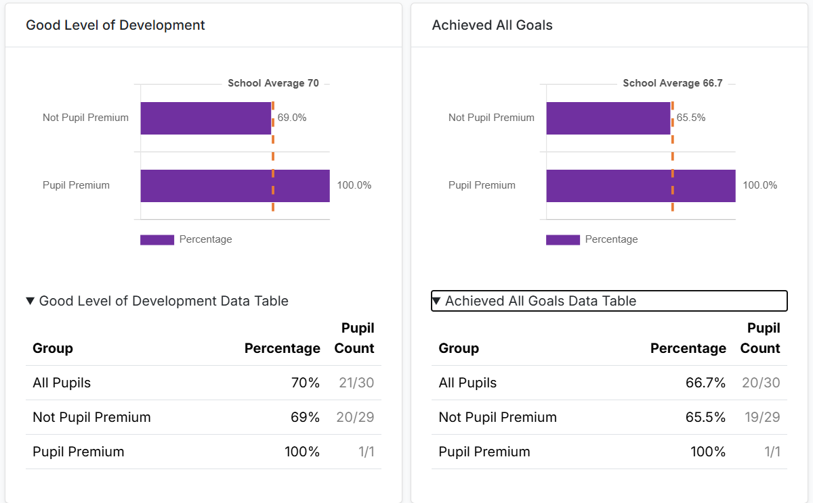
This data shows that the Pupil Premium Pupil achieved a Good Level of Development.
Reading & Phonics
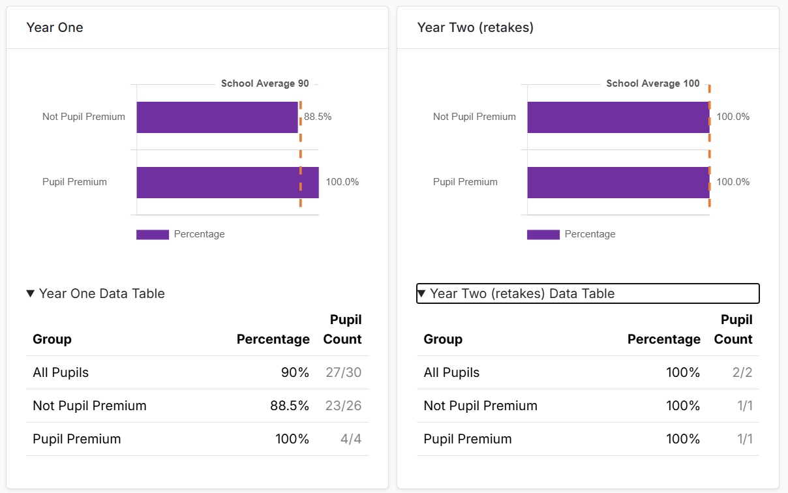
Lesson observations show that the quality of phonics teaching in EYFS and KS1 is consistently strong. Additional whole class phonic sessions were provided as well as group and individual intervention.
Phonics scores for PPG children show.
Year 1 4/4 children who were PPG reached the expected level in June 2025.
Year 2 1 1/1 Children who did not pass the check in Year 1 reached the expected level in June 2025
Key Stage 1
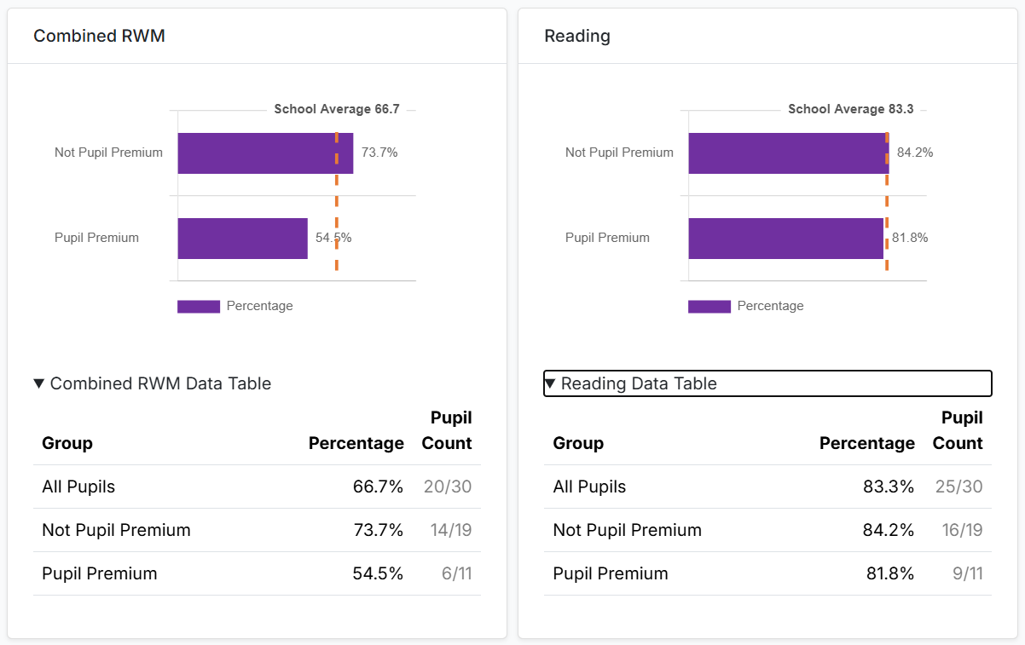

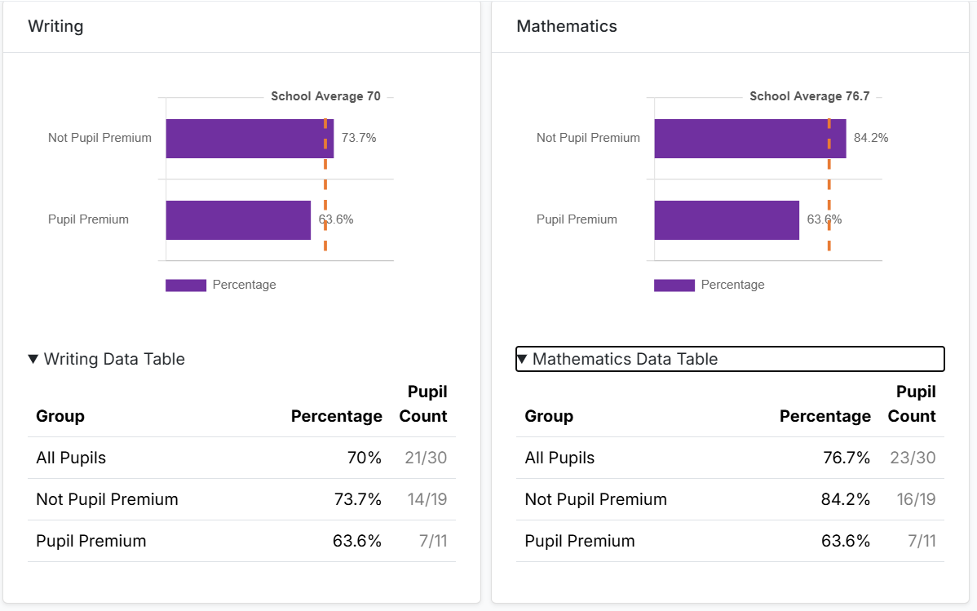

Multiplication Check
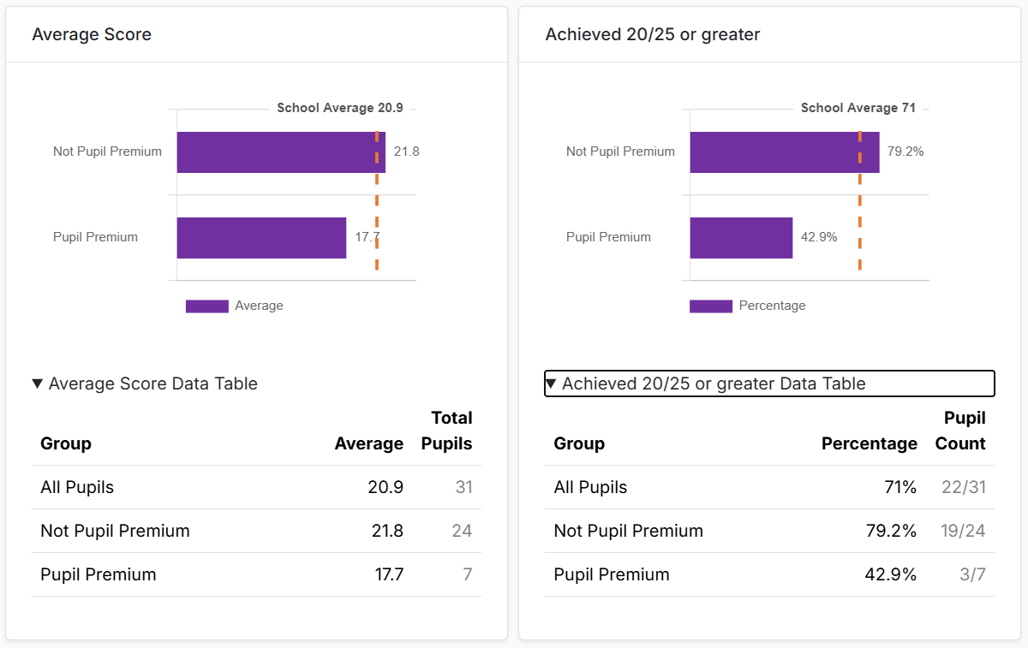
KS2
IDSR does not identify any statistically significant weaknesses in Key Stage 2 outcomes. Progress is broadly average in reading, writing, and mathematics. However, internal analysis continues to show that disadvantaged pupils, particularly boys, require further targeted support to match the attainment of their peers.
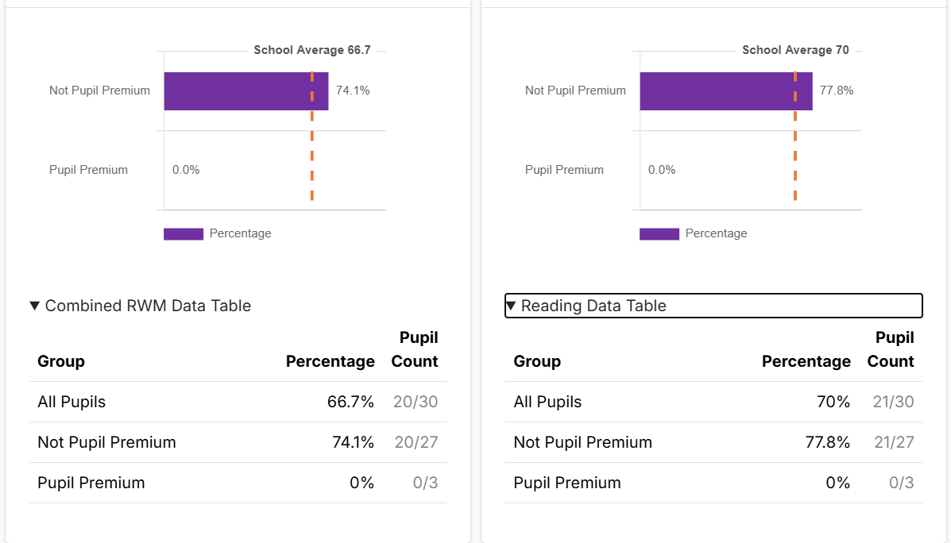
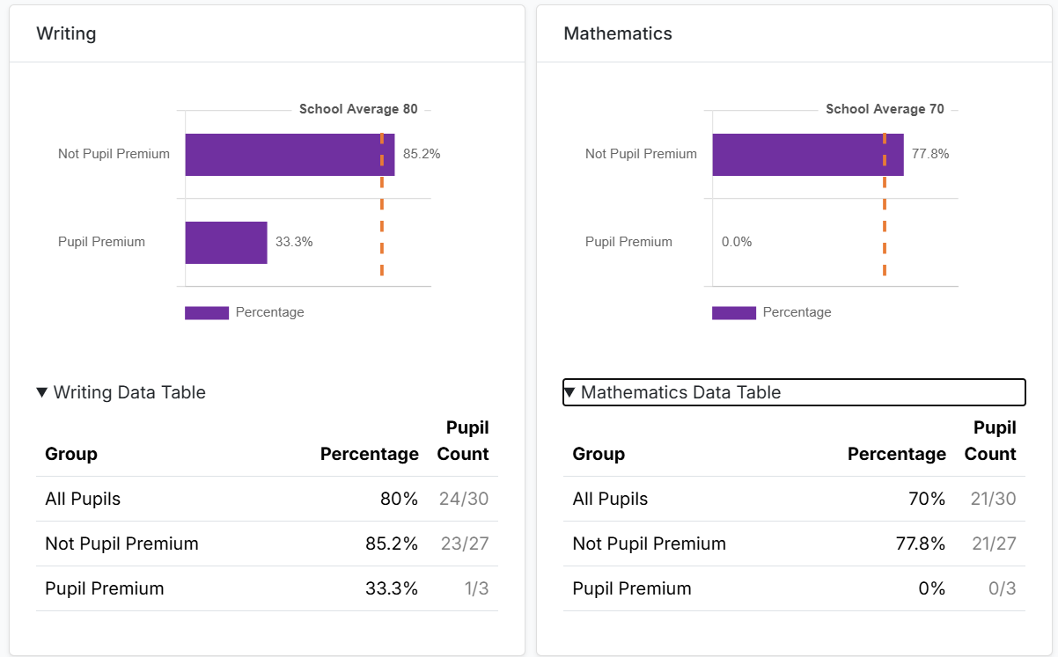
Attendance
Systems are robust and ensure that the school reacts quicker to concerns. The attendance of FSM children and PPG is still a concern. There are a small number of individual pupils having a big impact upon attendance figures. IDSR categorises attendance as ‘close to average’. Although the school has made improvements (FSM 95.4% and PPG 94.7% in 2025), attendance remains a key priority due to its direct impact on learning time for disadvantaged pupils.
2021 2022 2023 2024 2025
FSM 93.87% FSM 91.41% FSM 92.96% FSM 90.91% FSM 95.4%
PPG 94.65% PPG 92.35% PPG 93.23% PPG 92.21% PPG 94.7%
Pastorally the children who accessed friendship group and counselling made good gains in confidence, self-esteem, and ability to express themselves. Gains were also seen in their behaviour in class and their ability to regulate their behaviour and emotions.

