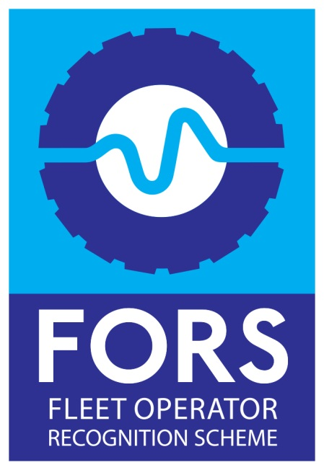
The Fleet Operator Recognition Scheme (FORS) is a voluntary accreditation scheme for fleet operators which aims to raise the level of quality within fleet operations, and to demonstrate which operators are achieving exemplary levels of best practice in safety, efficiency, and environmental protection.
Becoming a FORS member can bring you the peace of mind that your company is managing its work related road risk (WRRR) – and demonstrates to your customers and supply chain your commitment to exceeding the industry standard.

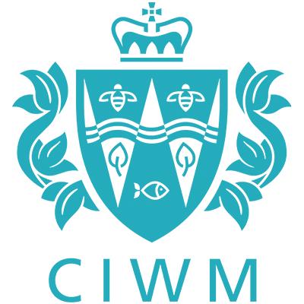
The objectives of the CIWM are to advance the scientific, technical and practical aspects of wastes and resource management for the safeguarding of the natural environment, to promote education, training, and research in wastes and resource management, and the dissemination of knowledge of the topic; and to strive to achieve and maintain the highest standards of best practice, technical competence and conduct by all its members.

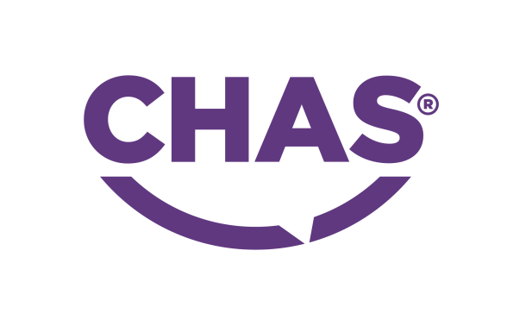
CHAS (The Contractors Health and Safety Assessment Scheme) is a pre-approval scheme, which allows contractors to demonstrate to potential clients that they meet the required health and safety standards.

The Environmental Services Association (ESA) is the trade body representing the UK's resource and waste management industry. ... We work with governments, local authorities, regulators and the public to deliver a more sustainable waste and resource management solution.


