Reviewed July 2025



ST MICHAEL’S ce primary school
English Policy
-Reading
-Phonics
-Writing
-Spelling

Our vision: Immersed in a Christian Community, each individual is encouraged, challenged and nurtured to learn and grow to achieve their full potential.

Our Inspiration: “For I know the plans I have for you,” declares the LORD,” plans to prosper you and not to harm you, plans to give you hope and a future.”
Jeremiah 29:11

Our School Values: Love, Faith, Honesty, Kindness, Courage and Respect

Reading
“I think it’s the books that you read when you are young that live with you forever”- J.K Rowling

Intent
At St. Michael’s CE Primary School we believe that reading is a key life skill and is the foundation of our curriculum. Reading feeds pupils’ imagination and opens up a treasure-house of wonder and joy for curious young minds. It is the fundamental pathway to achievement for all. This begins with a language rich, creative and purposeful Library fuelled by an appreciation of varied literary and cultural heritage. By ensuring children are primary literate, we are enabling them to be lifelong, fluent readers who can draw upon a range of strategies in order to comprehend the complex world around them to ultimately succeed and flourish. Additionally, we strive to enable all of our children to form good reading habits thus developing a love of reading for pleasure. Our children will then be able to fully engage and competently evaluate a wide variety of high-quality texts whilst forming and developing their own opinions.

Implementation
At St. Michael’s, in order for children to develop fluency and competency in reading we have devised a systematic reading curriculum and environment. In order for our children to become successful and motivated readers we use the following approaches.

Reading Library
The reading Library in each class is bespoke and tailor made to engage the children at an age-appropriate level. The environments are designed by the children and reflect individual interests in order to capture and inspire readers. All of our reading Libraries are inviting, calm spaces for children to unwind and immerse themselves in literature. St Michael’s has clear non-negotiable features of a reading Library to ensure consistency and to reflect St. Michael’s vision and passion for reading.
Every reading Library must include:
- a variety of clearly-labelled genres (including fiction, non-fiction and poetry)
- a celebration of a range of age-appropriate, diverse authors
- a collection of children and staff recommendations
- a regular rotation of material reflecting children’s current interests
- texts that reflect our literary heritage
- a repertoire of texts that promote diversity
Furthermore, the wider classroom environment is language rich. In every area of the curriculum, key vocabulary for the unit of the study is displayed for children to interact with as well key texts for that unit. A language rich environment is promoted by adults modelling language and enhancing children’s vocabulary daily via exposure to new terminology throughout curriculum areas. Adults are expected to model standard English at all times and promote children to use standard English.
In addition to individual reading libraries, we are lucky enough to have a communal library at St. Michael’s which is at the heart of our school and underpins our philosophy of reading. Each class has a designated school library session which encompasses reading for pleasure and library skill development. Throughout these sessions, ‘booktalk’ is promoted and children are encouraged to share their books of interest. Classes also access the library to enhance their knowledge and understanding of all curriculum areas. The library is also accessible throughout the week during the children’s free time for them to access the wealth of material, supporting them to become increasingly independent in their choice of texts. Children are encouraged to take these books home thus mirroring the function of a real library.
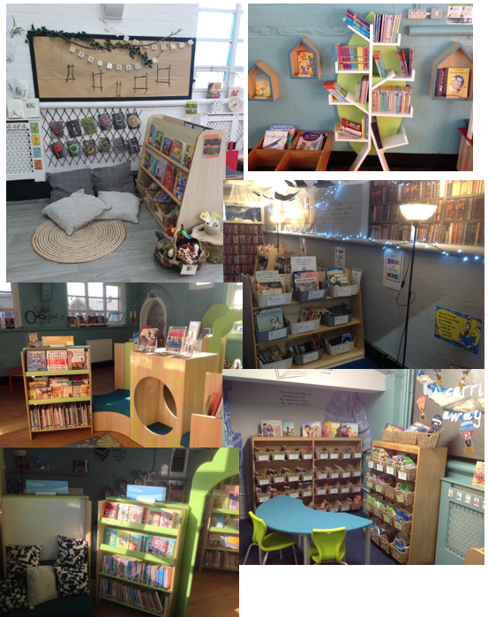

Reading for pleasure
‘Reading for pleasure is the single most important indicator of a child’s success.’ (OECD 2002)
‘The will influences the skill and vice versa.’ (OECD 2010)
School value reading for pleasure highly and work hard as a school to grow our Reading for Pleasure pedagogy. We are passionate that children of all ages have frequent opportunities to enjoy being read to and have time to read independently once they have developed sufficient fluency.
Every day includes a class novel or story time session, where children are exposed to the high-quality modelling of reading with prosody. We choose these books carefully as we want children to experience a wide range of books from a range of genres, authors and other worlds and cultures.
There is also a daily session of ‘drop everything and read’ (DEAR time). During this time children will access materials from the reading library in their classroom or enjoy other material they desire to read. During one of these sessions children make book recommendations to each other.
Throughout the whole school environment, reading is celebrated through a range of interactive reading displays including our ‘Extreme reading’ incentive. Books are promoted in every curriculum area to widen children’s curiosity and inspire them to develop new interests.

Progression through Phonics/Spelling teaching
At St. Michael’s we teach using the ‘Sounds Write’ approach because of its high quality instruction, emphasis on overlearning and its use of very precise language. The repetition of this approach aids children’s memory and gives them the confidence to read words instantly rather than seeing sounds in isolation. This is insured by teachers being given a clear lesson structure with accurate verbal and gestural language to use in these sessions. Through this evidence based approach, there is clear guidance on how to correct children’s errors and develop their own understanding of reading and spelling. This multi-sensory approach ensures continuity and progression for all children. Below is the progression through the Sounds Write teaching. Children have discrete, daily phonics/ spelling sessions (x20 minutes). The children are screened and assessed so that their starting points are accurate. This assessment is repeated termly.

EYFS and Key Stage One
Knowledge
Skills
Code:
Grapheme – the smallest meaningful contrastive unit in a writing system.
Phoneme - any of the perceptually distinct units of sound in a specified language that distinguish one word from another, for example p, b, d, and t in the English words pad, pat, bad, and bat.
GPC- This is short for Grapheme Phoneme Correspondence. Knowing a GPC means being able to match a phoneme to a grapheme and vice versa.
Segmenting – This involves hearing a word, splitting it up into the phonemes that make it, using knowledge of GPCs to work out which graphemes represent those phonemes and then writing those graphemes down in the right order.
Blending - Phonics blending (also known as visual blending) is the ability to string together the sounds that each letter stands for in a word.
Digraph - A grapheme containing two letters that makes just one sound (phoneme).
Trigraph - A grapheme containing three letters that makes just one sound (phoneme).
Syllable - a unit of pronunciation having one vowel sound, with or without surrounding consonants, forming the whole or a part of a word; for example, there are two syllables in water and three in inferno.

In KS1, children will have one lesson a week on the teaching of polysyllabic words.

Year Group | Autumn Term | Spring Term | Summer Term | End of year expectation
EYFS  Sounds Write Initial code | -Children know that sounds in speech are represented by letters.  -A sound can be represented by one letter spelling.  -Words have meaning and can be constructed into sentences.  -Children can blend and segment spoken words.  -Children can segment the learnt phonemes.  -Children can blend the learnt phonemes.  -Manipulate learnt phonemes in and out of words  Unit 1 (a, i, m, s, t)*  Unit 2 (n, p, o)*  Unit 3 (b, c, g, h)*  Unit 4 (d, f, v, e)*  *CVC words | -Children know that some sounds can be represented by two letter spellings (digraph)  -Words have meaning and can be constructed into sentences.  -Children can blend and segment spoken words.  -Children can segment the learnt phonemes.  -Children can blend the learnt phonemes.  -Manipulate learnt phonemes in and out of words  Unit 5 (k, l, r, u)*  Unit 6 (j, w, z)*  Unit 7 (x, y, ff, ll, ss, zz)*  Unit 8 (VCC, CVCC) | -Children know that some sounds can be represented by two letter spellings (digraph)  -Words have meaning and can be constructed into sentences.  -Children can blend and segment spoken words.  -Children can segment the learnt phonemes.  -Children can blend the learnt phonemes.  -Manipulate learnt phonemes in and out of words  Unit 9 (CVCC)  Unit 10 (CCVCC, CCCVC)  Unit 11 (sh, ch, th, ck, wh, ng, qu) | -Children are able to use the skills to read and write 3, 4 and 5 sound words with the structures CVC, VCC, CVCC, CCVC, CCCVC and CCVCC within the context of a sentence.  Reading Early Learning Goal (ELG):  -Children read and understand simple sentences.  -They use phonic knowledge to decode regular words and read them aloud accurately.  -They also read some common irregular words.  -They demonstrate understanding when talking with others about what they have read.
Year One onwards; Polysyllabic words. There will be a weekly polysyllabic lesson. Words will be chosen around previously taught phonemes.

-Children can separate words into syllables

-Children can take each syllable in turn and segment it into phonemes

-Children can blend phonemes into syllables

-Children can blend syllables into the word

-Children will know that some words are made up of more than one syllable
- The spelling of some common syllables such as prefixes and suffixes
Year One  Sounds Write Extended code | -Children know that many sounds can be represented by more than one spelling.  -Children know that many spellings represent more than one sound.  -Children will know the most common spellings which represent the target sound.  -Children will know the most common sounds represented by the target spelling.  -Children can blend and segment spoken words.  -Children can segment the learnt phonemes.  -Children can blend the learnt phonemes.  -Manipulate learnt phonemes in and out of words  Unit 1- Sound /ae/ First spellings  Unit 2- Sound /ee/First spellings  Unit 3- Spelling <ea>  Unit 4- Sound /oe/ First spellings  Unit 5- Spelling <o>  Unit 6- Sound /er/First spellings  Unit 7- Sound /e/  Unit 8- Sound /ow/ | -Children know that many sounds can be represented by more than one spelling.  -Children know that many spellings represent more than one sound.  -Children will know the most common spellings which represent the target sound.  -Children will know the most common sounds represented by the target spelling.  -Children can blend and segment spoken words.  -Children can segment the learnt phonemes.  -Children can blend the learnt phonemes.  -Manipulate learnt phonemes in and out of words  Unit 9- Spelling <ow>  Unit 10- Sound /oo/ e.g Moon  First spellings  Unit 11- Sound /ie/  Unit 12- Sound /oo/ e.g. Book  Unit 13- Spelling <oo>  Unit 14- Sound /u/  Unit 15- Spelling <ou>  Unit 16- Sound /s/ | -Children know that many sounds can be represented by more than one spelling.  -Children know that many spellings represent more than one sound.  -Children will know the most common spellings which represent the target sound.  -Children will know the most common sounds represented by the target spelling.  -Children can blend and segment spoken words.  -Children can segment the learnt phonemes.  -Children can blend the learnt phonemes.  -Manipulate learnt phonemes in and out of words  Unit 17- Spelling <s>  Unit 18- Sound /l/  Unit 19- Sound /or/ First spellings  Unit20- Sound /air/  Unit 21 Sound /ue/  Unit 22 Spelling <ew>  Unit 23 Sound /oy/  Unit 24 Sound /ar/  Unit 25 Sound /o/  Unit 26- Spelling <a>  Unit 27- Sound /ae/ more spellings | Statutory Assessment: Phonics screening test-June  National Curriculum  Pupils should be taught to: -apply phonic knowledge and skills as the route to decode words  -respond speedily with the correct sound to graphemes (letters or groups of letters) for all 40+ phonemes, including, where applicable, alternative sounds for graphemes  -read accurately by blending sounds in unfamiliar words containing GPCs that have been taught  -read common exception words, noting unusual correspondences between spelling and sound and where these occur in the word  -read words containing taught GPCs and –s, –es, –ing, –ed, –er and –est endings  -read other words of more than one syllable that contain taught GPCs  - read words with contractions [for example, I’m, I’ll, we’ll], and understand that the apostrophe represents the omitted letter(s)  -read aloud accurately books that are consistent with their developing phonic knowledge and that do not require them to use other strategies to work out words  -re-read these books to build up their fluency and confidence in word reading.
Year Two  Sounds Write Extended code continued | -Children know that many sounds can be represented by more than one spelling.  -Children know that many spellings represent more than one sound.  -Children will know the most common spellings which represent the target sound.  - Children will know the most common sounds represented by the target spelling.  -Children can blend and segment spoken words.  -Children can segment the learnt phonemes.  -Children can blend the learnt phonemes.  -Manipulate learnt phonemes in and out of words  Unit 28- Sound /d/  Unit29- Sound /ee/ more spellings  Unit 30 Sound /i/  Unit 31 Spelling <y>  Unit 32 Sound /oe/ more spellings  Unit 33 Sound /n/  Unit 34 Sound /er/more spellings | -Children know that many sounds can be represented by more than one spelling.  -Children know that many spellings represent more than one sound.  -Children will know the most common spellings which represent the target sound.  - Children will know the most common sounds represented by the target spelling.  -Children can blend and segment spoken words.  -Children can segment the learnt phonemes.  -Children can blend the learnt phonemes.  -Manipulate learnt phonemes in and out of words  Unit 35 Sound /v/  Unit 36 Sound /oo/ e.g moon- more spellings  Unit 37 Sound /j/  Unit 38 Sound /g/  Unit 39 Spelling <g>  Unit 40 Sound /f/  Unit 41: Spelling <gh>  Unit 42 Sound /m/  Unit 43 Sound /or/ more spellings | -Children know that many sounds can be represented by more than one spelling.  -Children know that many spellings represent more than one sound.  -Children will know the most common spellings which represent the target sound.  - Children will know the most common sounds represented by the target spelling.  -Children can blend and segment spoken words.  -Children can segment the learnt phonemes.  -Children can blend the learnt phonemes.  -Manipulate learnt phonemes in and out of words  Unit 44 Sound /h/  Unit 45 Sound /k/  Unit 46 Sound /r/  Unit 47 Sound /t/  Unit 48 Sound /z/  Unit 49 Sound /eer/  Unit 50 Sound schwa /Ə/ | Statutory Assessment: KS1 reading assessment in May  National Curriculum  Pupils should be taught to: -continue to apply phonic knowledge and skills as the route to decode words until automatic decoding has become embedded and reading is fluent  -read accurately by blending the sounds in words that contain the graphemes taught so far, especially recognising alternative sounds for graphemes  -read accurately words of two or more syllables that contain the same graphemes as above  - read words containing common suffixes  -read further common exception words, noting unusual correspondences between spelling and sound and where these occur in the word  -read most words quickly and accurately, without overt sounding and blending, when they have been frequently encountered  -read aloud books closely matched to their improving phonic knowledge, sounding out unfamiliar words accurately, automatically and without undue hesitation  - re-read these books to build up their fluency and confidence in word reading.

Key Stage Two

Phonic knowledge should continue to underpin spelling after key stage 1; teachers should still draw pupils’ attention to GPCs that do and do not fit in with what has been taught so far. (National Curriculum 2014)

The emphasis in Key stage Two is teaching more complex polysyllabic words as well recognising and using a range of spelling rules. The teachers will be using the Sounds Write polysyllabic lessons to teach reading and spelling. Ks2 children will have one lesson per week on the teaching of the National Curriculum Statutory words.

Year Three | Spelling <sh>  Spelling <ch>  Sound /ae/  Spelling <ae>  Sound /ee/  Spelling <ey>  Sound /er/  Homophone focus;  mail/male  main/mane  meet/meat  grate/great  break/brake  heel/heal/he’ll  peace/piece  plain/plane  rain/rein/reign  scene/seen  Suffix focus;  -ing  -er  Prefix focus;  pre- | Sound /e/  Sound /oe/  Spelling <ou>  Homophone focus;  groan/grown  berry/bury  medal/meddle  weather/whether  Suffix focus:  -ed  Prefix focus;  dis -  mis –  Final stable syllables;  -zhure | Sound /ie/  Sound /oo/  Homophone focus;  missed/mist  whose/who’s  Suffix focus;  -ly  Prefix focus  in-  Final stable syllables;  -zhun | Children must achieve all statements from each term in order to be meeting the Year 3 standard.
Year Four | Spelling <k>  Sound /u/ Spelling<u>  Sound /or/  Sound /air/  Homophone focus; ball/bawl  fair/fare  Suffix focus;  -en  Prefix focus;  Im-  Il-  Ir- | Sound /ue/  Spelling <g>  Spelling <ng>  Sound /ar/  Spelling <s>  Homophone focus;  hear/here  knot/not  Suffix focus;  s/-s  Prefix focus;  Re-  Sub-  Inter-  Super-  Final stable syllables;  -tion | Sound /o/  Sound /i/  Spelling <i>  Spelling <y>  Homophone focus;  affect/effect  accept/except  Suffix focus:  -ous  Prefix focus;  Anti –  Auto-  Final stable syllables;  -ture | Children must achieve all statements from each term in order to be meeting the Year 4 standard.

National Curriculum Word Lists Year 3 and 4.
Autumn. |  |  | Spring. |  |  |  | Summer.
accident(ally)  actual(ly)  address  answer  appear  arrive  believe  bicycle  breath  breathe  build  busy/business  calendar  caught  centre  century  certain  complete  consider  continue  decide  describe  different  difficult  disappear  early  earth  eight/eighth  enough  exercise  experience  experiment  extreme |  |  | famous  favourite  February  forward (s)  fruit  grammar  group  guard  guide  heard  heart  height  history  imagine  increase  important  interest  island  knowledge  learn  length  library  material  medicine  mention  minute  natural  notice  naughty  notice  occasion (ally)  often  opposite  ordinary  particular  peculiar |  |  |  | perhaps  popular  position  possess(ion)  possible  potatoes  pressure  probably  promise  purpose  quarter  question  recent  regular  reign  remember  sentence  separate  special  straight  strange  strength  suppose  surprise  therefore  though/although  thought  through  various  weight  woman/women
Year Five | Sound /a/  Sound /ae/  Sound /ee/  Homophone focus  draft/draught  stationary/stationery  affect/effect  led/lead  heard/herd  aisle/isle  Suffix focus  -ing  -ly |  |  | Sound /e/  Sound /oe/  Sound /o/  Homophone focus  morning/mourning  profit/prophet  bridal/bridle  cereal/serial  advice/advise  device/devise  Suffix focus  -ed  -able  -ible  Final stable syllables  -cial  -tial |  | Sound /er/  Sound /oo/  Sound /ie/  Homophone focus  guessed/guest  past/passed  steal/steel  aloud/allowed  wary/weary  Suffix focus  -cy  -al  -ee  Use of a hyphen  Prefix co- meaning ‘together’ |  | Children must achieve all statements from each term in order to be meeting the Year 5 standard.
Year Six | <i> sound  <u> sound  <or> sound  Homophone focus  desert/dessert  principle/principal  descent/dissent  ascent/assent  license/licence  practice/practice  Suffix focus  -en  -ant  -ent  Use of a hyphen  Prefix re- meaning ‘again’ |  |  | <air> sound  <ue> sound  <ar> sound  Homophone focus  alter/altar  father/farther  Who’s/whose  prophecy/prophesy  compliment/complement  Suffix focus  -‘s/s’  -ance  -ence  Final stable syllables  -cious  -tious  -ious |  | Recap and review based on individual needs and that of the cohort. |  | Children must achieve all statements from each term in order to be meeting the Year 6 standard.
National Curriculum Word Lists Year 5 and 6
Autumn |  | Spring |  |  | Summer
Accommodate  accompany  according  achieve  aggressive  amateur  ancient  apparent  appreciate  attached  available  average  awkward  bargain  bruise  category  cemetery  committee  communicate  community  competition  conscience  conscious  controversy  convenience  correspond  criticise (critic + ise)  curiosity  definite  desperate  determined  develop  dictionary  disastrous |  | embarrass  environment  equip (–ped, –ment)  especially  exaggerate  excellent  existence  explanation  familiar  foreign  forty  frequently  government  guarantee  harass  hindrance  identity  immediate(ly)  individual  interfere  interrupt  language  leisure  lightning  marvellous  mischievous  muscle  necessary  neighbour  nuisance |  |  | occupy  occur  opportunity  parliament  persuade  physical  prejudice  privilege  profession  programme  pronunciation  queue  recognise  recommend  relevant  restaurant  rhyme  rhythm  sacrifice  secretary  shoulder  signature  sincere(ly)  soldier  stomach  sufficient  suggest  symbol  system  temperature  thorough  twelfth  variety  vegetable  vehicle  yacht

Phonics and Spelling lesson structure
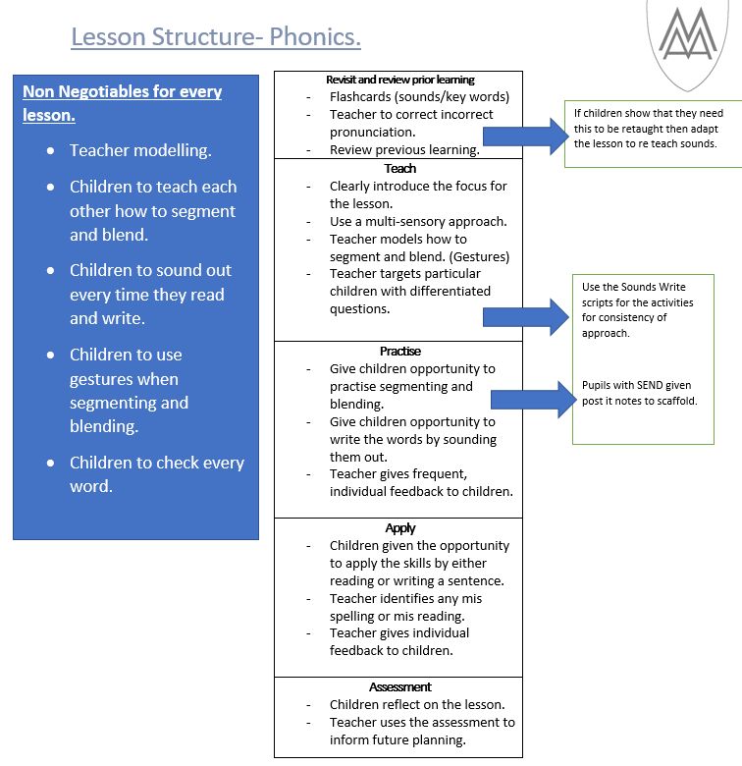

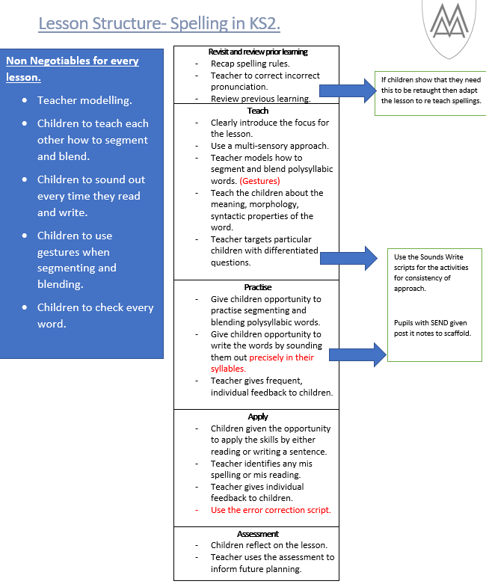

Progression through comprehension teaching
The progression of comprehension begins with using pictures and digital literacy to help children to observe and understand what they can see. This is supported by children being able to understand what is being read to them and develops into them understanding what they have read independently. At St. Michael’s we give children the opportunity to develop all skills linked to comprehension. These skills support children to think critically and reason about what they have read. We are implementing the ‘Are you really reading?’ Shine project principles. Within this there are 5 strands; The timeline strand, the six word summary (hashtag) strand, the emoji strand, the impression and evidence strand and the 3/5 most important things strand. Through this project children will be equipped with the skills of reading for meaning.
Teachers use these strategies in whole class reading sessions, guided reading and when reading individually with children. Whole class reading is taught three times a week following a specific lesson structure.
Whole Class Reading at St Michael’s.
Before starting a text teachers must choose the text carefully.
Week 1 – fiction
Week 2- Non fiction
Week 3 – Poetry or Digital literacy
*3 sessions a week.
Session 1.
- Introduce the text. Look at the front cover, blurb, contents, glossary.
- Teacher to introduce the text to scaffold the reading but leaves some problem solving for the readers to do.
- Decoding must be a priority in this lesson. Discuss word reading strategies. Model using Soundswrite strategies, working out the context of the sentence.
- Focus on the vocabulary, children to highlight unknown words, teacher to model using the context of the sentence to try and identify meaning, teacher to clarify vocabulary.
Sessions 2 and 3.
- Recap previous lesson.

Reading the text.
- Teacher to model use of tone and expression.
Discussion of text.
The teacher invites children to discuss the text, guiding the discussion and comprehension.
Use the 5 strands from ‘Are you really reading?’. The timeline strand, the six word summary (hashtag) strand, the emoji strand, the impression and evidence strand and the 3/5 most important things strand.
Focus on children highlighting evidence from text to justify their answers.
Year Group | Autumn term | Spring term | Summer term | End of year expectation
EYFS | • Enjoys rhyming and rhythmic activities.  •Recognises rhythm in spoken words.  • Listens to and joins in with stories and poems, one-to-one and also in small groups.  • Joins in with repeated refrains and anticipates key events and phrases in rhymes and stories.  •Beginning to be aware of the way stories are structured.  •Suggests how the story might end.  •Describes main story settings,  events and principal characters.  •Shows interest in illustrations and print in books and print in the environment  • Looks at books independently.  • Handles books carefully.  •Knows information can be relayed in the form of print.  •Knows that print carries meaning | • Enjoys an increasing range of books.  •Knows that information can be retrieved from books and computers.  Continues a rhyming string | •Begins to read words and simple sentences.  •Uses vocabulary and forms of speech that are increasingly influenced by their experiences of books. | Early Learning Goal:  Children read and understand simple sentences.  They demonstrate understanding when talking with others about what they have read.
Year One | Children should be taught to:  -develop pleasure in reading, motivation to read, vocabulary and understanding by: listening to and discussing a wide range of poems, stories and non-fiction at a level beyond that at which they can read independently  -being encouraged to link what they read or hear read to their own experiences  - becoming very familiar with key stories, fairy stories and traditional tales, retelling them and considering their particular characteristics  -recognising and joining in with predictable phrases  -learning to appreciate rhymes and poems, and to recite some by heart  -discussing the significance of the title and events  -predicting what might happen on the basis of what has been read so far  -participate in discussion about what is read to them, taking turns and listening to what others say | -discussing word meanings, linking new meanings to those already known  -understand both the books they can already read accurately and fluently and those they listen to by: drawing on what they already know or on background information and vocabulary provided by the teacher  -checking that the text makes sense to them as they read and correcting inaccurate reading | -making inferences on the basis of what is being said and done  -explain clearly their understanding of what is read to them. | -Children must achieve all statements from each term in order to be meeting the Year 1 standard.
Year Two | Children should be taught to:  -becoming increasingly familiar with and retelling a wider range of stories, fairy stories and traditional tales  -recognising simple recurring literary language in stories and poetry  -discussing and clarifying the meanings of words, linking new meanings to known vocabulary  -discussing their favourite words and phrases  - checking that the text makes sense to them as they read and correcting inaccurate reading | -develop pleasure in reading, motivation to read, vocabulary and understanding by: listening to, discussing and expressing views about a wide range of contemporary and classic poetry, stories and non-fiction at a level beyond that at which they can read independently  -discussing the sequence of events in books and how items of information are related  -being introduced to non-fiction books that are structured in different ways  - answering and asking questions about what they have read | -continuing to build up a repertoire of poems learnt by heart, appreciating these and reciting some, with appropriate intonation to make the meaning clear  - participate in discussion about books, poems and other works that are read to them and those that they can read for themselves, taking turns and listening to what others say  -explain and discuss their understanding of books, poems and other material, both those that they listen to and those that they read for themselves. | Children will sit the Ks1 Statutory reading assessment in May.
Lower Key Stage 2
The following National Curriculum statements divided into years 3 and 4 to ensure progression.
Year three | Children should be taught to:  -develop positive attitudes to reading and understanding of what they read by: listening to and discussing a wide range of fiction, poetry, plays, non-fiction and reference books or textbooks  -retrieve and record information from non-fiction  - participate in discussion about both books that are read to them and those they can read for themselves, taking turns and listening to what others say. | -asking questions to improve their understanding of a text  - discussing words and phrases that capture the reader’s interest and imagination  -using dictionaries to check the meaning of words that they have read | -predicting what might happen from details stated and implied  - identifying main ideas drawn from more than one paragraph and summarising these  - recognising some different forms of poetry [for example, free verse, narrative poetry]  - preparing poems and play scripts to read aloud and to perform, showing understanding through intonation, tone, volume and action | Children must achieve all statements from each term in order to be meeting the Year 3 standard.
Year Four | Children should be taught to:  -develop positive attitudes to reading and understanding of what they read by: listening to and discussing a wide range of fiction, poetry, plays, non-fiction and reference books or textbooks  -participate in discussion about both books that are read to them and those they can read for themselves, taking turns and listening to what others say. | -drawing inferences such as inferring characters’ feelings, thoughts and motives from their actions, and justifying inferences with evidence  -understand what they read, in books they can read independently, by: checking that the text makes sense to them, discussing their understanding and explaining the meaning of words in context  - reading books that are structured in different ways and reading for a range of purposes | -identifying how language, structure, and presentation contribute to meaning  -recognising some different forms of poetry [for example, free verse, narrative poetry]  - identifying themes and conventions in a wide range of books English  - increasing their familiarity with a wide range of books, including fairy stories, myths and legends, and retelling some of these orally | Children must achieve all statements from each term in order to be meeting the Year 4 standard.
Upper Key Stage 2
The following National Curriculum statements divided into years 5 and 6 to ensure progression.
Year Five | Pupils should be taught to: -maintain positive attitudes to reading and understanding of what they read by: -continuing to read and discuss an increasingly wide range of fiction, poetry, plays, non-fiction and reference books or textbooks  -reading books that are structured in different ways and reading for a range of purposes  -retrieve, record and present information from non-fiction  -asking questions to improve their understanding | -discuss and evaluate how authors use language, including figurative language, considering the impact on the reader  -drawing inferences such as inferring characters’ feelings, thoughts and motives from their actions, and justifying inferences with evidence  -understand what they read by: checking that the book makes sense to them, discussing their understanding and exploring the meaning of words in context | -recommending books that they have read to their peers, giving reasons for their choices  -summarising the main ideas drawn from more than one paragraph, identifying key details that support the main ideas  -identifying how language, structure and presentation contribute to meaning  -preparing poems and plays to read aloud and to perform, showing understanding through intonation, tone and volume so that the meaning is clear to an audience | Children must achieve all statements from each term in order to be meeting the Year 5 standard.  -distinguish between statements of fact and opinion
Year Six | -increasing their familiarity with a wide range of books, including myths, legends and traditional stories, modern fiction, fiction from our literary heritage, and books from other cultures and traditions  -predicting what might happen from details stated and implied  - identifying and discussing themes and conventions in and across a wide range of writing | -provide reasoned justifications for their views.  -participate in discussions about books that are read to them and those they can read for themselves, building on their own and others’ ideas and challenging views courteously | -explain and discuss their understanding of what they have read, including through formal presentations and debates, maintaining a focus on the topic and using notes where necessary  -learning a wider range of poetry by heart  -making comparisons within and across books | Children will sit the Ks2 Statutory reading assessment in May.

Support for learners who are not on track for age related expectations.
In addition to the whole class reading sessions, guided reading sessions take place for children who need further support and practice with both fluency and comprehension skills. (see structure below). These children have been identified through a rigorous assessment process including a phonics assessment, Salford reading test, termly NFER tests. Teachers use the assessment to identify specific areas of development for children and plan these sessions around this. In addition to this, these children read with an adult in school frequently. Children requiring further support have 1:1 reading sessions with an adult every day.
Furthermore, the parents of these children will be asked to attend a Reading meeting with the child’s class teacher to discuss joint support strategies. St Michael’s also have a range of reading interventions that are used for more targeted support. These include extra Sounds Write sessions (individual and small group), Boosting Reading Potential and Reading between the lines. Very often these interventions are undertaken after specialist advice from the TESS team. The interventions are reviewed every 10 weeks to monitor progress.
In addition to this, children who have dyslexic tendencies are given personal dictionaries, reading rulers and prompts of strategies to use (e.g. sound mats) to further support/consolidate their reading skills. Classrooms are carefully designed to ensure that they are dyslexia friendly. The school also works closely with the TESS team (targeted education support staff) to encourage dyslexia friendly first quality teaching strategies. The TESS team also ensure that school are effectively supporting pupils with dyslexic tendencies and children with additional needs.

Before starting a text teachers must choose the text carefully. The text must be at instructional level and engaging for the group.
Session 1.
- Introduce the text. Look at the front cover, blurb, contents, glossary.
- Teacher to introduce the text to scaffold the reading but leaves some problem solving for the readers to do.
- Make predictions about the text and explore vocabulary within the text.

Other sessions.
Children should read approximately 4 pages per session.
- Recap previous lesson.

Reading the text.
- Children and teacher to take it in turns to read aloud. Teacher to model use of tone and expression.
If a child is struggling to read a word discuss word reading strategies. Model using Soundswrite strategies, working out the context of the sentence.
- Read a paragraph at a time and then discuss.

Discussion of text.
The teacher invites children to discuss the text, guiding the discussion and comprehension using the 5 strands of ‘Are you really reading?’

NB. If using a book, the book maybe used for several weeks of guided reading.

Reading books.
At St Michael's we have banded books into phonics books and high frequency word books.
Phonics books.
The phonics books following the progression of the Sounds Write Phonics program that we follow. The aim of these books is to practice the reading skills of decoding, segmenting and blending. Therefore, the phonics book that children take home will be consolidating the sounds that they have learnt/ they are currently learning. Alongside their phonics books younger children will take home a reading for pleasure, high quality text book to enjoy. For those children in Key Stage 2 who still need to practice the early reading skills, we have purchased Sounds Write books that are more engaging and the content is more age appropriate. We have named this section of the reading scheme ‘Star readers’.
Reading scheme books.
When children have completed the phonics scheme books they move onto high frequency word books. The aim of this is to practice the reading skill of recognising the high frequency words as well using context to predict what words are and mean. The high frequency word books have been banded according the schemes that have been used, for example the Oxford Reading tree stages have been followed. Other schemes and non-fiction texts have been weaved within the Oxford Reading tree book scheme to ensure that children receive a comprehensive diet of literature. The scheme has been divided into the key stages with Key Stage 2 being divided into year groups. The Key Stage 2 reading scheme we use is Rising Stars reading planet because these modern books are written by real authors and are linked to the different curriculum areas. They also cater for our children who have a lower reading age than their chronological age by providing books that match their reading age but also have an interest level for their chronological age. Once the children have completed the scheme for their year group carefully chosen age appropriate children’s books are on their year group shelf to enjoy. There is also a section in the Key Stage 2 reading area for children to select books from a range of genres and author studies. These books have been categorised into year groups and can be read alongside their scheme book if children choose.
Teachers will work on children reading their current reading books at 80% accuracy to be considered an appropriately challenging book. Comprehension is encouraged with both the phonics reading books and high frequency word books.
High Frequency words.
In EYFS and KS1, high frequency words are sent home with children to help them to recognise these words in their reading. The high frequency words given in Reception are the 45 first high frequency words and in Year 1 and 2 these words are the common exception words from the Year 1 and 2 curriculum. The children are encouraged to recognise and correctly spell words in their reading and writing. These words are also incorporated into phonics and English lessons.

Reading in our wider curriculum.
To ensure that children are embedding their reading skills we need to ensure that they are exposed to a wide variety of texts throughout the curriculum. Quality fiction, non-fiction texts and poetry will be linked in every area of the curriculum including a range of diversity books about different family units, disabilities, races, gender and refugees. Both within the classroom and in our environment, every curriculum area and display will feature a range of appropriate, challenging reading material for the children to access. Some of these may make up part of the whole class reading time or 10 minute reading time at the end of the day. Our library is organised into curriculum areas for the children to access at their leisure and during scheduled class library time.

Through the use of immersion in all lessons, children are encouraged to develop their emotional literacy skills through the medium of drama and expressive arts. These sessions help to promote the children’s understanding of the text, vocabulary development, their imagination and allow them to engage creatively in a process to further their emotional, cognitive, physical and social development. These experiences support the children to incorporate a range of literary devices to enhance the quality of their reading and writing.

Parental engagement.
The importance of reading is relayed to parents from the moment they enter St Michael’s. The Reception class teacher discusses the importance of reading at the New Starters meeting in the Summer term before children begin their St Michael’s journey. They are given resources to support their child’s love of reading. This is followed up by reading workshops each year in the Autumn term. The reading workshops model the teaching of reading in each key stage. They also give parents the opportunity to ask questions about supporting their child read. Teachers model writing comments in children’s diaries so that parents can know how to support their child to read. If children do not read 5 times a week then on a Friday, they stay in at playtime so that the teacher can further support the child’s reading. If the child persistently doesn’t read at home then the teacher will engage with the parents to support them individually via regular meetings. As a partnership, class teachers commit to reading to the class daily for 10 minutes. This reading session helps to bring the children closer together in an atmosphere which promotes the love of reading.

Assessment
In Reception, children’s reading is assessed in the first few weeks of their St Michael’s journey which acts as a baseline which helps to inform the teacher’s starting points for the teaching of reading.
From Year 2 written comprehensions are completed weekly, each with a specific VIPER focus and following a fiction, non-fiction, poetry weekly structure. Further to this, teachers will make summative assessments during whole class reading sessions. Teachers will use all of these as an ongoing form of reading assessment.
EYFS and KS1.
In phonics all children in EYFS and KS1 are screened every term using the Sounds Write Assessment. Teachers then use this assessment to ensure that the children are in the correct phonics group. This also helps to identify any gaps in phonetical knowledge so that teachers can reinforce these sounds. In addition to this, Year 1 children are given a ‘phonics screening check’ paper each term so that they become familiar with the layout of the statutory assessment which takes place in June.
In order to assess children’s reading comprehension skills, children sit a termly Testbase reading assessment from Spring term in Year 1 through to Year 6. In addition to this, EYFS and KS1 teachers listen to children read weekly and conduct summative assessments that form individual children’s next steps. There is an expectation that teacher’s regularly update a reading log assessing the expected reading standards for all children which later support teacher judgements to be accurate.
Year 2 children also have regular practice of the Year 2 SATS reading paper so that they become familiar with the layout of the statutory assessment. This practice enables children to develop their reading stamina as well as giving the teacher accurate assessment data.
KS2.
Children in KS2 complete termly Testbase tests to assess their comprehension skills. Teachers are expected to hear all children read every term with the exception of the lowest attaining pupils who are part of a daily guided reading group. PPG pupils are heard read weekly.
Year 6 children also have regular practice of the Year 6 SATS reading paper so that they become familiar with the layout of the statutory assessment. This prepares them for the statutory reading assessment in May.
Children who are working below the expected standard in their reading are given a Salford reading test to determine areas for development and to put appropriate support strategies in place.

Impact
The impact on our children is clear: progress, sustained learning and transferrable skills. Children will leave St Michael’s having a love of reading and a set of core reading skills that will enable them to understand and live successfully in the diverse world around them. They will have enjoyed a breadth of reading material empowering them to form individual opinions that they can express coherently. They will use their reading skills as a catalyst to access all areas of life so that they can achieve their dreams. We hope that as children move on from us to further their education and learning that their creativity, passion for reading and high aspirations travel with them and continue to grow and develop as they do.

Writing
“No matter what anybody tells you, words and ideas can change the world.”
John Keating

Writing

Intent
Writing is a fundamental part of the curriculum at St Michael’s. By the end of Year Six, we aim for our children to have developed a love for writing and to be able to express their thoughts and ideas clearly and creatively through the written word. We also strive to create writers who can confidently re-read, edit and improve their own work, using essential skills in grammar, punctuation, and spelling. At St Michael’s, we set high expectations for all children to take pride in their work and develop a fluent, cursive handwriting style, while allowing their imaginations to flourish.
At St Michael’s CE Primary School, we are committed to helping our children become articulate and imaginative communicators, equipped with the core skills needed to become lifelong learners, with English playing a central role. We aim to foster a genuine love of language and writing through a text-based approach. Careful cross-curricular links ensure that children’s English learning is relevant and meaningful, often connecting reading and writing with topics in History and Geography. We also ensure that children understand the wide use of writing in everyday life and the importance of the skills they are developing.
Our intentions in writing are for children to:
- Write with purpose.
- See themselves as genuine writers.
- Take ownership of their writing.
- Enjoy and engage with the writing process.
- Develop the ability to organise and plan their writing effectively.

Implementation

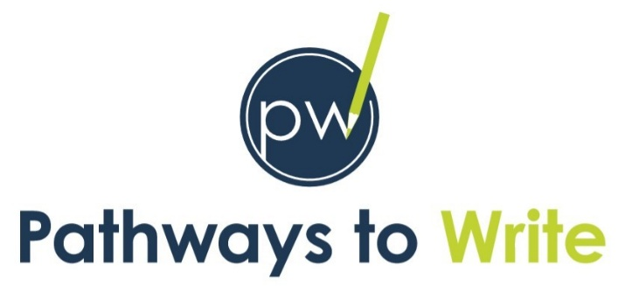
At St Michael’s, our English curriculum is thoughtfully designed around carefully selected texts that inspire and drive pupils’ writing development. From Reception through to Year 6, we follow The Literacy Company’s Pathways to Write programme, providing a consistent and structured approach that supports every child in becoming a confident and skilled writer.

As our approach to writing, we use Pathways to Write: a ‘proven methodology which develops vocabulary, reading and writing skills through the mastery approach’ (The Literacy Company). Using a ‘mastery approach’ to writing within our teaching, allows for a greater development of vocabulary and spelling. We also intend for our children to be able to independently re-read, revise and edit their writing both during and after the writing process.
Our Aims for Writing
- To enable pupils to write effectively across a broad range of genres, including both narrative and non-fiction forms.
- To develop the skills necessary for writing for varied purposes and audiences with clarity and creativity.
- To nurture a genuine love for writing, fostering independence, confidence, and enjoyment.
- To provide diverse writing opportunities both within English lessons and across the wider curriculum, allowing pupils to apply their skills meaningfully in real-world contexts.

The Writing process
The Pathways to Write scheme ensures that pupils across all year groups develop a secure and deep understanding of the purpose, structure and language features of a wide variety of genres. Each unit is built around high-quality texts that serve as models for writing, offering pupils rich and varied vocabulary experiences that build on the school’s strong foundation in language development.
Writing skills are developed progressively within each unit through repetition and varied application, allowing pupils to practise and embed these skills across a range of writing tasks. Spelling, punctuation, and grammar are explicitly taught and purposefully embedded throughout lessons using a variety of approaches to support all learners in achieving success.
In the Foundation Stage and Key Stage 1, early writers are supported through structured strategies such as ‘hold a sentence’ and dictation. These targeted activities help pupils strengthen their transcriptional skills—handwriting and spelling—before moving confidently into composition. Daily transcriptional practice throughout the school reinforces pupils’ fluency and accuracy.
The scheme promotes the full writing process, with regular opportunities for oral rehearsal, retelling, and refining of texts as essential preparation for writing. Lessons incorporate a balance of shared, guided, and independent writing, with teachers modelling writing explicitly to support pupils' gradual transition to independent composition. Where appropriate, cross-curricular links enrich pupils’ writing experiences by providing meaningful and engaging contexts.
Extended writing opportunities are carefully planned across the curriculum, enabling pupils to apply their writing skills creatively and purposefully in a range of contexts, such as historical narratives or scientific explanations

The Writing Sequence
- The Gateway (1-2 Sessions)
- Begins with an engaging ‘hook’ to captivate pupils and introduce the learning context.
- Pupils make predictions and consider the purpose and audience.
- Revisits previously taught mastery skills through an assessed writing task.

- The Pathway (10 Sessions)
- Introduces new writing skills aligned with the year group’s curriculum (mastery keys), which are displayed in classrooms.
- Provides varied writing tasks to practise and apply new skills, including character descriptions, poetry, dialogue, fact files, and diary entries.
- Revisits and reinforces previously taught skills.

- The Writeaway (4 Sessions)
- Pupils plan, sequence, and draft extended pieces of writing independently or collaboratively.
- Provides time for drafting, checking, editing, redrafting, and publishing.
- Concludes in a polished fiction or non-fiction piece, covering a wide variety of genres and themes.

The Keys: Gateway, Mastery and Feature
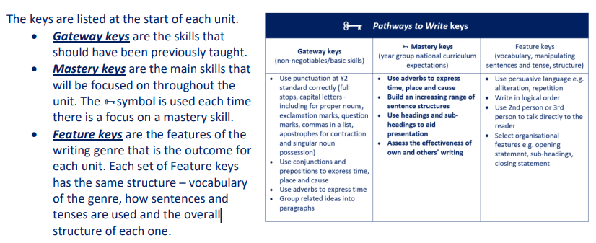

Feature keys
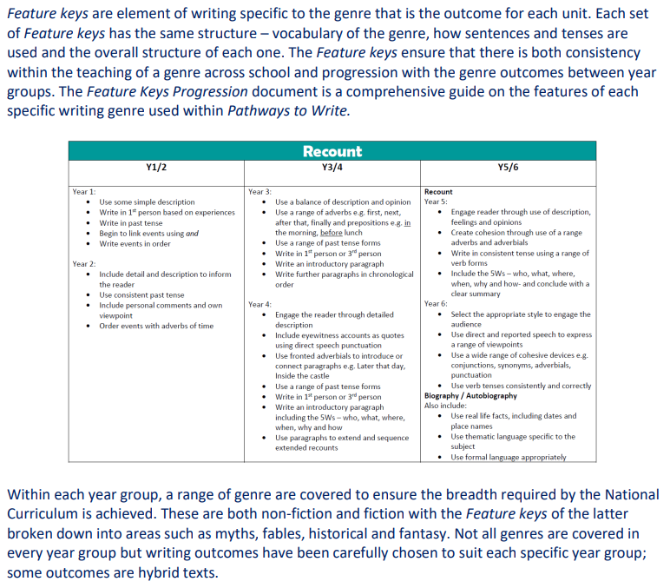

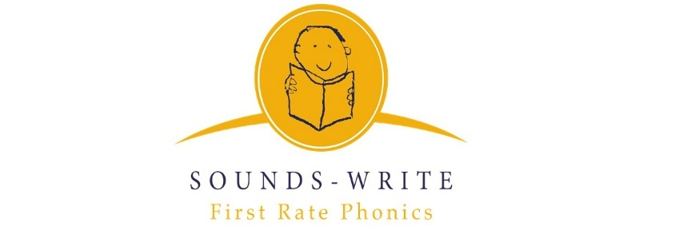
Spelling

KS1 Spelling
In Key Stage 1, spelling is taught through the Sounds-Write programme, a systematic, phonics-based approach that develops children’s understanding of the relationship between sounds and letters. Sounds-Write focuses on building strong foundations in phonemic awareness, enabling children to segment, blend, and manipulate sounds confidently to support accurate spelling and reading. The programme is structured around the explicit teaching of phonemes and graphemes, progressing from simple to more complex sound patterns in a logical sequence suited to young learners.
Sounds-Write encourages children to develop essential transcription skills through a multi-sensory approach, combining visual, auditory, and kinaesthetic activities to reinforce learning. Children are taught to listen carefully to the sounds in words, identify the correct letters or letter combinations, and apply spelling rules to compose words independently. This approach supports the accurate spelling of both regular words and irregular ‘tricky’ words.
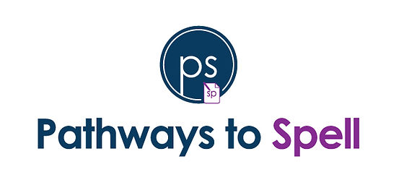
Throughout KS1, children have frequent opportunities to practise spelling in context, using dictation, writing sentences, and oral rehearsal. Sounds-Write also fosters self-monitoring and editing skills, encouraging children to become reflective spellers who can identify and correct their errors. This solid foundation in phonics and spelling prepares children to transition confidently to the Pathways to Spell programme in Key Stage 2, where they build on and expand their spelling knowledge.

KS2 Spelling
From Key Stage 2, children follow Pathways to Spell, an innovative and engaging spelling programme designed to fascinate pupils about words and develop confident, independent spellers. Pathways to Spell is a research-based series of lessons structured around the Review, Explain, Practise, Apply, and Reflect model. This approach ensures that children not only learn spelling rules and patterns but also revisit and reinforce previously taught objectives throughout the curriculum, closing gaps and supporting long-term retention. Pathways to Spell encourages pupils to become self-aware learners who understand their spelling strengths and weaknesses and develop strategies to improve.
Teaching through Pathways to Spell involves multiple approaches, including:
- A developmental progression from phonics and grapheme-phoneme correspondences (GPCs) to word patterns and visual recognition, paced appropriately for each child's age.
- Generalisation strategies, where pupils apply known spelling patterns to new words.
- Rote visual memorisation techniques such as look/say/cover/write/check.
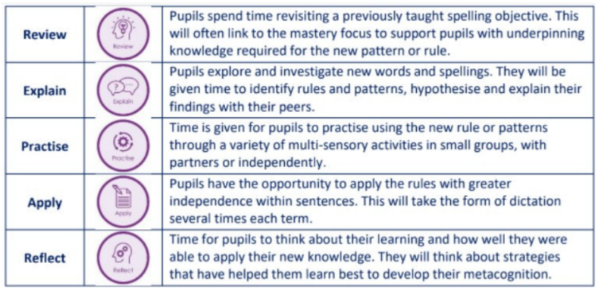
Through these methods, pupils build essential knowledge in key areas including phonemic awareness, orthographic understanding, morphological meaning, and etymological origins of words. This multi-faceted approach helps children grasp the complexity of English spelling beyond simple memorisation.

Handwriting
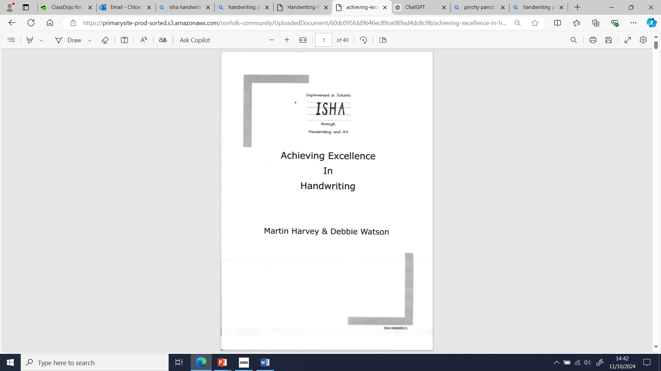
Our Curriculum
At St. Michael's, we believe an effective approach to handwriting helps pupils become proficient handwrites from an early age. Our focus is on developing a style that is neat, legible, and efficient. To teach handwriting, we use the ‘Achieving Excellence in Handwriting scheme’ starting with our youngest pupils in Reception through to Year 1. This scheme, based on the ISHA handwriting framework by Martin Harvey and Debbie Watson, guides students through a systematic progression from basic letter formation with joining strokes to full joined handwriting.

Beginning the journey: Handwriting in EYFS
The semi-cursive handwriting style taught through this scheme is simple yet clear and achievable for our pupils. Our goal is to deliver structured handwriting lessons that help students commit transcription skills to muscle memory, supporting their growth as proficient writers. The handwriting journey begins in Reception, where pupils are introduced to foundational skills that will support their development. In the EYFS, pupils learn the mnemonic associated with grapheme-phoneme correspondences from our phonics program, SoundsWrite, which supports the early stages of handwriting. This approach helps children form a strong connection between sounds and letters, setting the stage for fluent writing. They are also introduced to essential aspects of our handwriting scheme, such as the ‘pinchy parrot’ technique to encourage correct pencil grip and the use of line guides to assist with letter placement. By focusing on these elements early on, we ensure that pupils build confidence and precision in their handwriting, providing a solid foundation that will be reinforced and refined as they progress through the school.

Handwriting instruction framework
At St. Michael's, we teach handwriting across the school every day for 10 minutes, with a specific focus on individual practice. During these sessions, teachers model handwriting for pupils as they introduce new words, discussing whether the letters are tall, tail, or short letters. Additionally, handwriting is modelled and taught within phonics lessons, reinforcing the connection between letters, sounds, and writing skills. By integrating handwriting into daily routines and phonics lessons, we aim to support our pupils' literacy development, building both confidence and precision in their writing skills.

The handwriting scheme
Our writing scheme is based on ‘letter families,’ grouping letters according to their starting point. The letter families we teach include:
- Family 1: The Straight Line Family (i, l, t, j)
- Family 2: The Coat Hanger Family (c, o, a, d, g, q, e)
- Family 3: The Bridge Family (h, b, k, p)
- Family 4: The Zig Zag Family (v, w)
- Family 5: The Smile Family (u, y)
- Family 6: The Misfits (s, f, x, z)
Effective handwriting instruction is supported through high-quality modelling. Teachers at St. Michael's regularly demonstrate letter formation and joins, observing pupils’ writing to ensure correct formation and providing support as needed.
Teachers follow the handwriting scheme with flexibility, using their professional judgment to adjust the pace according to the needs of their pupils. This may involve focusing on areas that need more improvement or advancing more quickly when appropriate. Peer assessment and self-assessment are encouraged throughout handwriting lessons, helping pupils take ownership of their handwriting progress. Pupils are also encouraged to take pride in their handwriting book, fostering a sense of responsibility and achievement in their writing journey.

Handwriting lines
The ISHA handwriting scheme utilises specially designed handwriting lines to support students in developing their writing skills effectively. These lines provide clear guidance for letter formation and sizing, helping pupils understand the correct placement of letters both in print and semi-cursive writing. The lines differentiate between the top broken line, top solid lane, bottom solid line and the bottom broken line. These guidelines make it easier for students to visualise the height and structure of each letter.
By using these lines consistently, pupils can develop a better understanding of spatial awareness on the page, which is crucial for neat and legible handwriting. The structured format encourages children to maintain proper sizing and spacing as they progress in their handwriting journey, ultimately fostering a sense of confidence and pride in their written work.
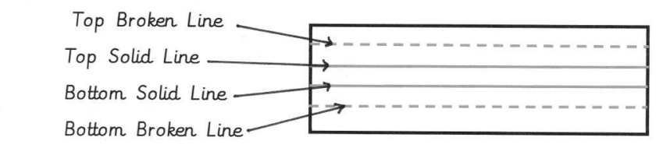

Letter types
The ISHA handwriting scheme categorizes letters into distinct types to facilitate effective teaching and learning of handwriting. This systematic approach helps pupils understand the unique characteristics of different letters and how to form them correctly. The main letter types in the ISHA scheme include:
- Tall Letters: These letters extend above the midline, providing an opportunity for students to practice maintaining consistent height. Examples include b, d, h, k, and l.
- Small Letters: These letters sit comfortably between the baseline and midline, allowing pupils to develop control and precision. Examples include a, c, e, i, and o.
- Tail Letters: These letters have descenders that go below the baseline, helping students learn the importance of proper spacing and size. Examples include g, j, p, and q.
- Curly Letters: These letters feature rounded shapes and curves, encouraging pupils to practice fluid movements in their writing. Examples include c, o, s, and u.
- Zigzag Letters: These letters are characterized by sharp angles and lines, helping students build confidence in writing more complex shapes. Examples include v and w.

Pencil grip techniques
Effective handwriting begins with the correct pencil grip, and the ISHA scheme emphasizes the importance of teaching various grip techniques to ensure students develop control and comfort while writing. The following are common pencil grip names used in our approach:
- The Pinchy Parrot Grip: This engaging technique encourages students to hold the pencil with their thumb and index finger, resembling a parrot pinching a twig. It promotes a relaxed grip and helps maintain proper control over the pencil.
- The Tripod Grip: This widely recognised grip involves using the thumb, index finger, and middle finger to hold the pencil. It offers stability and balance, allowing for better movement and precision during writing.
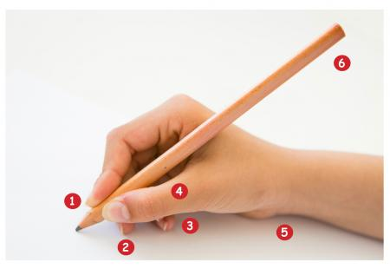
- The Dynamic Tripod Grip: A variation of the tripod grip, this technique encourages slight movement in the fingers while writing, allowing for fluidity and flexibility in handwriting. This grip is ideal for developing the fine motor skills necessary for legible writing.

Establishing proper writing posture
We follow consistent guidelines to support proper posture and technique, ensuring all children have
- TNT (Tummy next to the table)
- BBC (bottom at the back of the chair)
- "Six legs" (4 chair legs and 2 student legs)
- ‘Two hands’ engaged in writing.

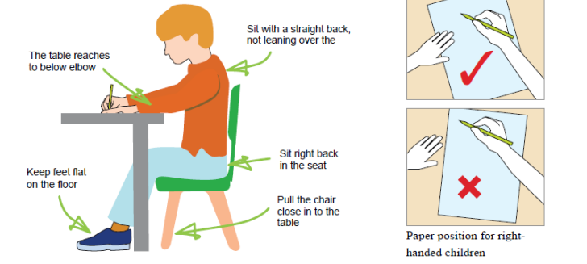
Teachers also check that each pupil has the correct pencil grip, which is essential for developing control and precision in their handwriting.

Handwriting books for English: Years 1 to 4
At St. Michael's, handwriting books are specifically designed for use during English lessons, intended to support students’ writing development. These books are integral to the ISHA handwriting scheme and provide a structured environment for pupils to practice their handwriting skills effectively.

Handwriting pens
At St. Michael's, we strive for our pupils to take pride in their writing and ownership of their books. With this in mind, pupils in the last term of Year 2 and above are invited to use a handwriting pen in all subjects, except Mathematics. We encourage pupils to write neatly and maintain a high standard of presentation in their work.

Impact
At St Michael’s, we are committed to ensuring that our English curriculum leads to measurable progress, deep understanding, and a love of writing. Through our carefully structured use of Pathways to Write, pupils develop their ability to write confidently and fluently across a wide range of genres. The consistent mastery-based approach ensures that writing skills are revisited, refined, and embedded over time. Children become adept at planning, drafting, editing, and publishing work that reflects both technical accuracy and creative flair. High-quality model texts and carefully scaffolded tasks build not only competence but also enjoyment and purpose in writing.
Our youngest children benefit from a strong foundation in transcription and early composition through Sounds-Write. This systematic and highly effective phonics programme enables children to become confident with grapheme-phoneme correspondences and early spelling strategies. It supports their progression from oral rehearsal and early mark-making to independent sentence construction and fluency. This secure start ensures that they develop the skills they need to become successful, confident writers as they move into Key Stage 2.
From Key Stage 2, children continue to develop their spelling through the Pathways to Spell programme. This innovative and research-driven approach builds curiosity and confidence around word structure, etymology, and morphology. Pupils learn to explore spelling rules, recognise patterns, and apply knowledge across the curriculum, rather than learning words in isolation. This strategy supports long-term retention and raises the profile of spelling as an essential component of writing success.
Throughout all key stages, we track pupil progress rigorously through ongoing teacher assessment, termly moderation, and regular opportunities for independent extended writing. Teachers use these assessments to identify gaps, set next steps, and provide timely interventions to ensure all children meet or exceed age-related expectations.
We believe writing should be purposeful, powerful, and personal. Our aspiration is that every child at St Michael’s leaves us not only as a competent writer, but as someone who sees themselves as a writer. They will be equipped with the technical skills and confidence to write fluently, accurately, and creatively across a range of purposes and genres. Beyond meeting national expectations, our pupils will have developed a genuine love for language and the written word—recognising writing as a tool for self-expression, communication, and influence in the wider world. Through our rich and cohesive curriculum, we nurture reflective, resilient, and articulate writers who are fully prepared for the next stage of their education and beyond.

